Migration of company iPhone

Please take your company iPhone and open your message service. You should have received an SMS with a link.

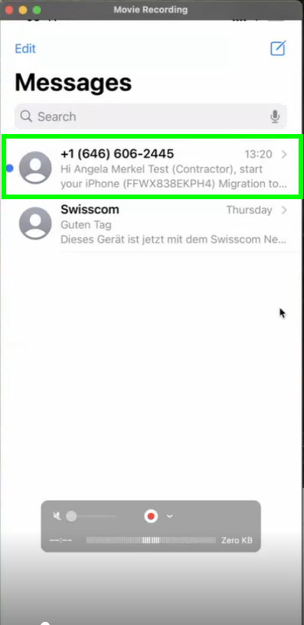

alt text

Please click on the link in the SMS

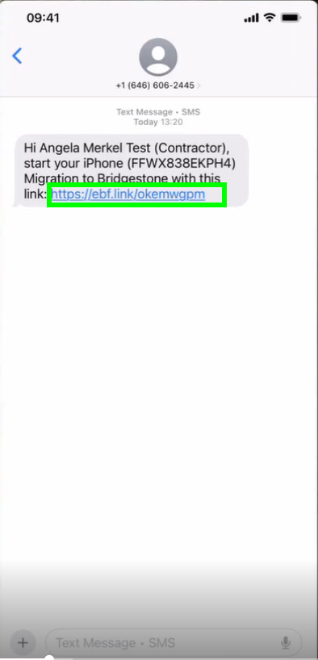

alt text

A new window will pop up. Please open first the migartion guide and then click on “Start Migration”

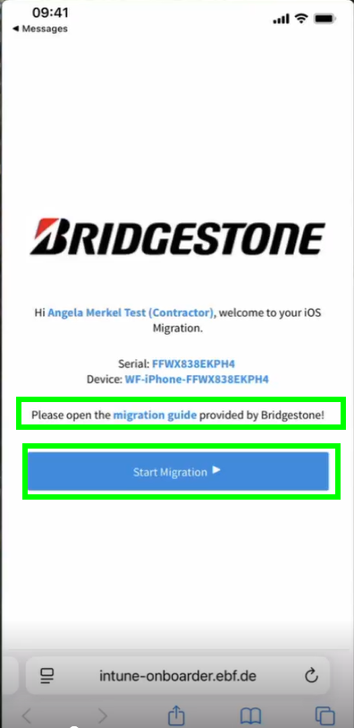

alt text

Please wait until the countdown is over:

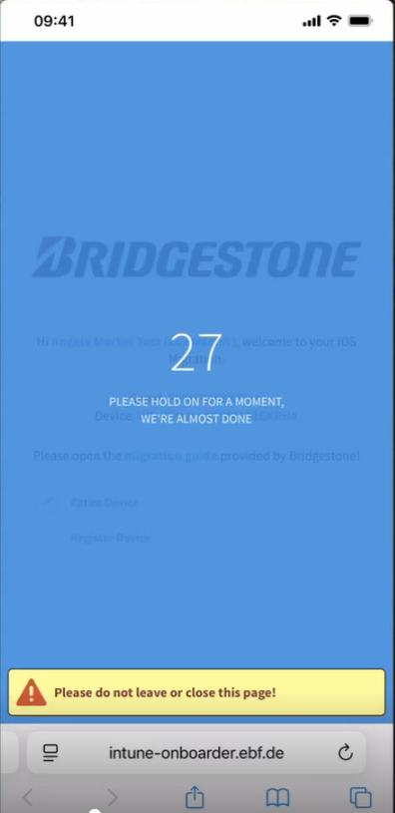

alt text

Sign in with your Bridgestone account. Your webfleet account will be blocked:

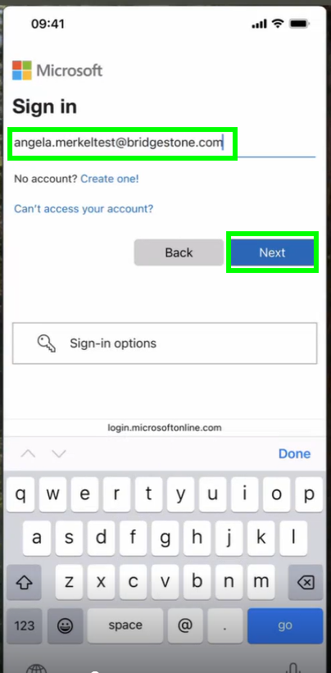

alt text

enter your password and click on “Sgin in”:

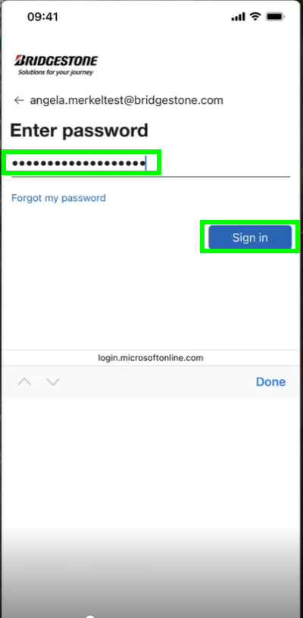

alt text

Please NEVER save a password in your phone:

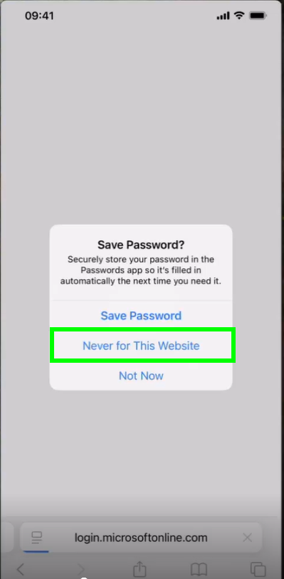

alt text

We are now ready to migrate your company iPhone. Pleae click on “Get started”:

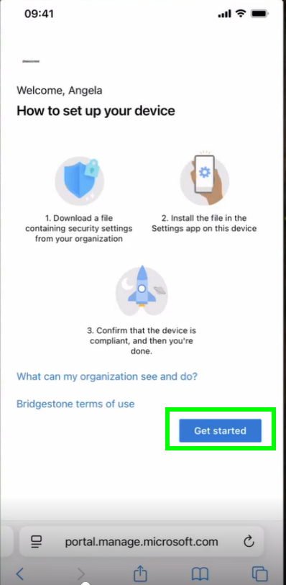

alt text

Here are the steps we need to take:

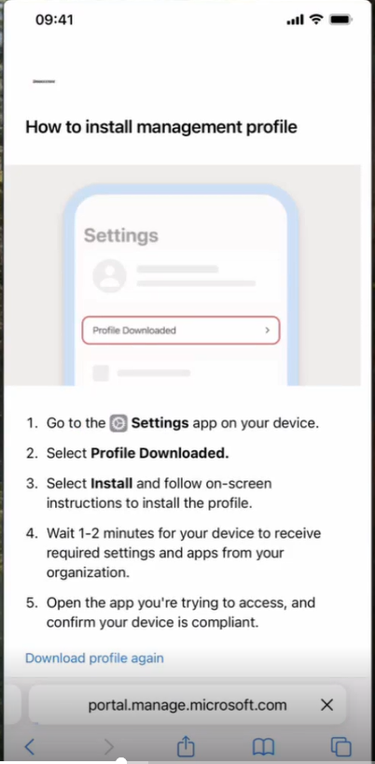

alt text

First allow the website to download a configuration profile:

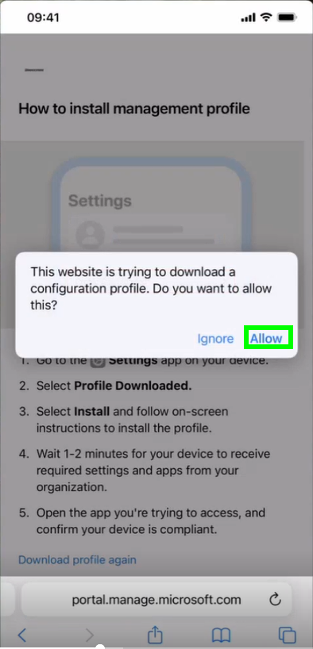

alt text

You can close the next pop up:

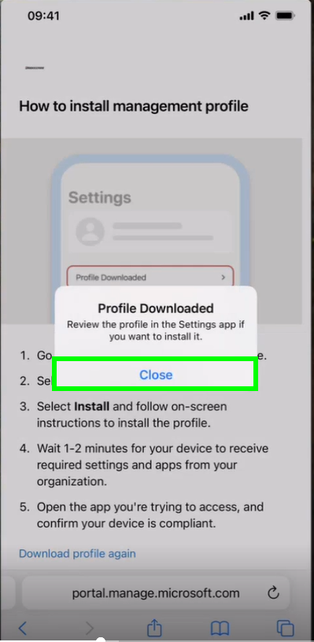

alt text

Open now the settings of your iphone and click on “Profile Donwloaded”:

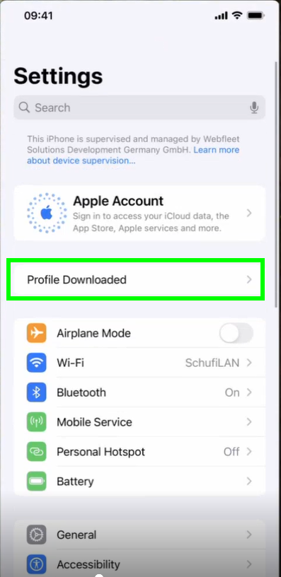

alt text

Click now on “Install” on the top right corner:

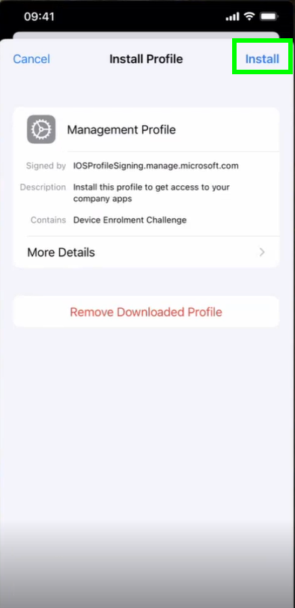

alt text

Enter your iPhone passcode:

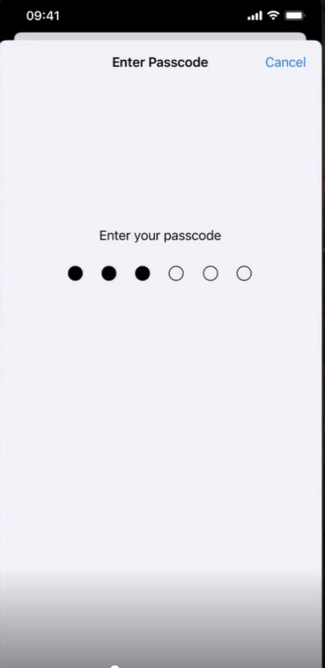

alt text

Click again on Install:

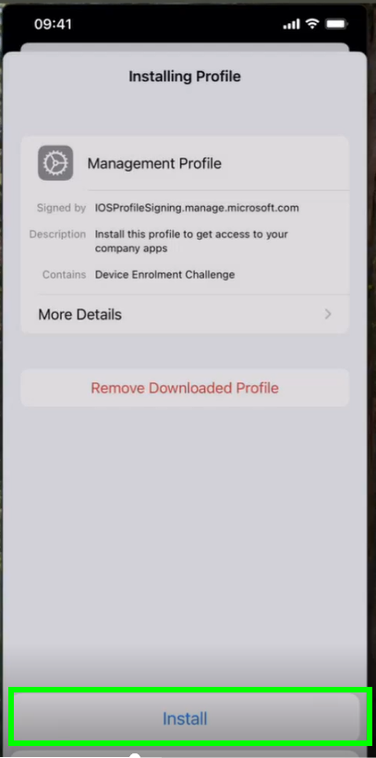

alt text

Confirm every step with “Next” and once arrived here, please click again on “Install” on the top right corner:

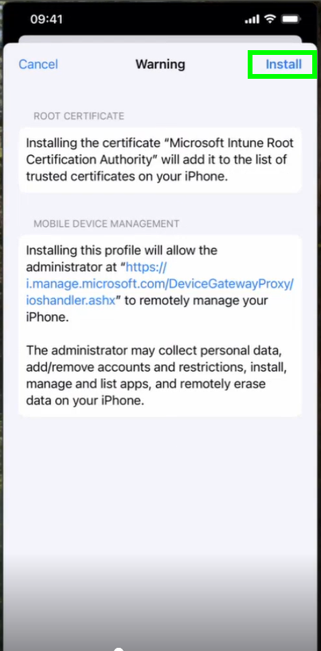

alt text

Confirm that you trust the profile’s source by clicking on “Trust”:

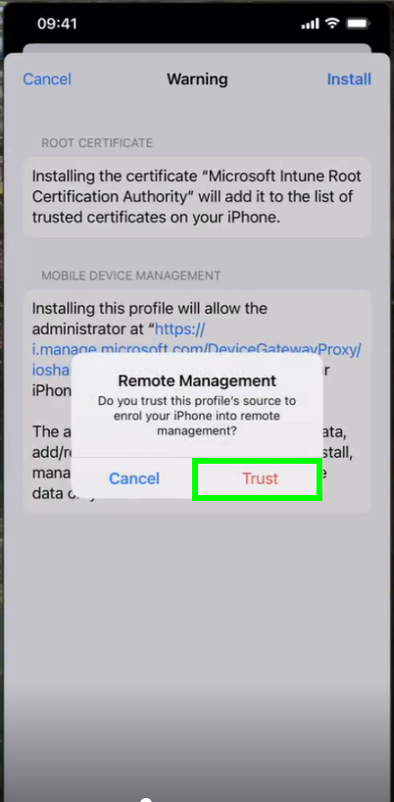

alt text

Your new Bidgestone profile is now installed. Please click on “Done” to complete:

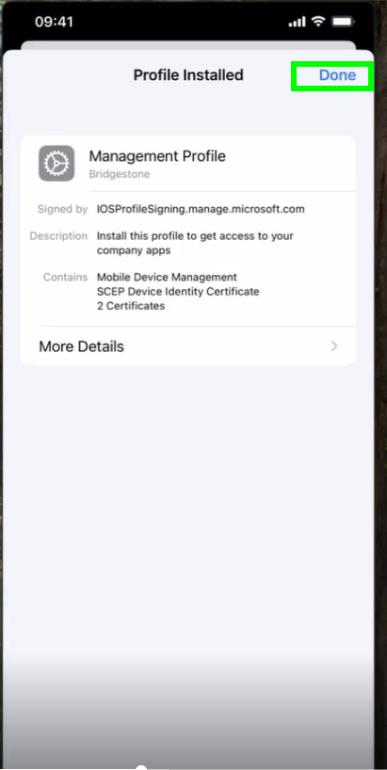

alt text

In a few minutes all your company apps will be available on the iPhone.

Please open now the Microsoft Teams app in order to login the first time. Please not that your webfleet account is still stored in the iPhone storage. To change it, please click on “Use another account”:

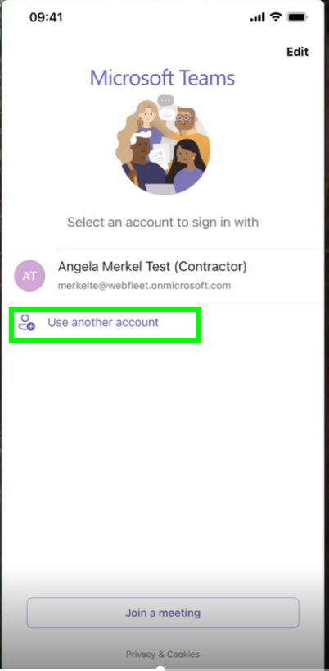

alt text

And login with your Bridgestone account:

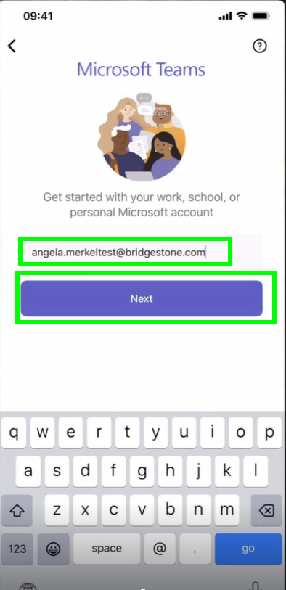

alt text

It may take a few seconds to the next step:

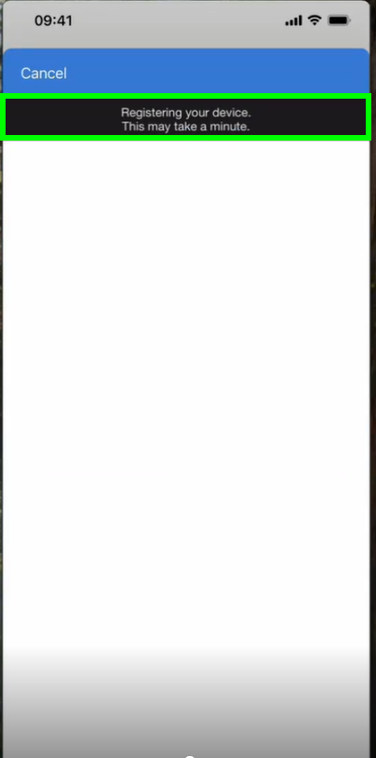 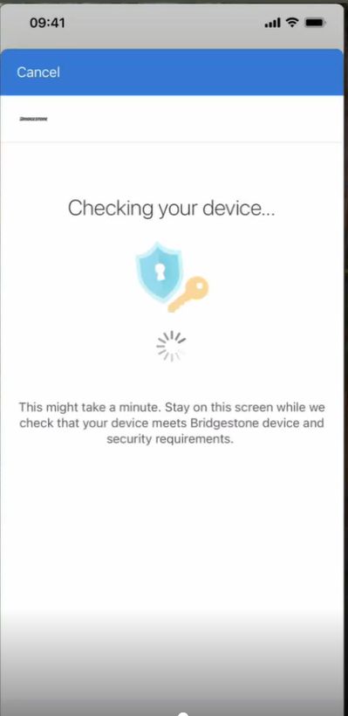

Please allow Temas to send you the notifications by clicking on “Allow”:

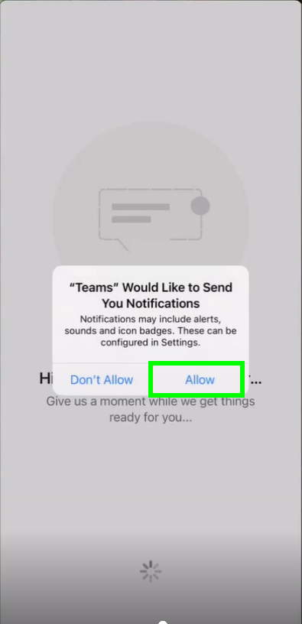

alt text

Please allow as well the access to the microphone:

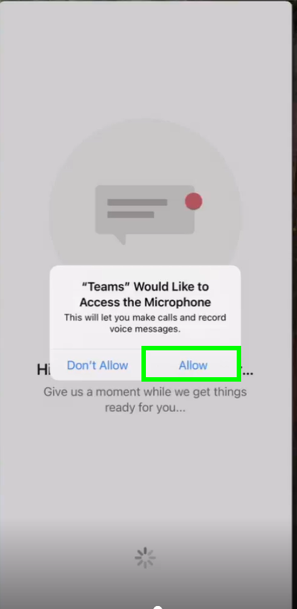

alt text

and you are ready with the company iPhone!