Migration of company MAC
You will find a file on the top right corner of your desktop. Please open the file:
alt text
alt text
a new window will pop up. Please open first the migartion guide and then click on “Start Migration”
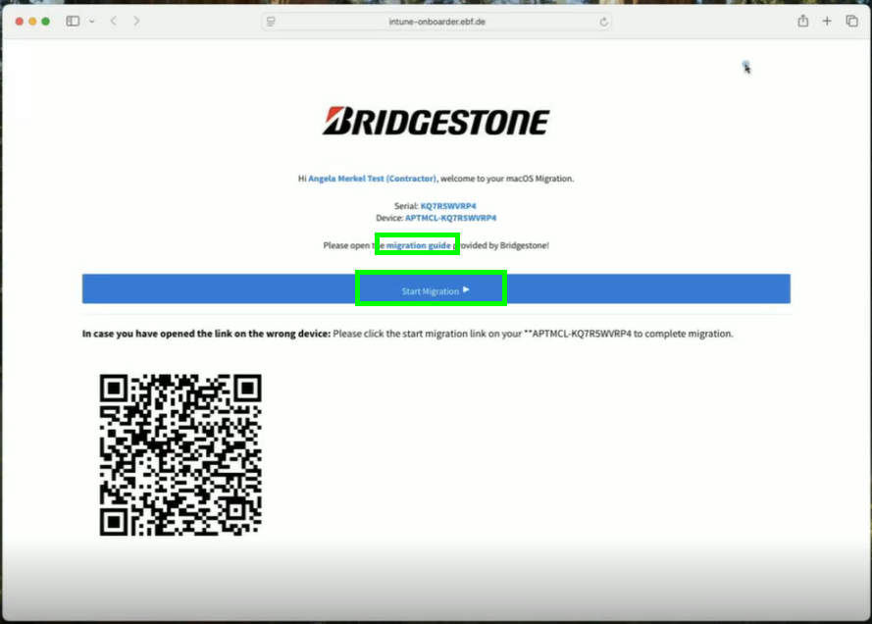
alt text
please wait until the countdown is over:
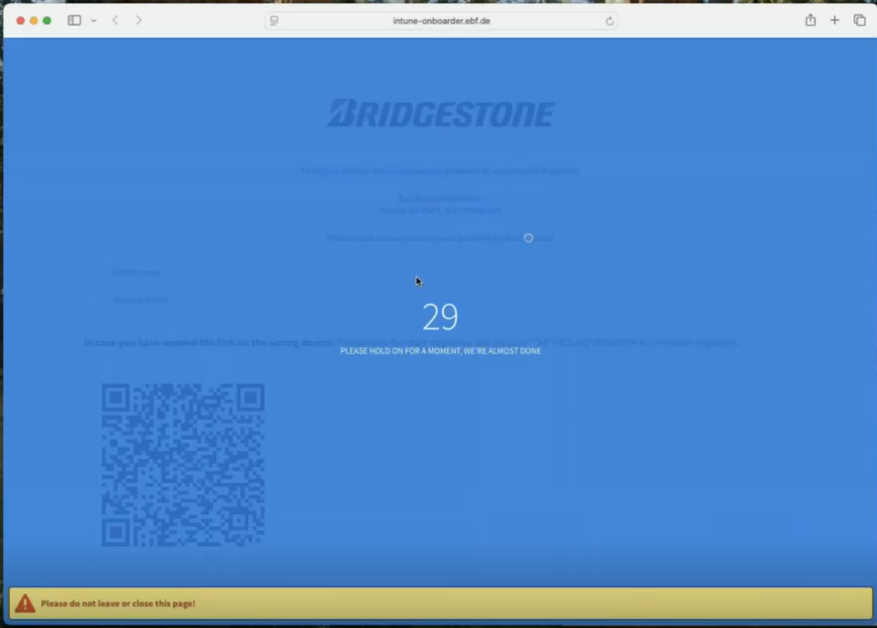
alt text
in case you will get warnings like the following plase click simply on “OK”:
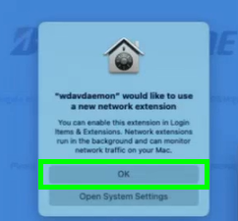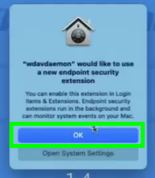
please download now the Migration Tool by clicking on “macOS - Migration Tool”:
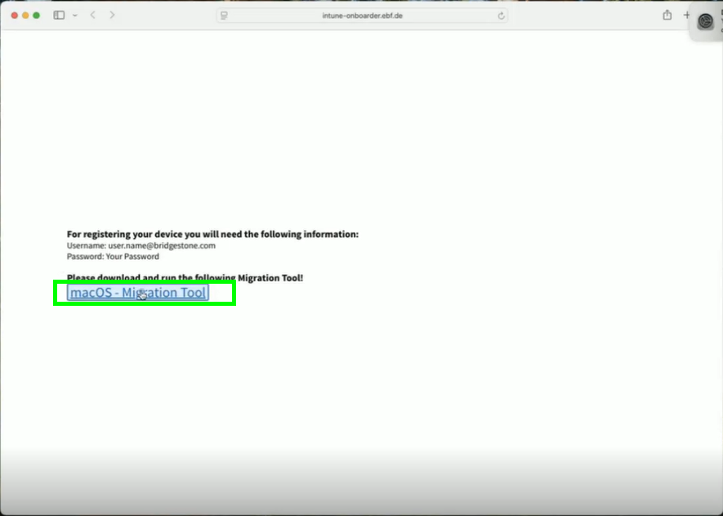
alt text
please confirm with “Allow”:
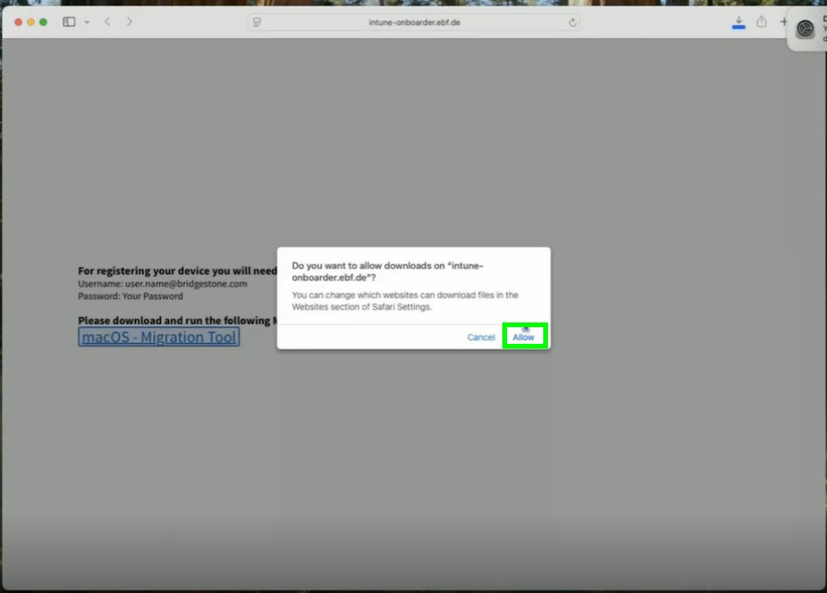
alt text
once the donwload is completed, please open the tool:
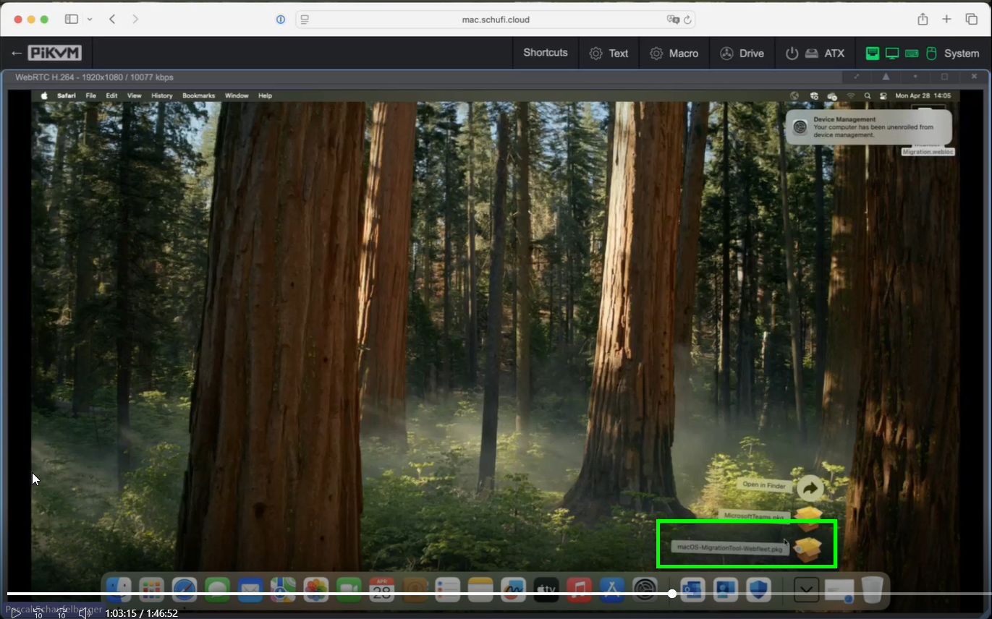
alt text
click on “Continue”:
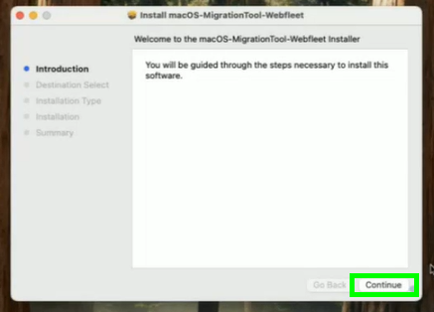
alt text
then on “Install”:
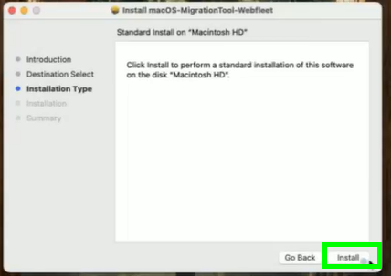
alt text
please enter your password and click on “Install Software”:
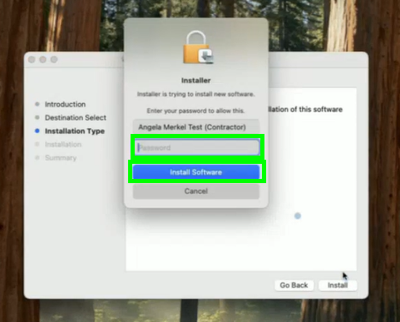
alt text
once the installation was successful, simply click on “Close”:
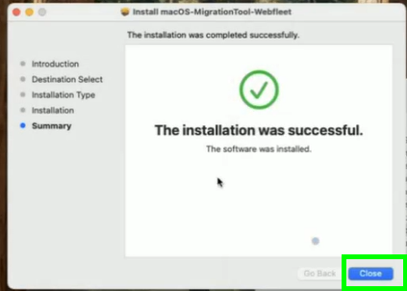
alt text
as we don’t need the software anymore, please click on “Move to Trash”:
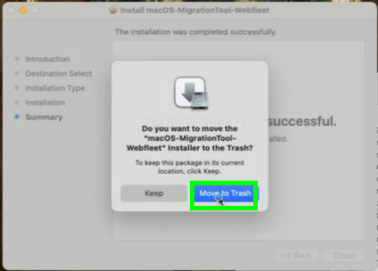
alt text
please open now the Company Portal and click on “Sign in”:
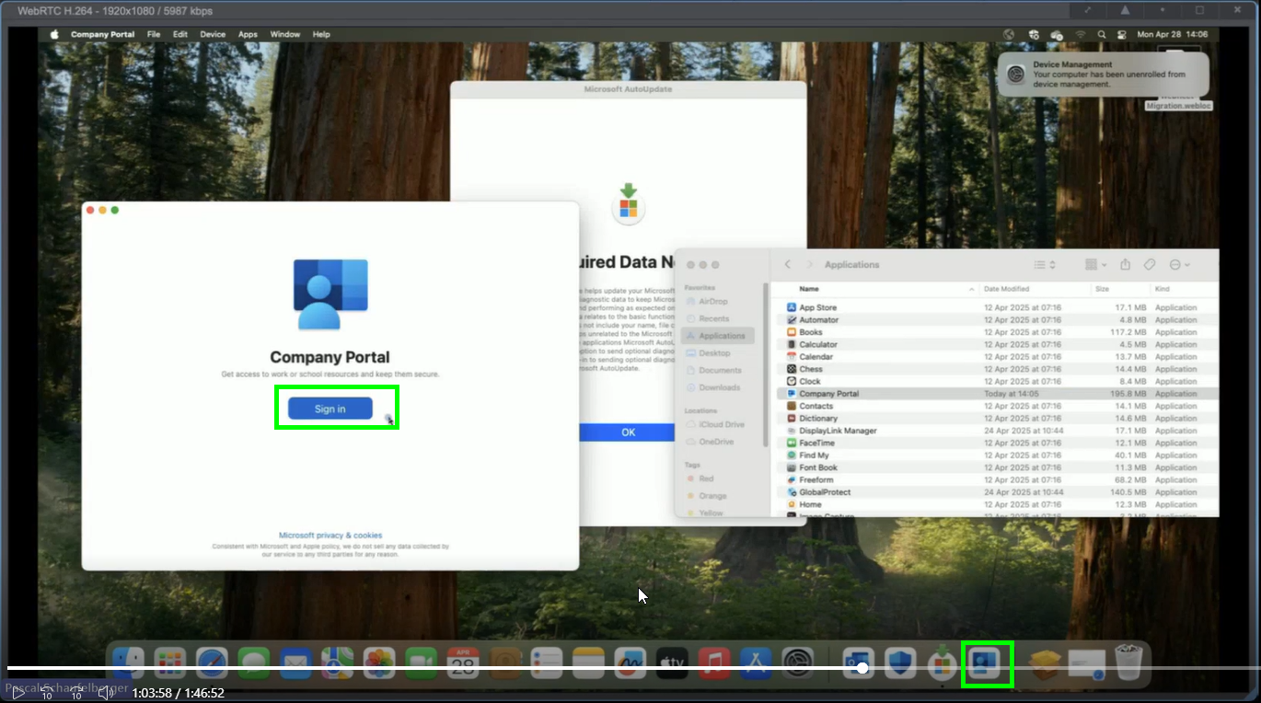
alt text
please choose “Use antoher account”:
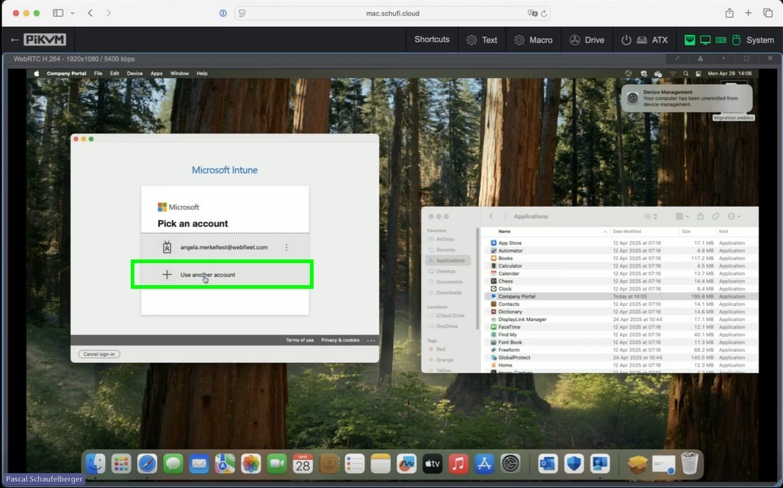
alt text
sign in with your Bridgestone account. Your webfleet account will be blocked:
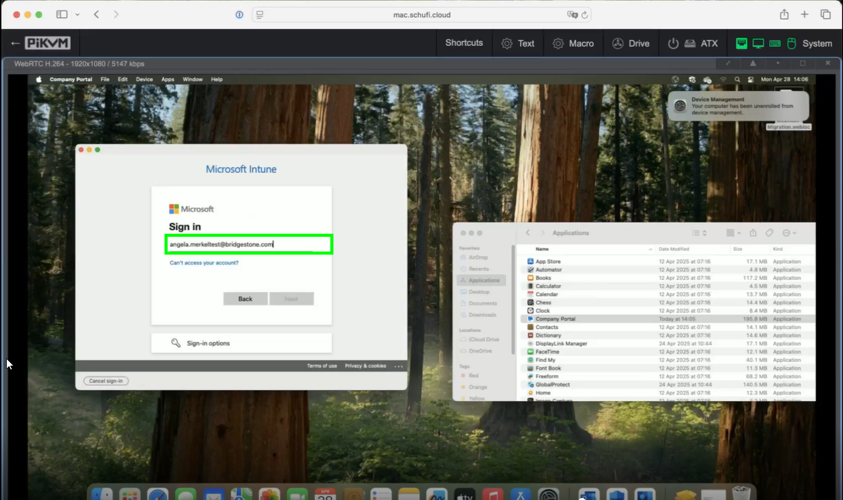
alt text
enter your password and click on “Sign in”:
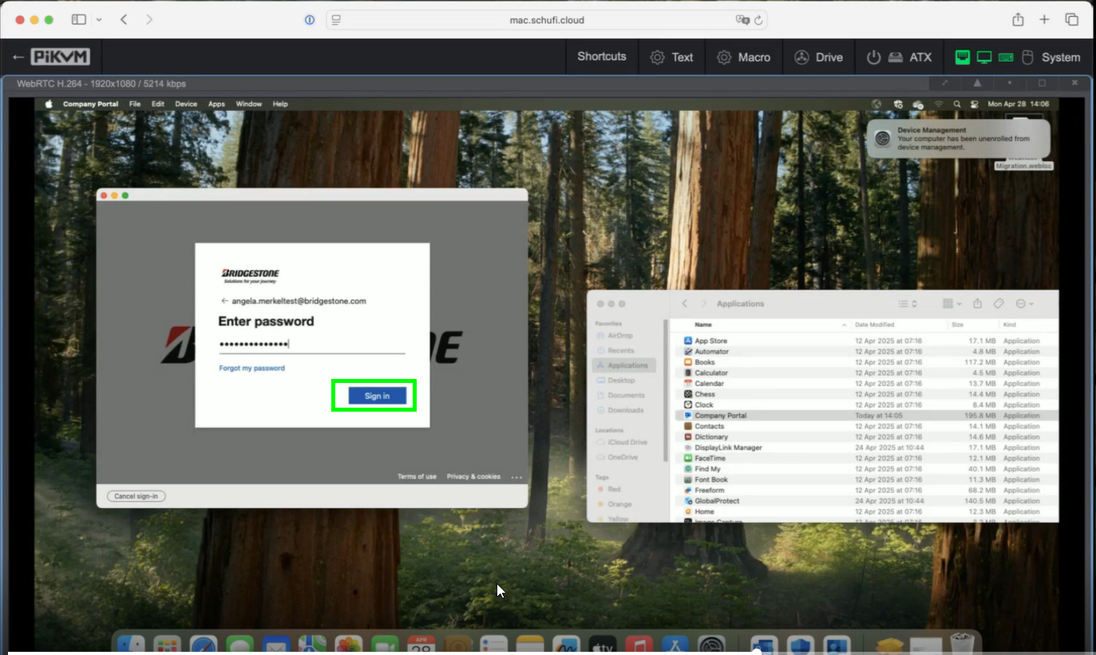
alt text
click now on “Begin” to setup up your Bridgestone access:
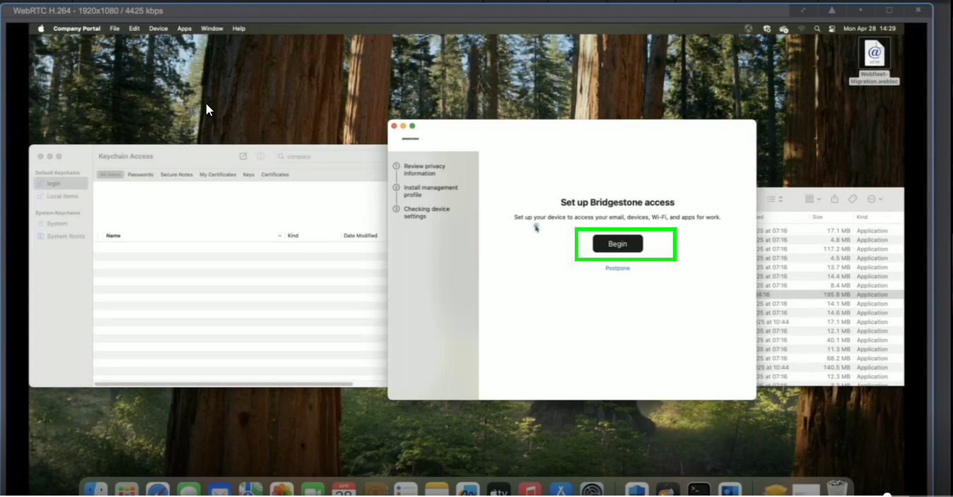
alt text
click now on “Continue”:
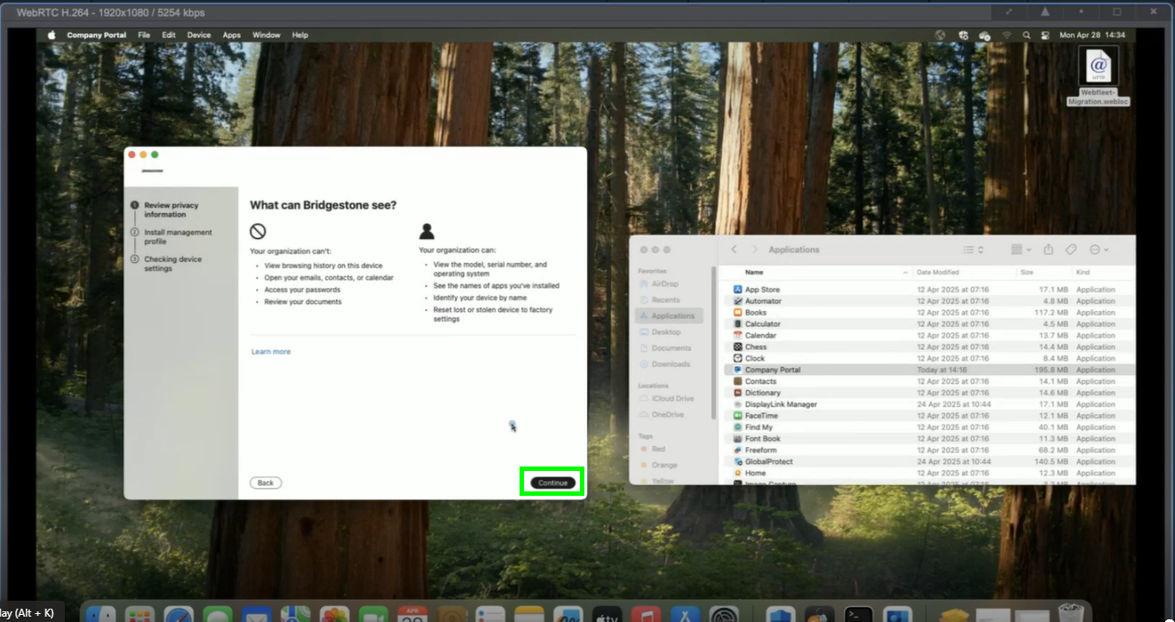
alt text
please click on “Download Profile”:
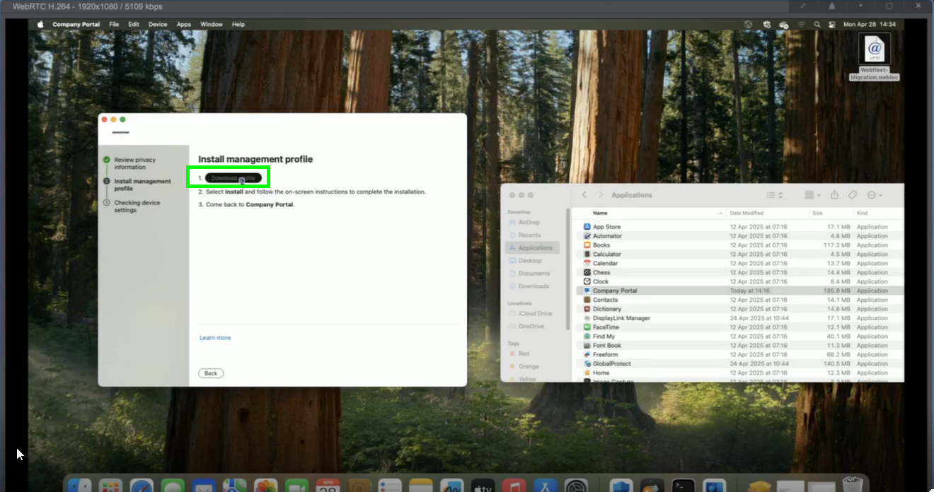
alt text
confirm with “OK”
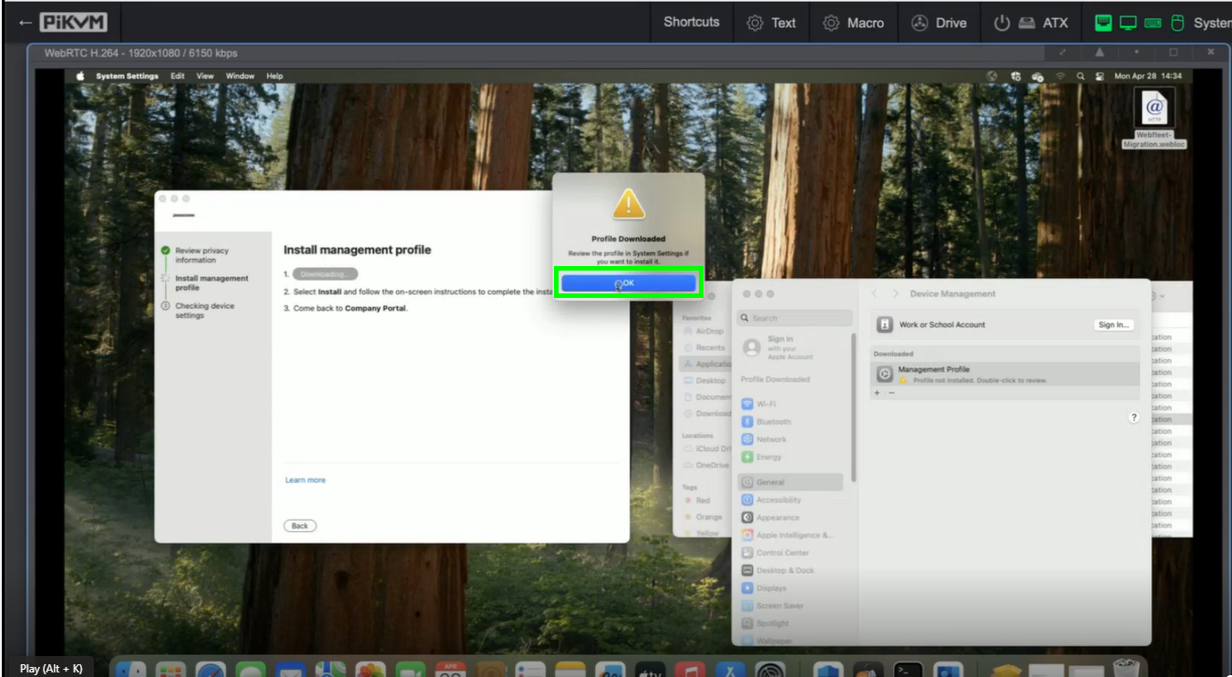
alt text
Click now in the General settings of your Mac on “Management Profile”
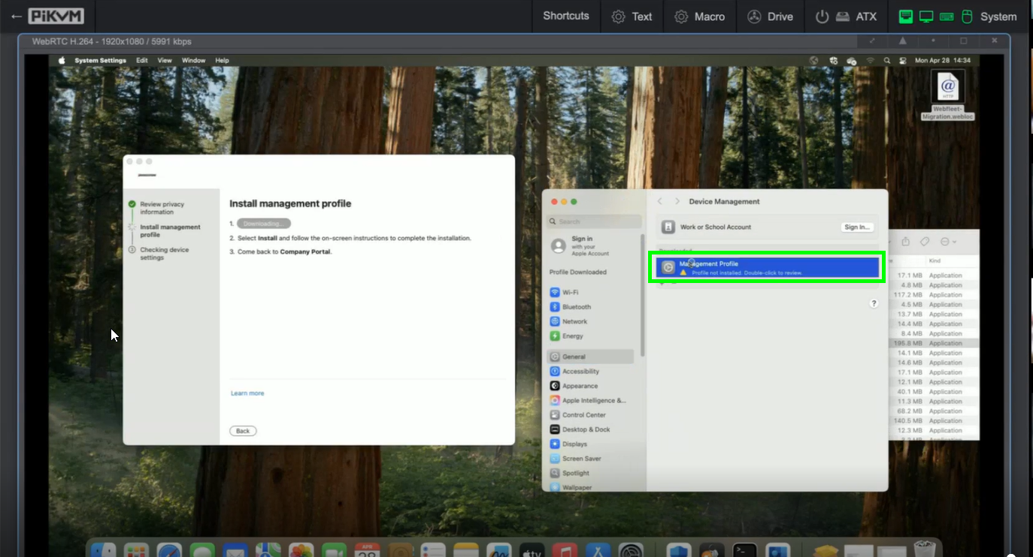
alt text
click now on “Install”:
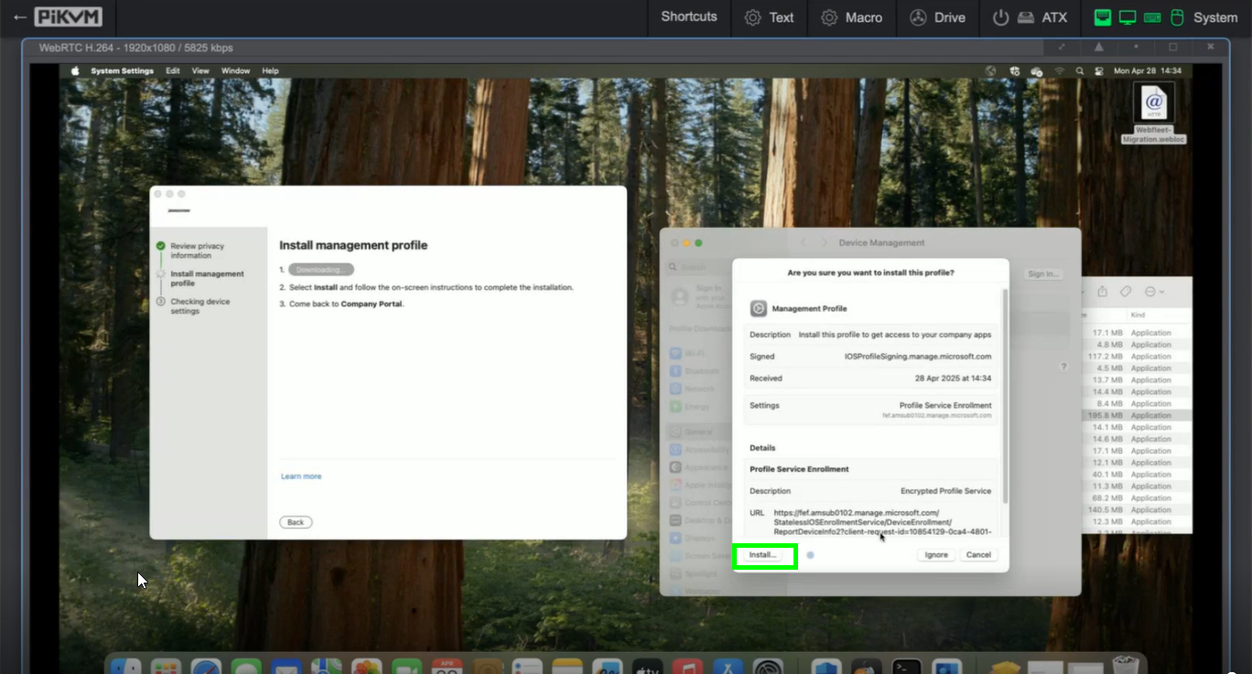
alt text
enter your password and click on “Enroll”:
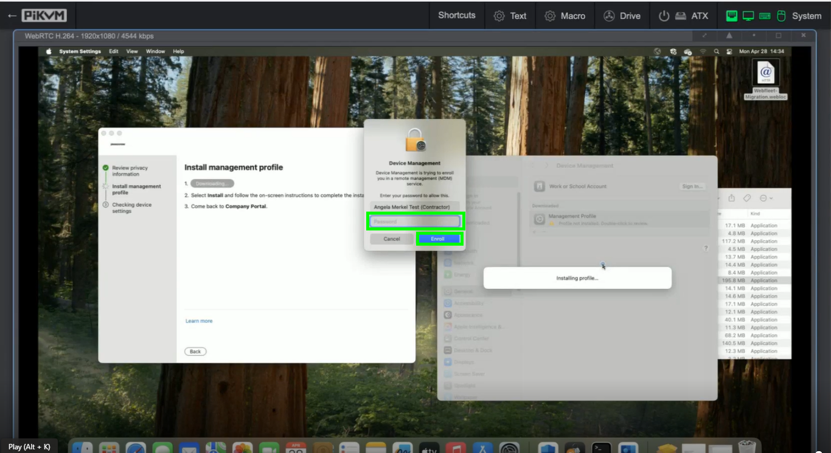
alt text
once the setup is completed you may simply click on “Done”:
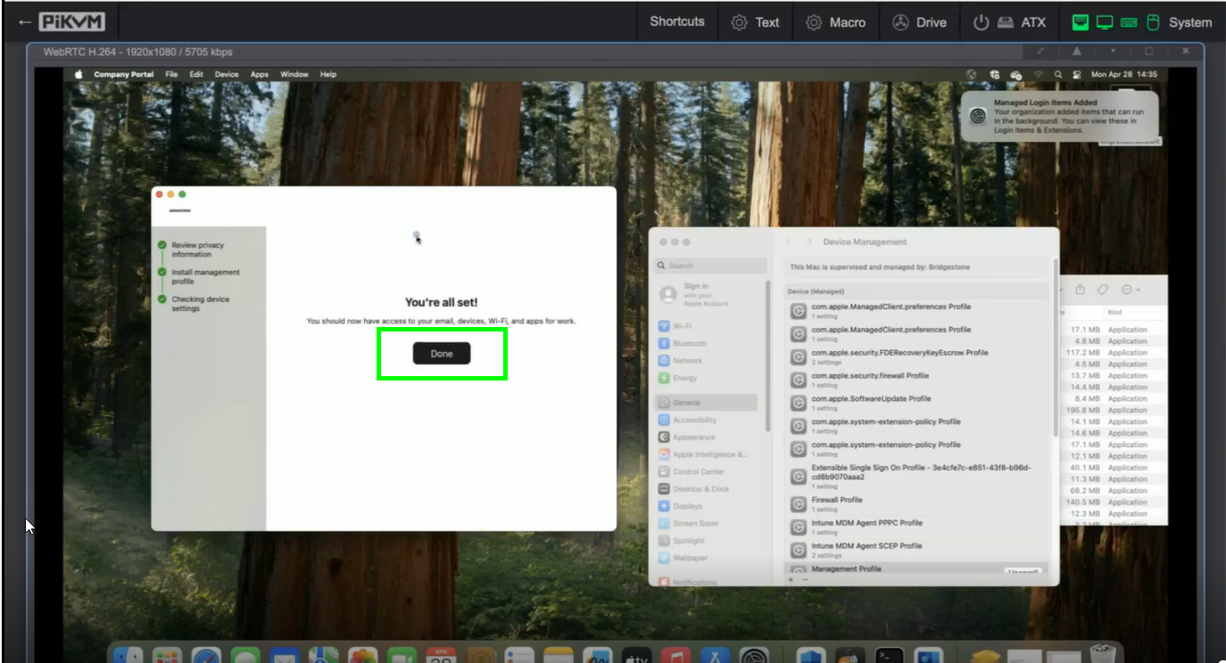
alt text
the last step to take is to sign in again in our office apps (Outlook, OneDrive, Teams etc.). Therefor please open your OneDrive, click on Settings and choose “Unlink Account”:
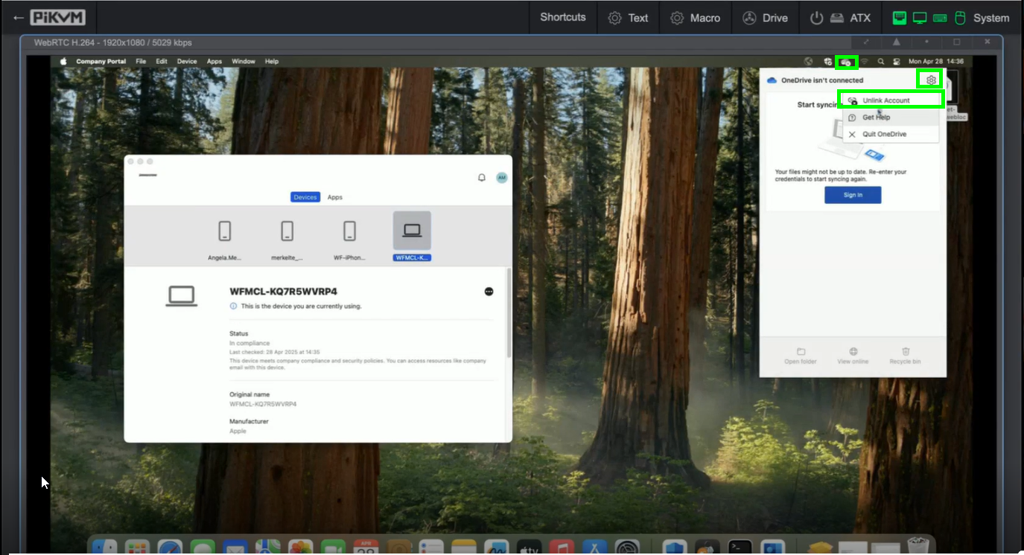
alt text
please confirm by clicking on “Unlink Account”:
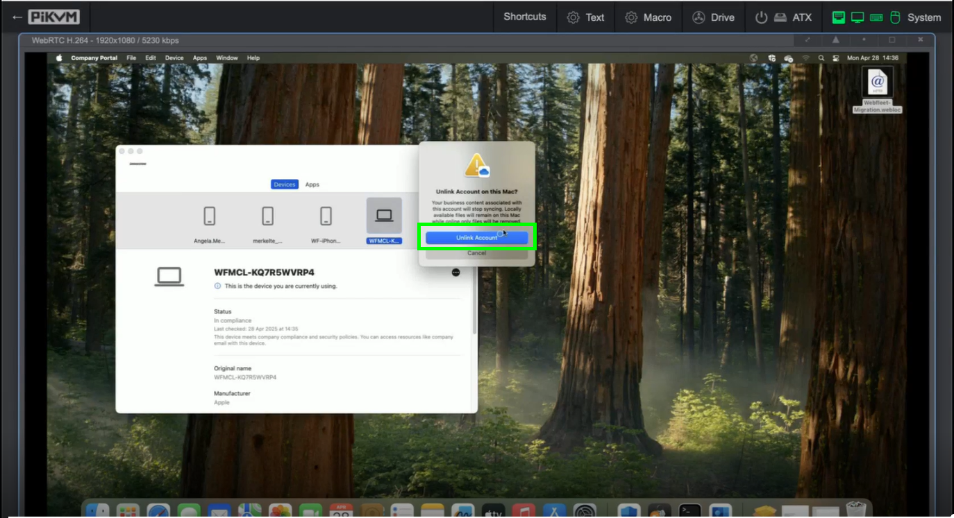
alt text
please enter now your Bridgestone eMail address and click on “Sign in”:
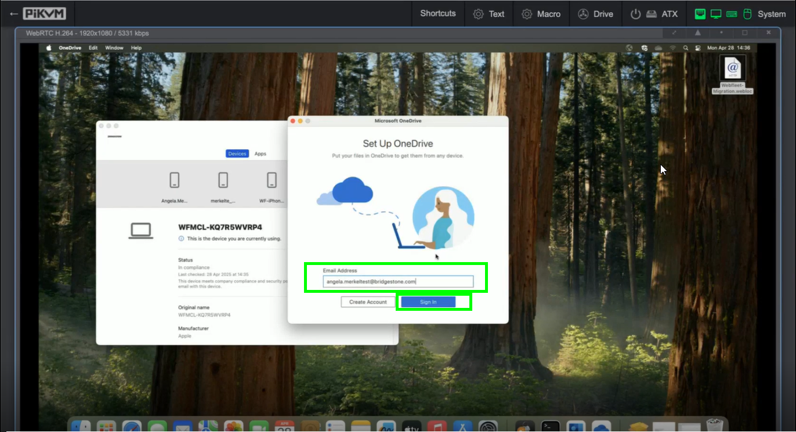
alt text
click on “Next”:
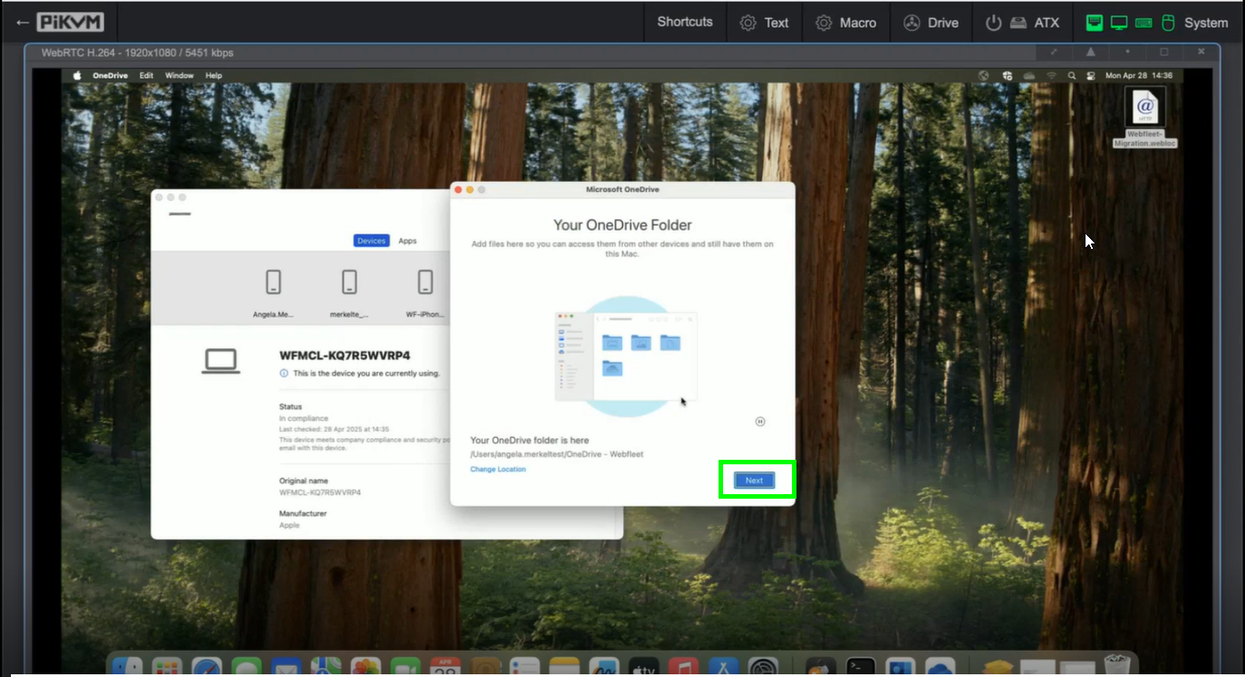
alt text
choose “Use This Folder”:
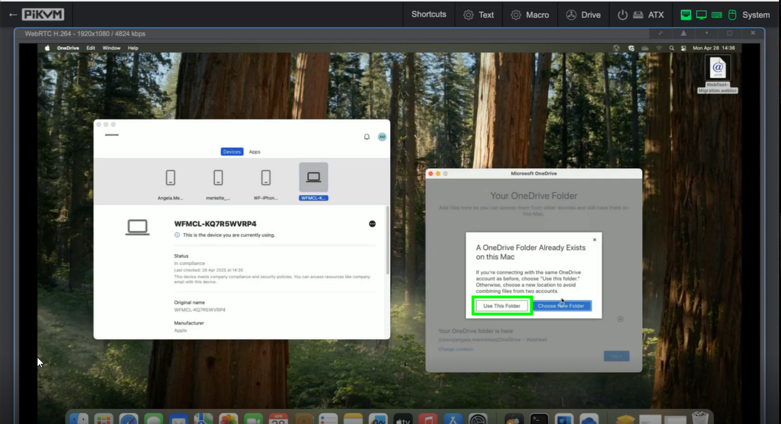
alt text
click on “Next”:
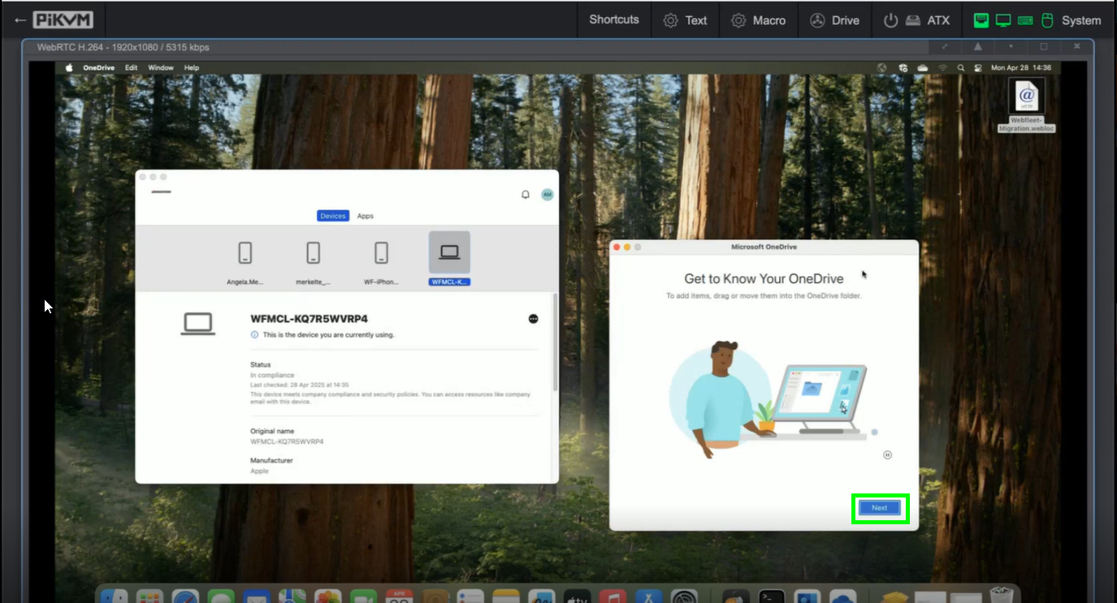
alt text
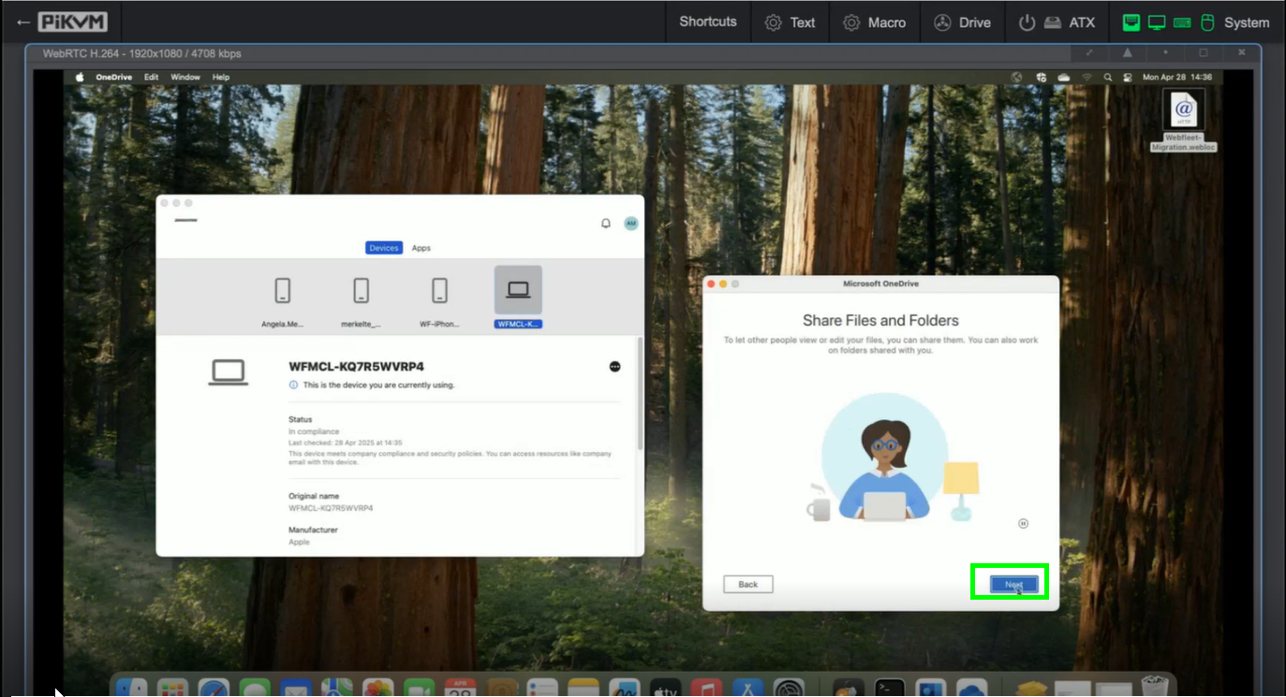
alt text
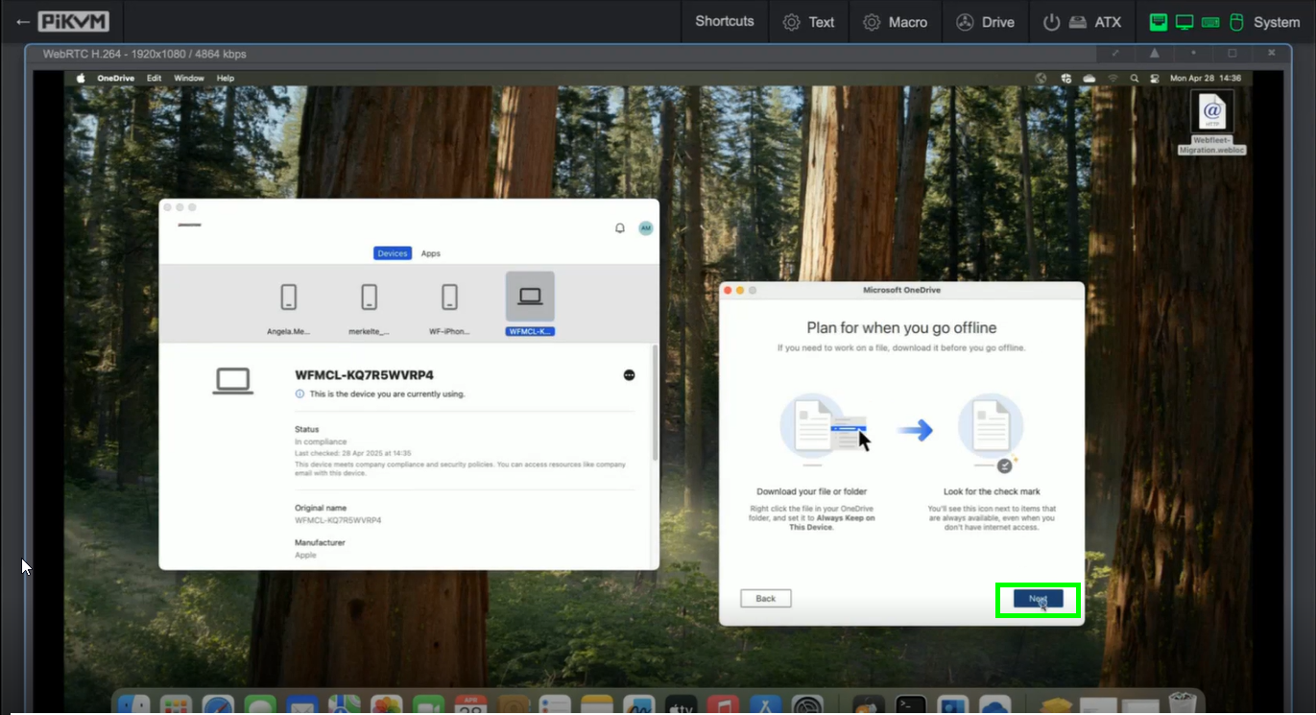
alt text
click on “Later”:
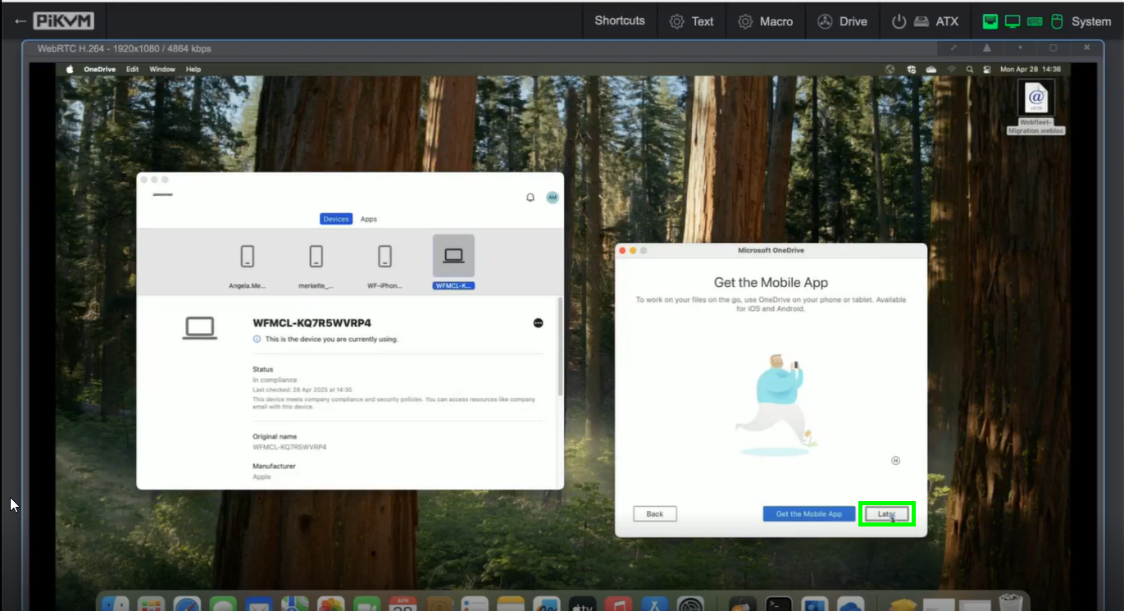
alt text
you may now open your OneDrive Folder or simply close the window:
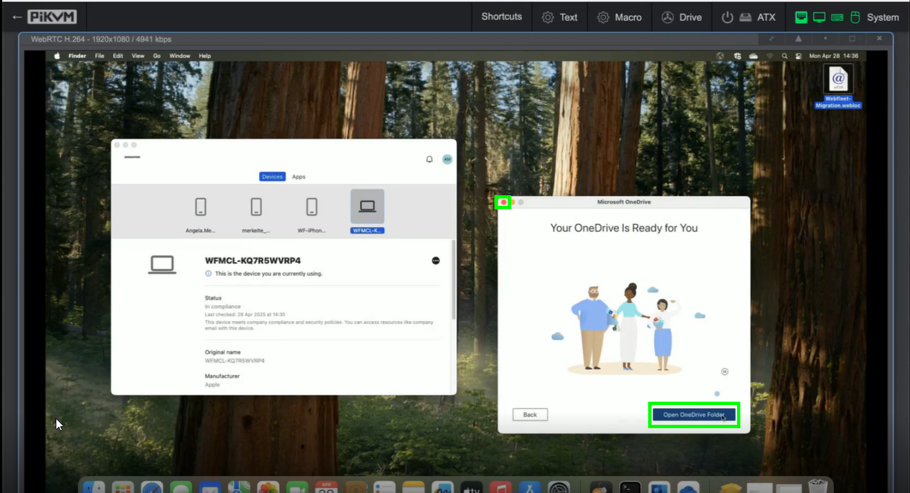
alt text

