Migration of company Android smartphone

The migration of an company Android smartphone requires a factory reset! This means all the settings will be reseted and all the data on the phone will be deleted. We highly recommend to force a backup of all needed data, which is stored on the phone BEFORE start the migration of your company Android smartphone!

Please take your company Android smartphone and open your message service. You should have received an SMS with a link.

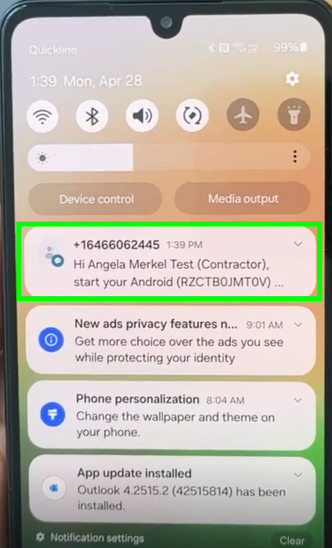

alt text

Please click on the link in the SMS

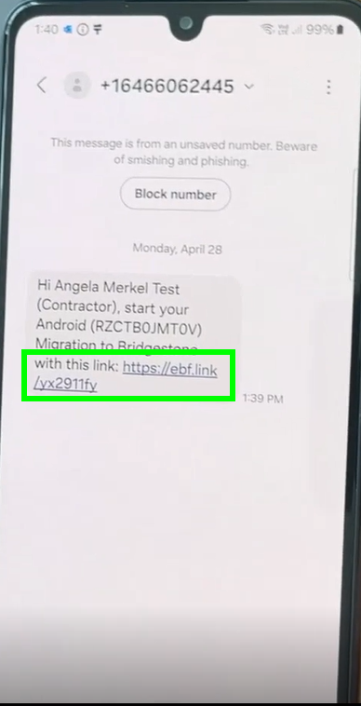

alt text

A new window will pop up. Please open first the migartion guide and then click on “Start Migration”

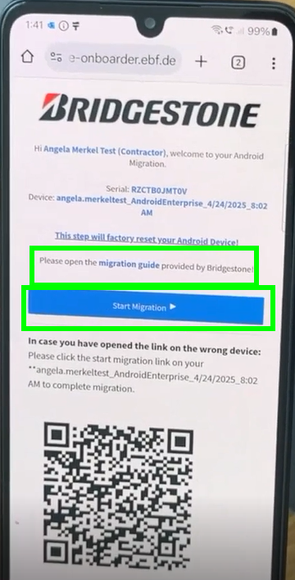

alt text

Please wait until the countdown is over:

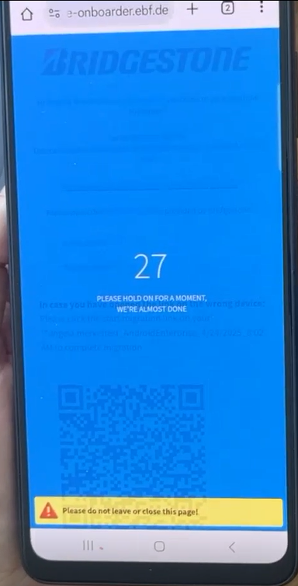

alt text

The phone will do now the reset. Pleae be patient. Once the phone is restarted you need to click 5x on the screen:

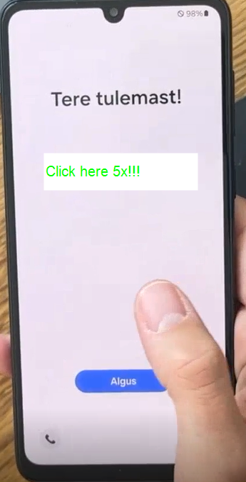

alt text

choose then your language and confirm with “Next”:

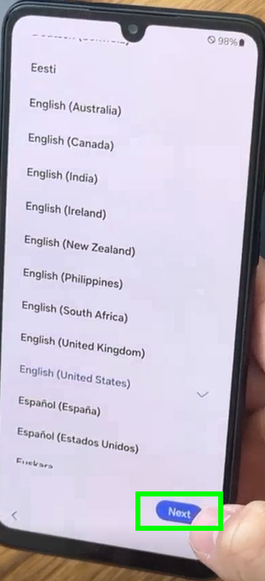

alt text

Pleaae scan now the QR code you have received by eMail:

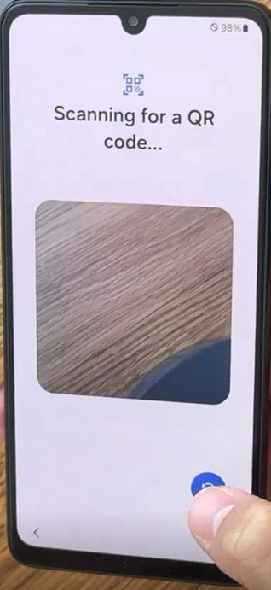

alt text

Please connect now your device to a network (Wi-Fi or mobile data):

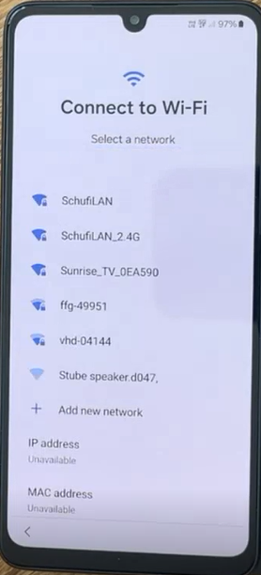

alt text

Your phone is now getting ready:

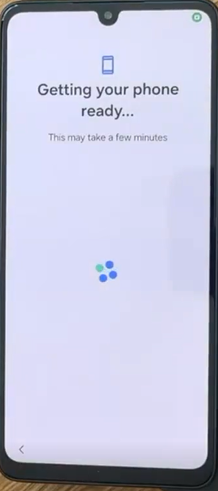

alt text

Please confirm the next step with “Next”:

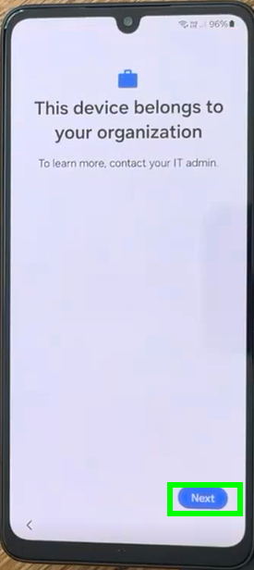

alt text

Please keep patient and click then on “Continue”:

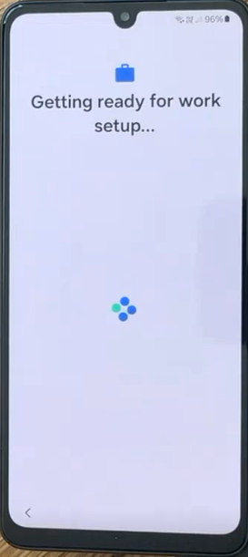 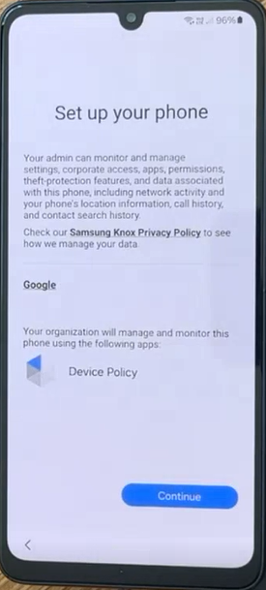

Please confirm again with “Next”:

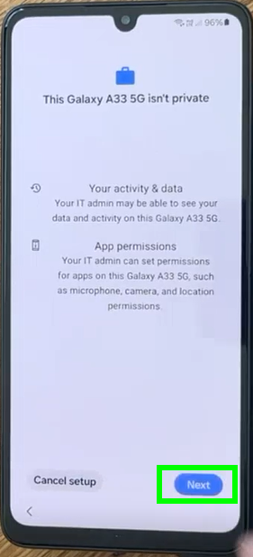

alt text

Once the phone is ready, the browser will open and you can sign in with your Bridgestone account:

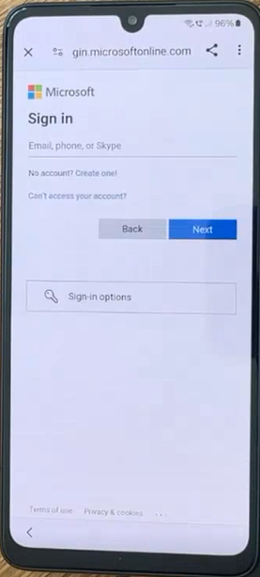

alt text

Enter your password and click on “Sign in”:

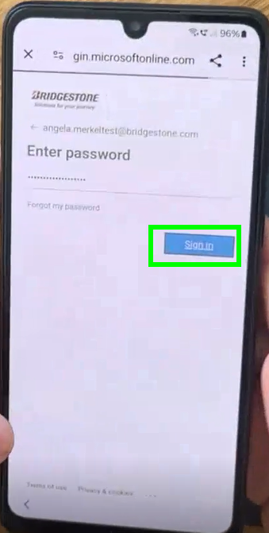

alt text

This will now take again a little moment:

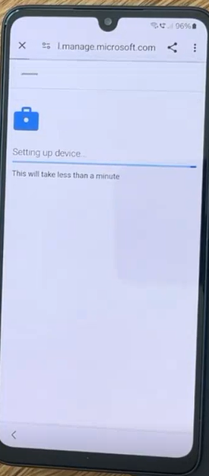

alt text

Please set a screen lock by clicking on “Set up”:

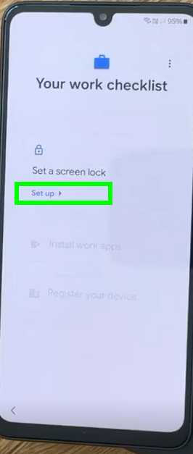

alt text

Please set a PIN with at least 6 digits and confirm it twice:

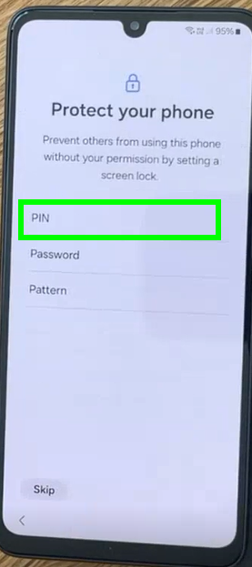 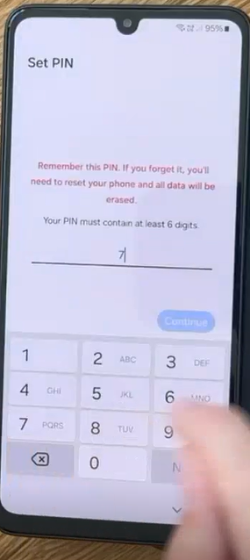

Please install then your work apps by clicking on “Install”:

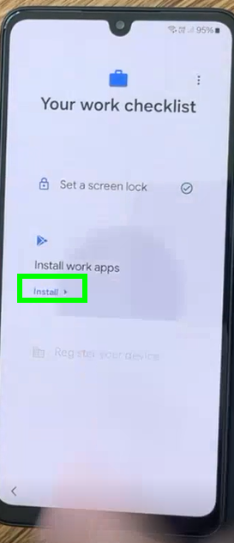

alt text

You will get now the list of all apps, which will be installed. Please click on “Done”:

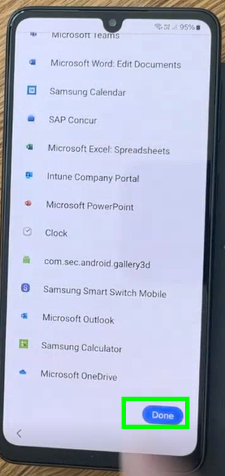

alt text

Register now your device by clicking on “Set up”:

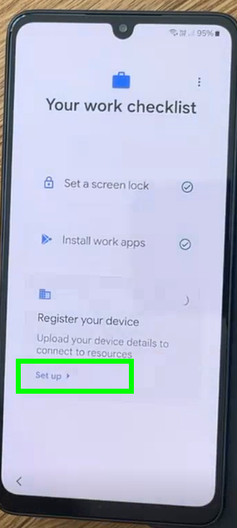

alt text

Click on “Sign in”:

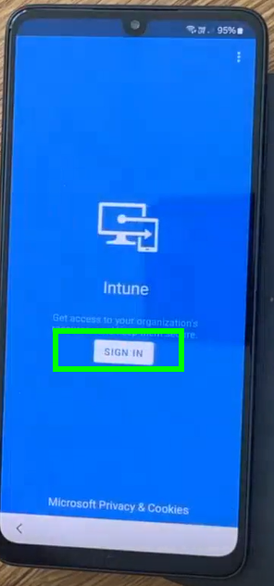

alt text

Please confirm with “Continue”:

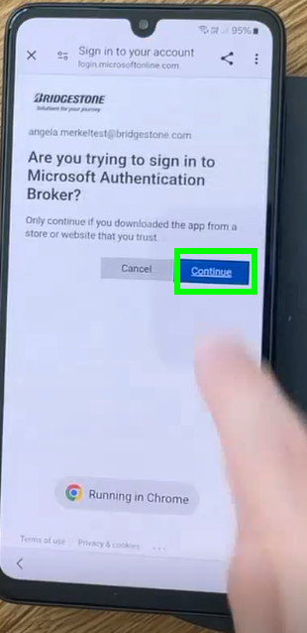

alt text

Then on “Register”:

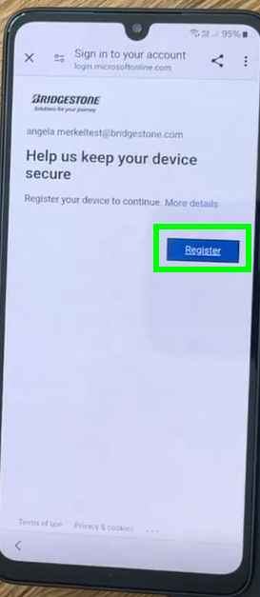

alt text

again on “Continue”

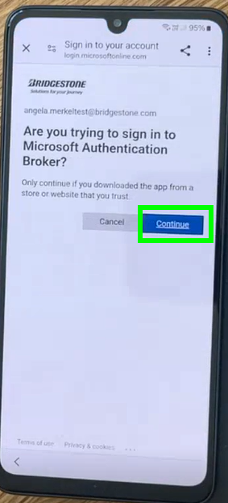

alt text

Click now on “Next”:

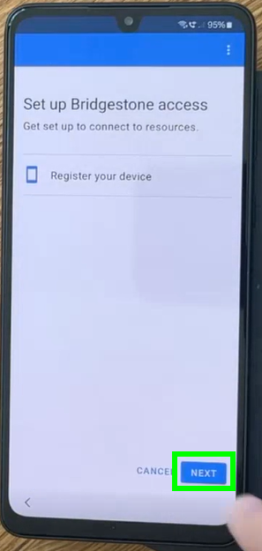

alt text

Confirm with “Done”:

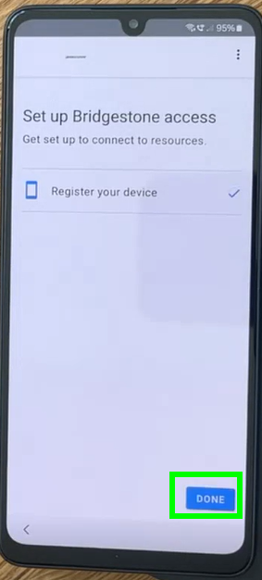

alt text

Three times “More” and then “Accept”:

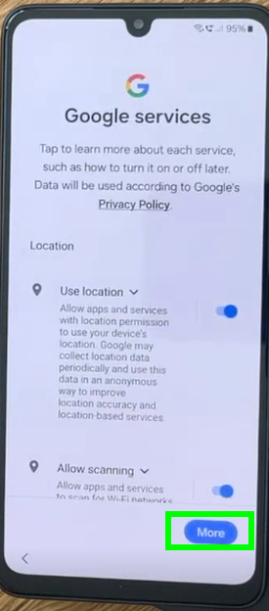 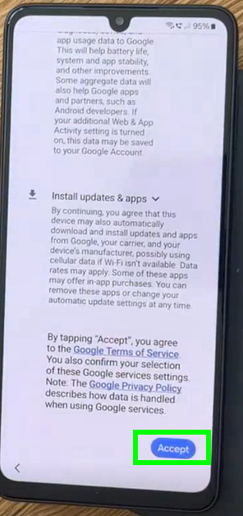

Pleae choose then “agree to all” and click on “Next”:

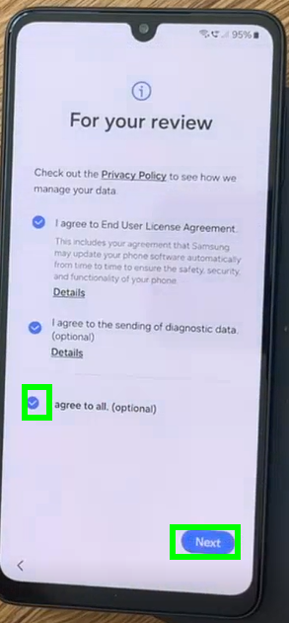

alt text

Missing the last steps on click on “Continue” and then on “Finish”:

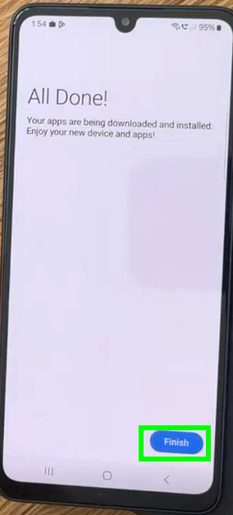

alt text

The phone is now completly set up again. The work apps will be installed in the next minutes.

Please open now the Microsoft Teams app in order to login the first time.

And login with your Bridgestone account:

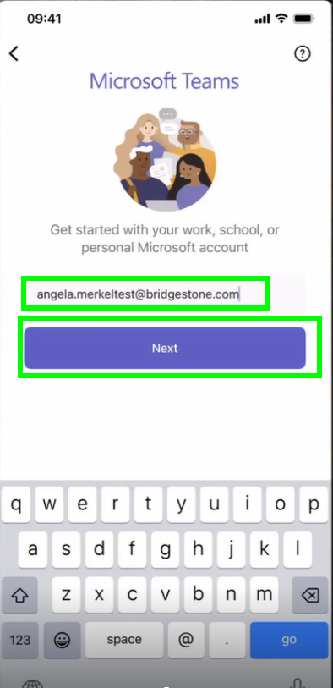

alt text

It may take a few seconds to the next step:

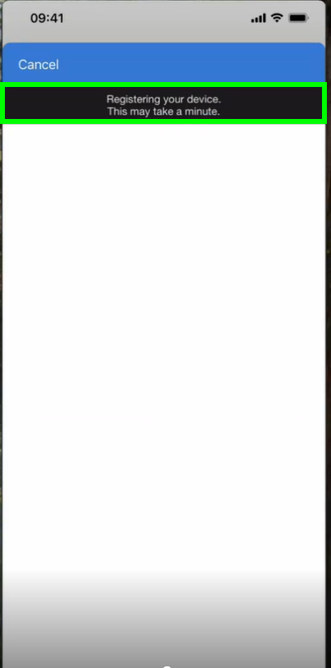 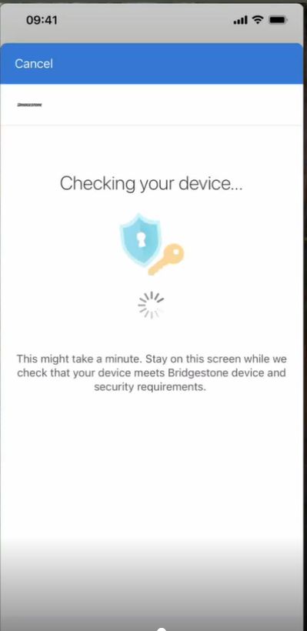

Please allow Temas to send you the notifications by clicking on “Allow”:

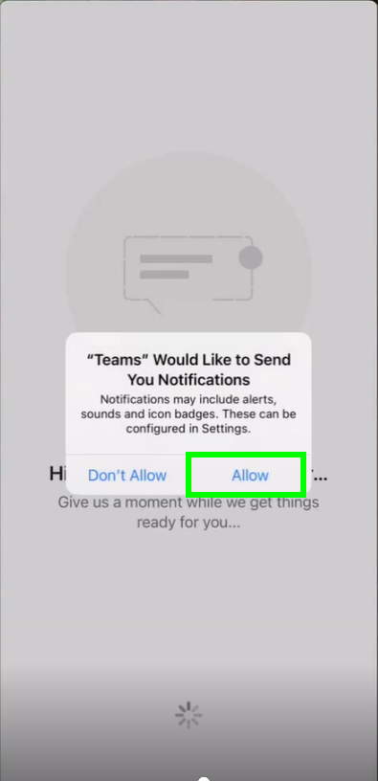

alt text

Please allow as well the access to the microphone:

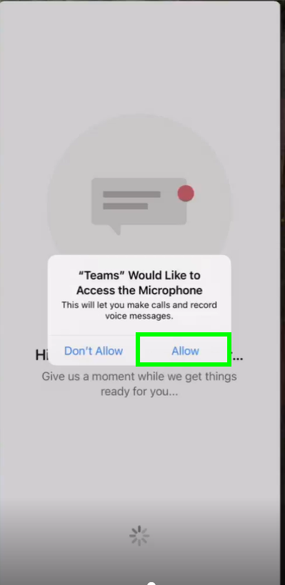

alt text

and you are ready with the company Android smartphone!