Setup MFA with Company Android

Please take your company Android and open the Microsoft Authenticator App.

Click on “Accept”

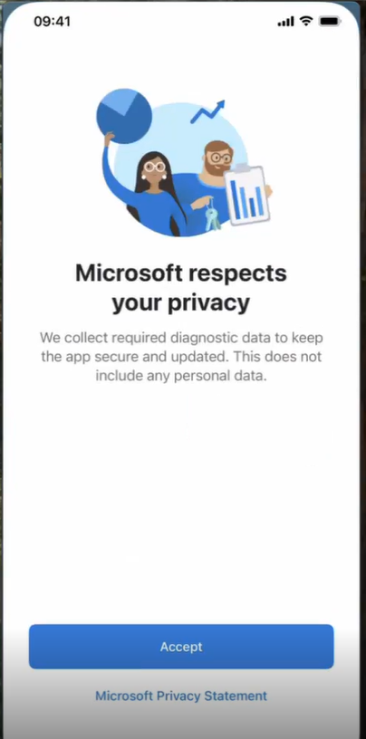

alt text

and on “Continue”

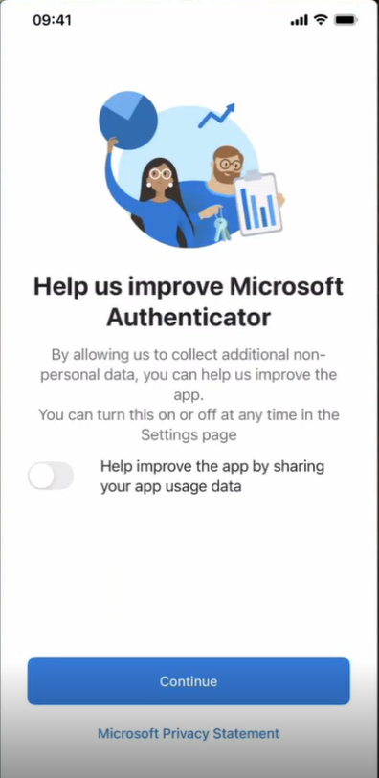

alt text

Please sign in with Microsoft using your Bridgestone account.

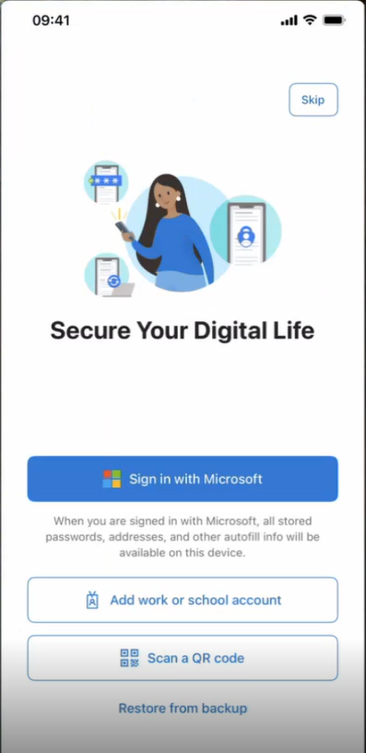

alt text

Add now a new account by clicking on the + on the top right corner:

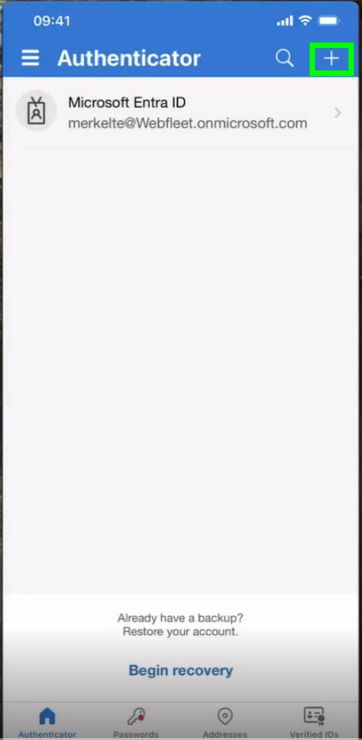

alt text

Please choose the “Work or school account” and click on “Sign in”:

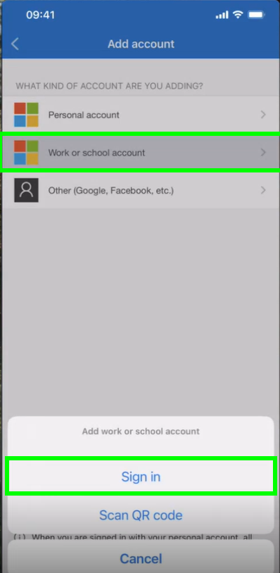

alt text

Tip in your Bridgestone email address and click on “Next”:

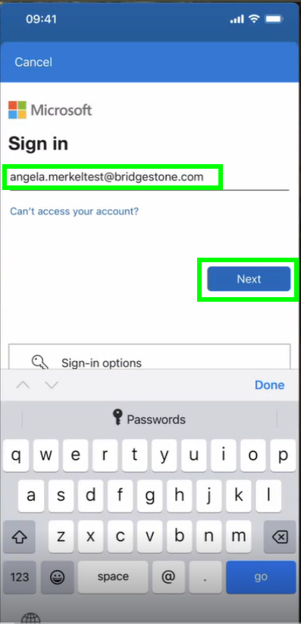

alt text

Enter your password and click on “Sign in”:

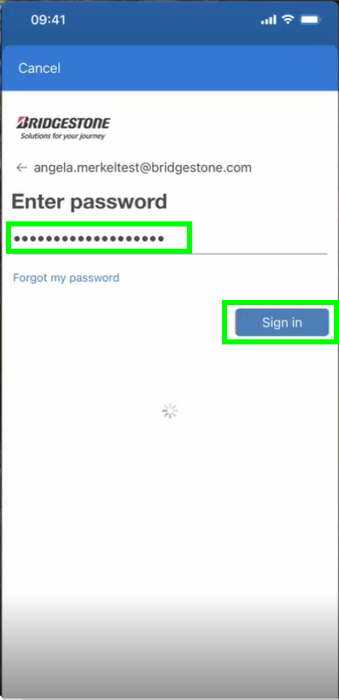

alt text

Click on “Open browser” to continue:

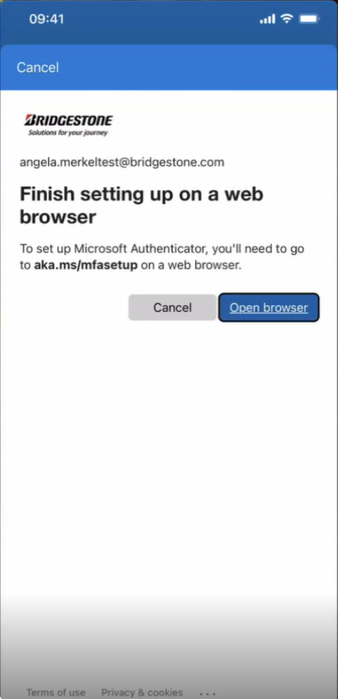

alt text

Please select now your Bridgestone account:

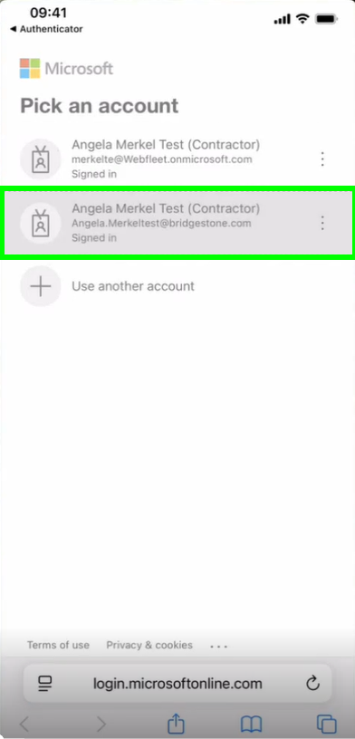

alt text

Click on “Next”:

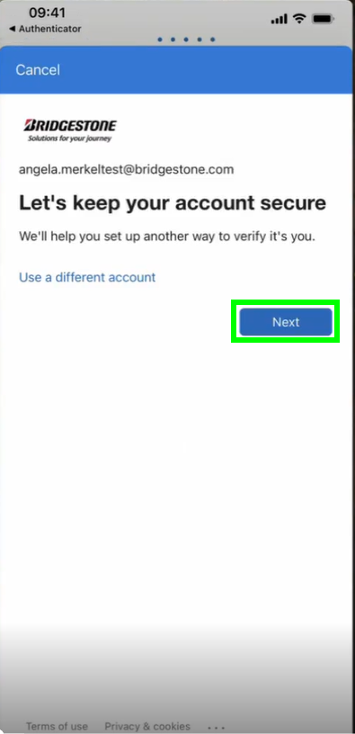

alt text

Again on “Next”:

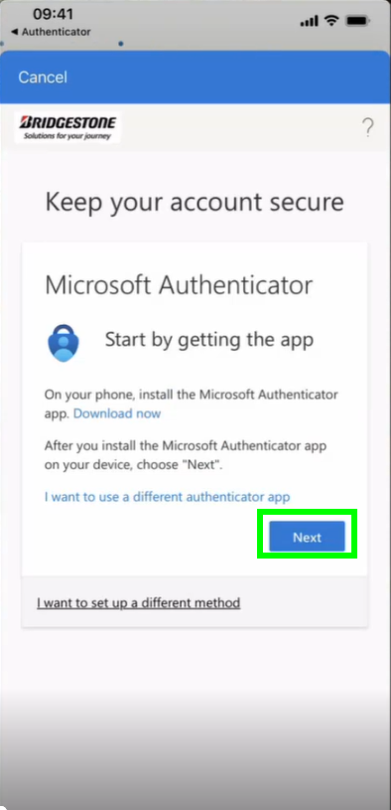

alt text

Now it is really IMPORTANT to click on “Pair your account to the app by clicking this link”

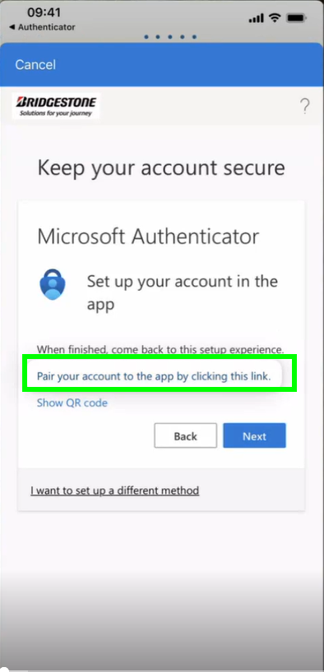

alt text

Please “allow” in the next step the Authenticator to send you notifications:

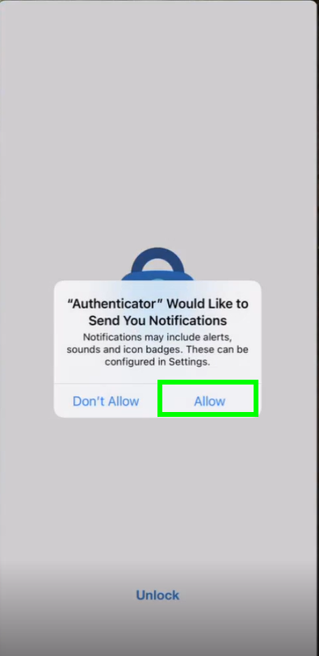

alt text

Enter now your iPhone Passcode:

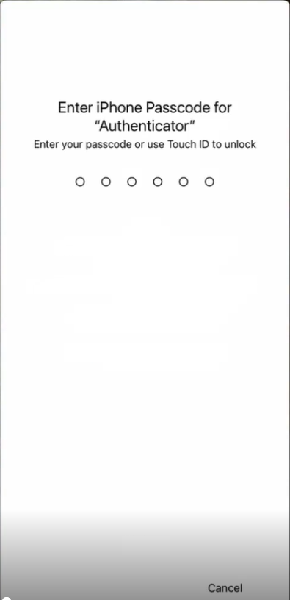

alt text

Go back to the browser and click on “Next”:

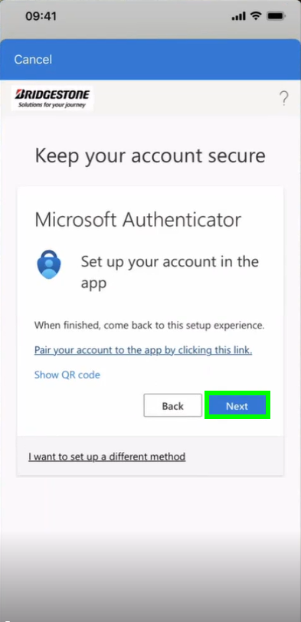

alt text

Enter now the number you see in the browser into the Authenticator notification:

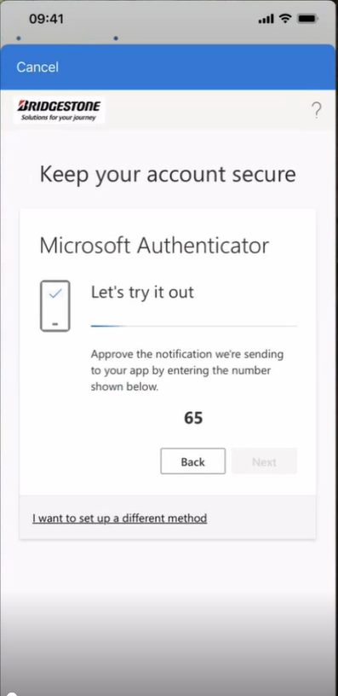 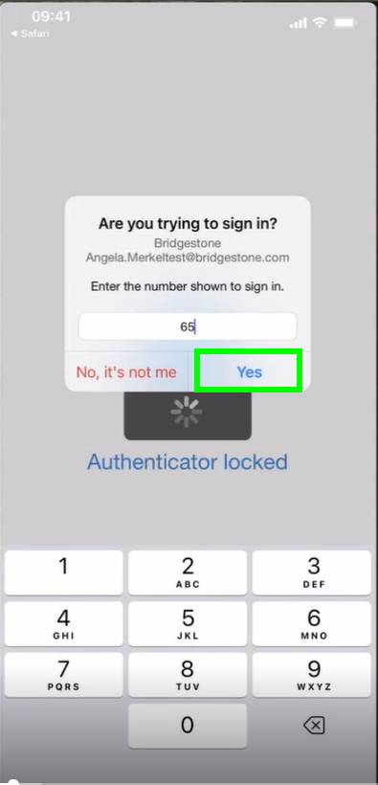

Enter again your iPhone passcode:

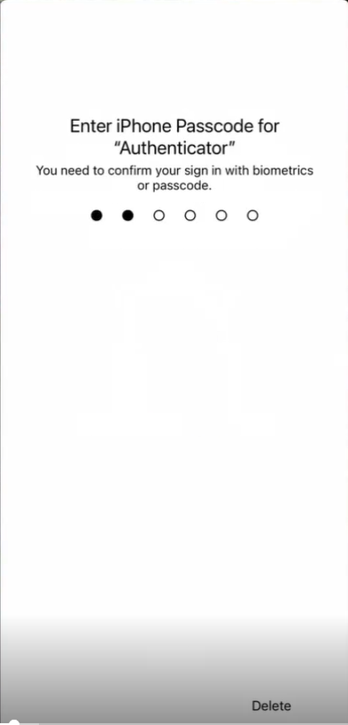

alt text

Go back to the browser and complete the registration by clicking on “Next”:

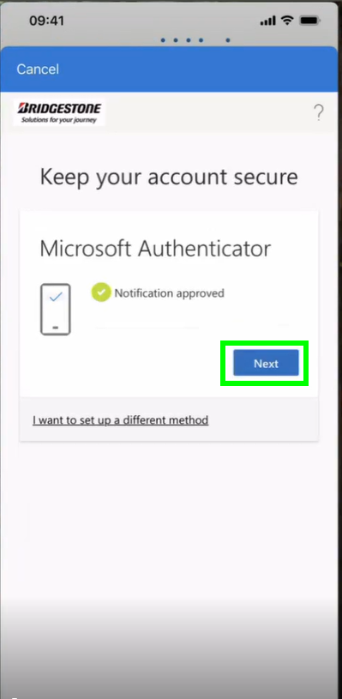

alt text

Click on “Done”:

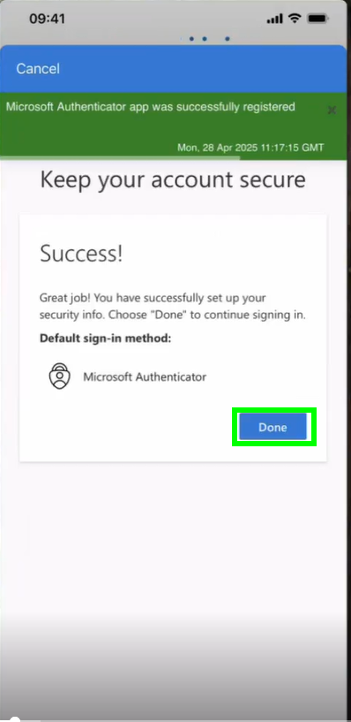

alt text