Agent Documentation_QUEST Migration pop-up guideline

Open the Migration Desktop on your computer by clicking the Windows button and then the “On Demand Migration Desktop Up..”

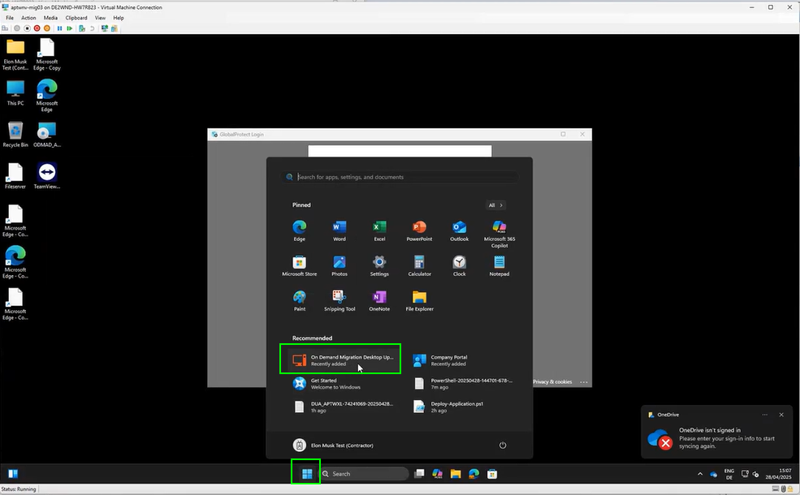

alt text

Start the migration while following the instructions in the Migration Desktop Agent.

The agent will guide you through the entire migration process. In case the agent will not connect by himself, please wait a few minutes and try to strat it again.

When you are ready click on “Start”. Please be aware that **NO** other program beside of the migration agent may be running.

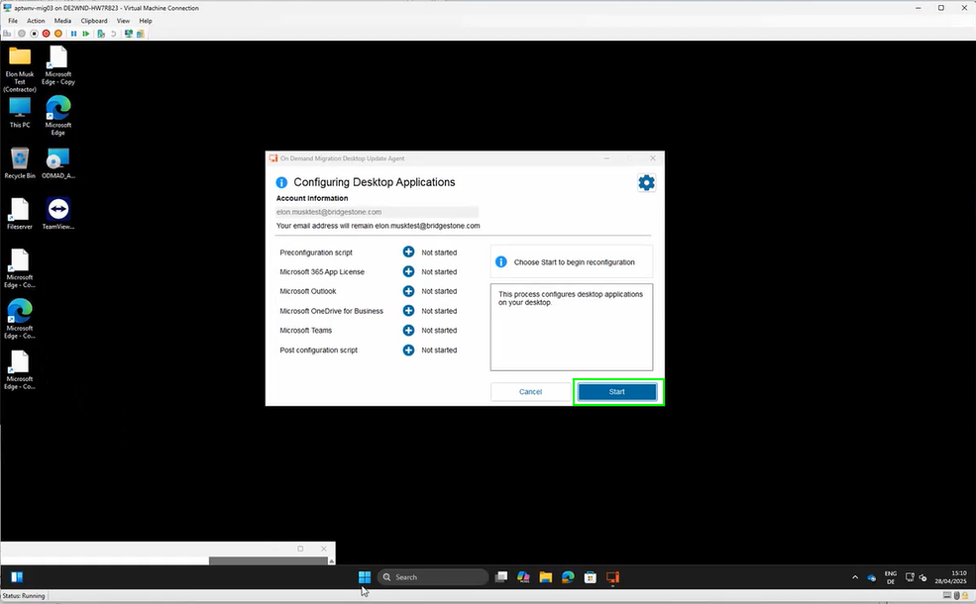

alt text

Please wait, until all steps are completed.

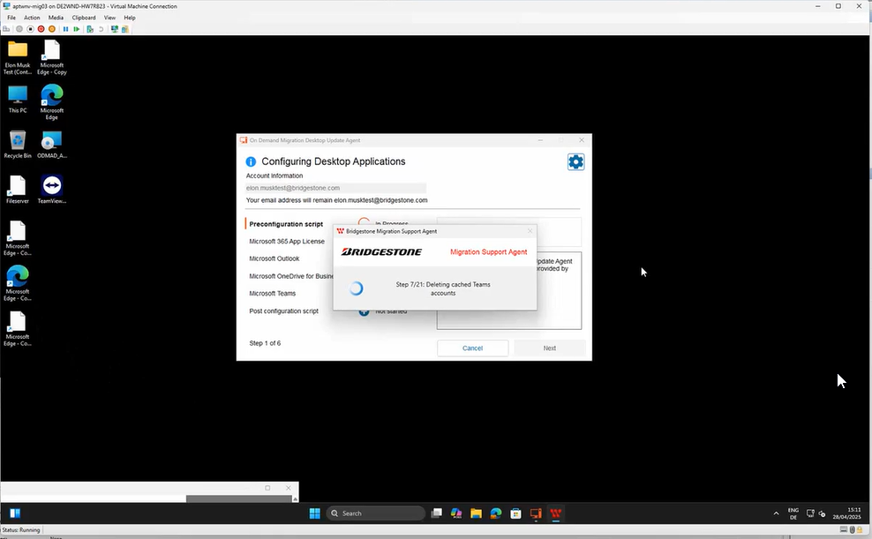

alt text

click on “Next” every time when it is active

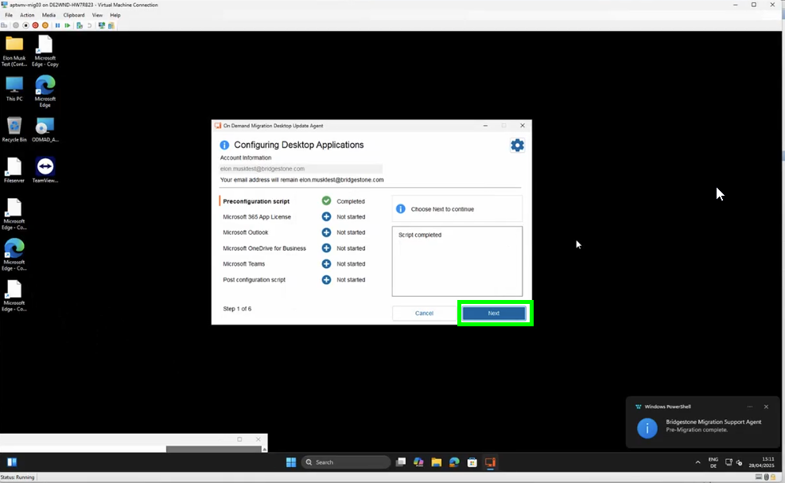

alt text

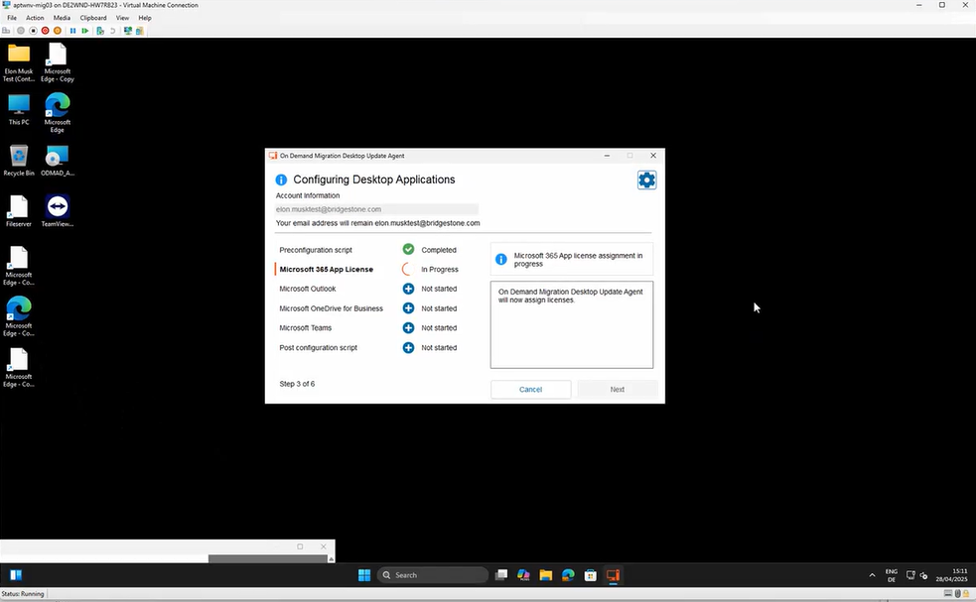

alt text

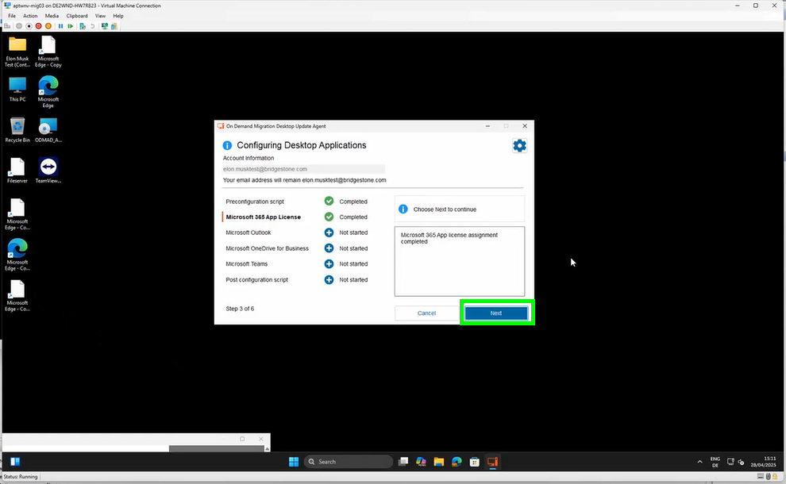

alt text

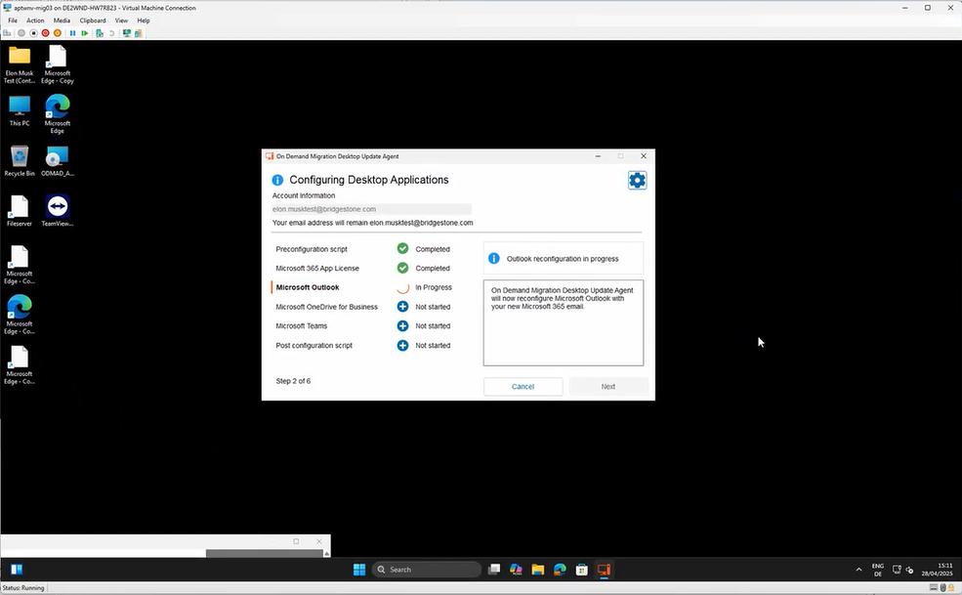

alt text

Once you started the 3rd step Outlook will open in a new window:

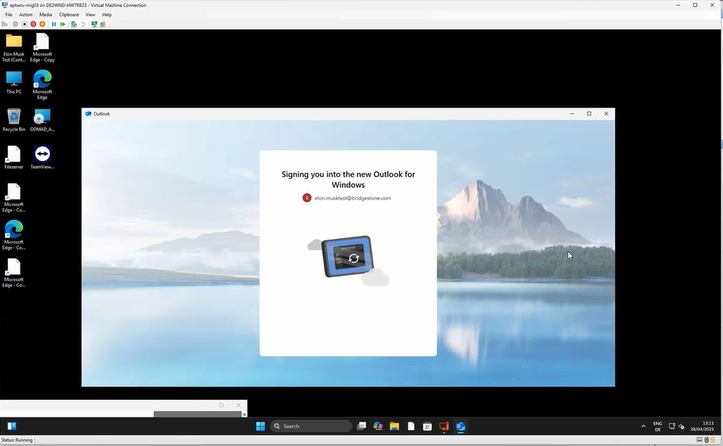

alt text

Wait a little moment until a new window will open and you will be asked to Continue to sign in. Click on “Continue”:

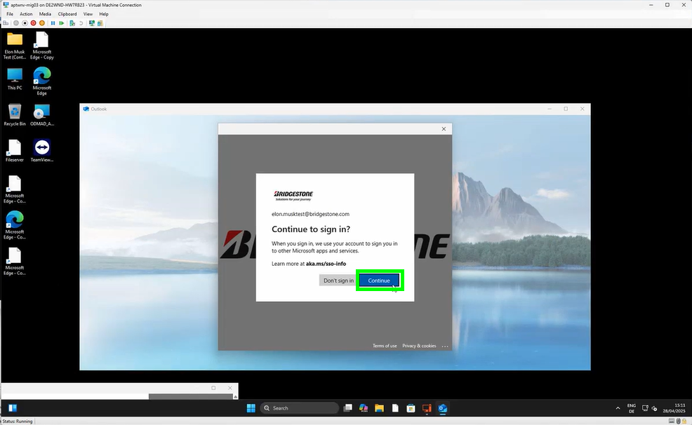

alt text

Outlook will now continue with the migration:



alt text

The migration agent will pop up again. In case you have the following error message, no worry, click simply on “Close Microsoft Outlook now”:

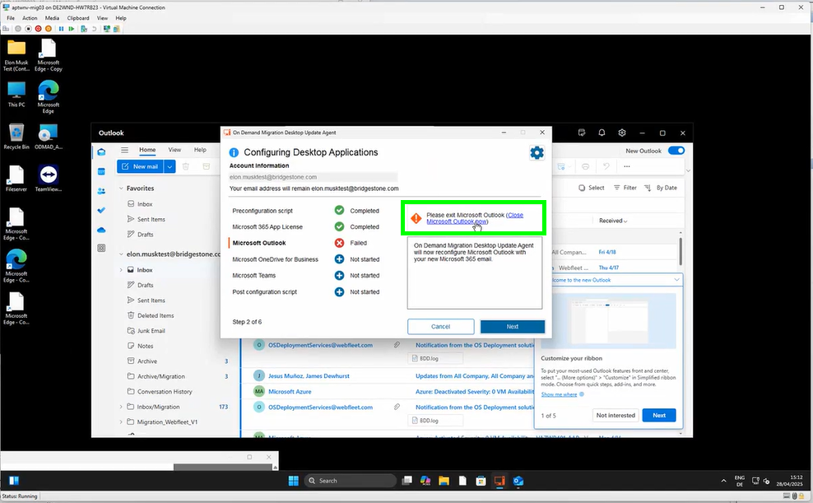

alt text

Once the OneDrive migration starts a new window will pop up. Please sign in with your Bridgestone Account:

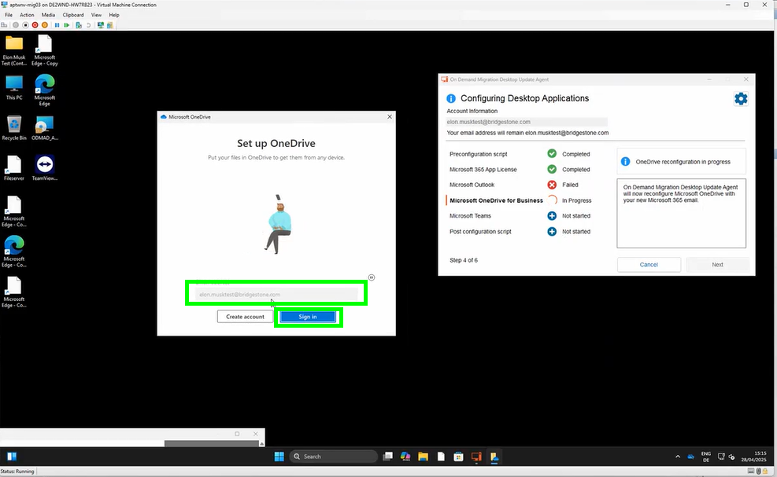

alt text

click on “Next”:

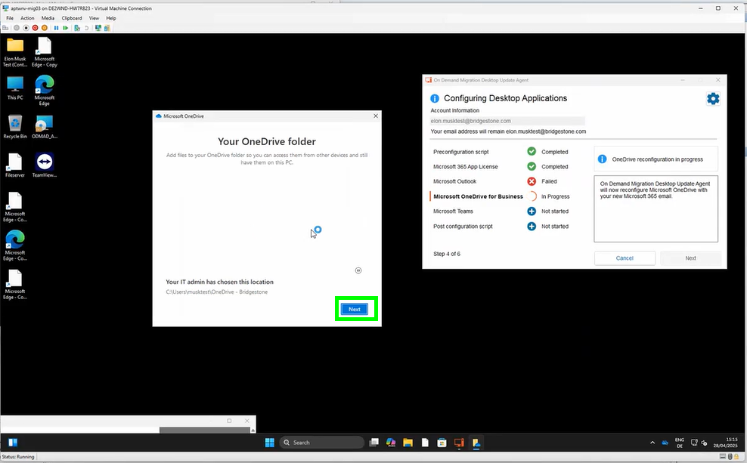

alt text

click on “Use this folder”:

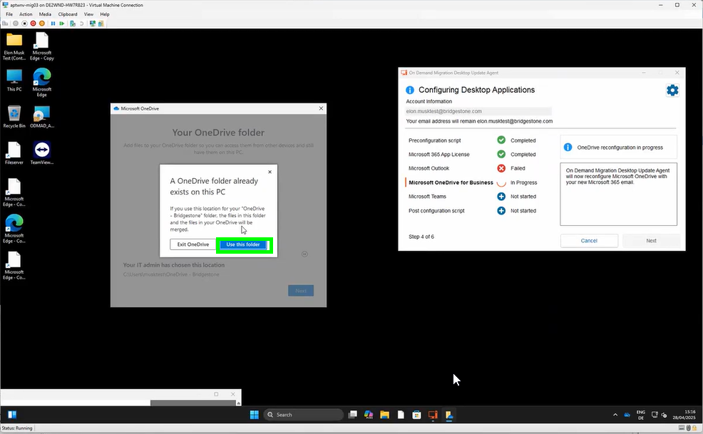

alt text

click on “Next”:

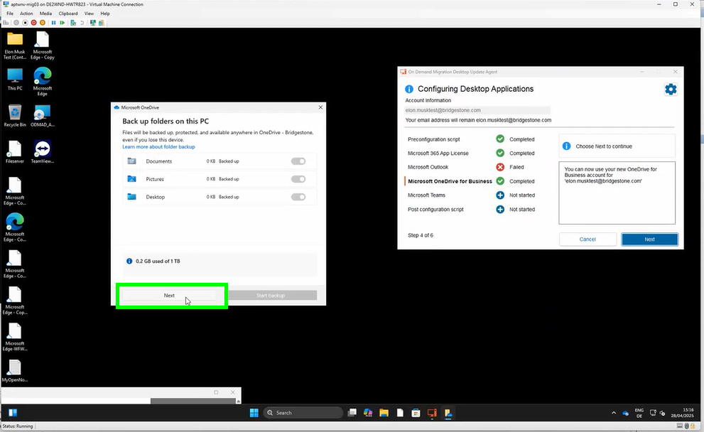

alt text

click again on “Next”:

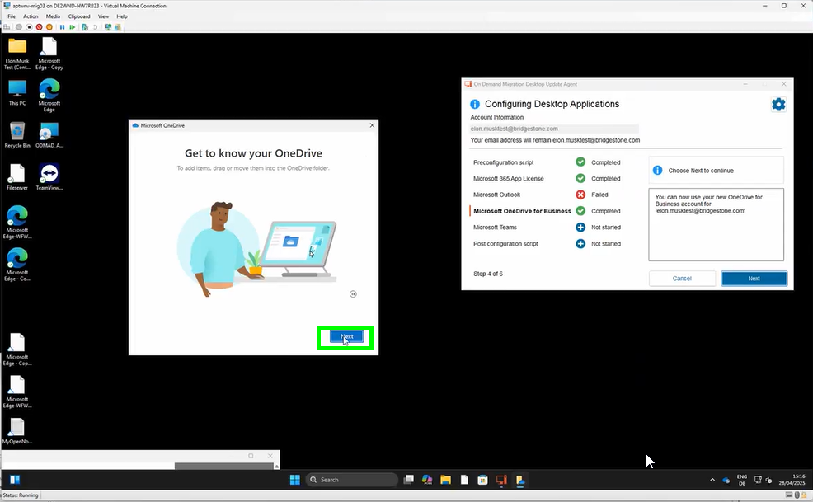

alt text

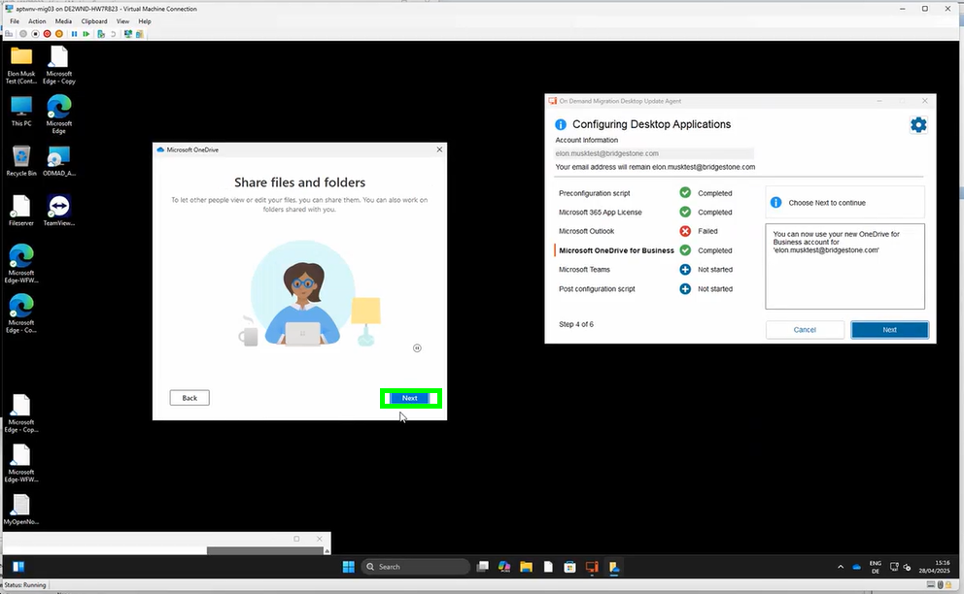

alt text

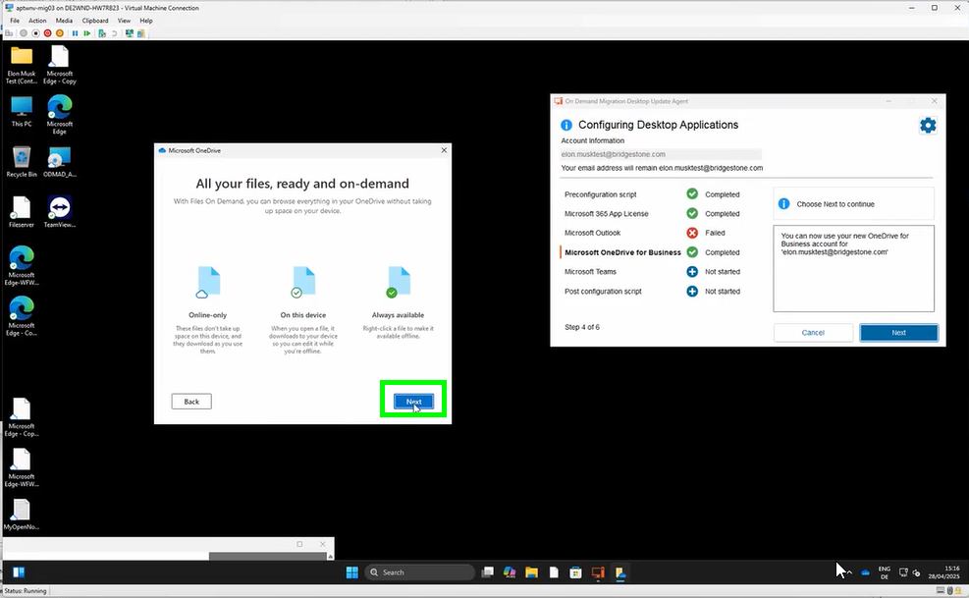

alt text

and now on “Later”:

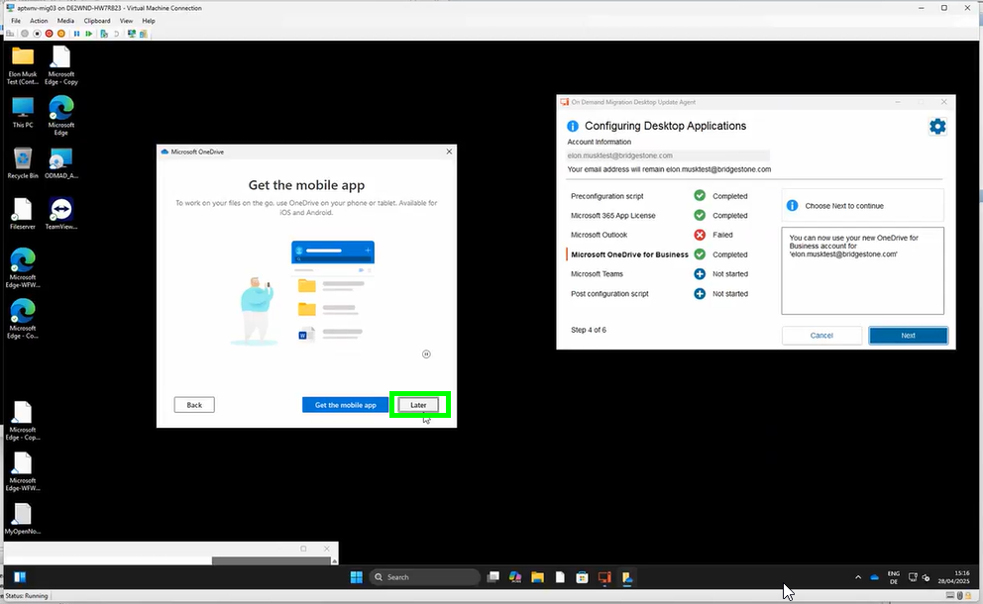

alt text

the migration of your OneDrive is now completed. You may choose “Open my OneDrive Folder” or simply close the window by clicking the cross on the top right:

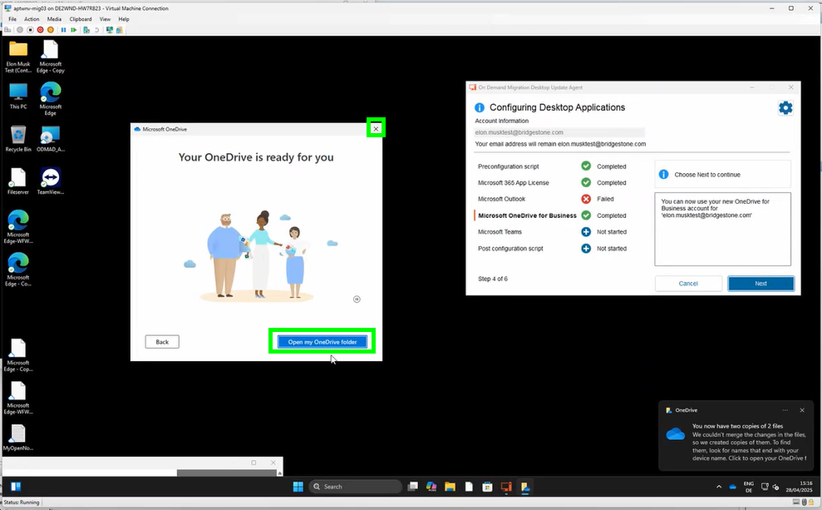

alt text

go now back to the migration agent and click on “Next”:

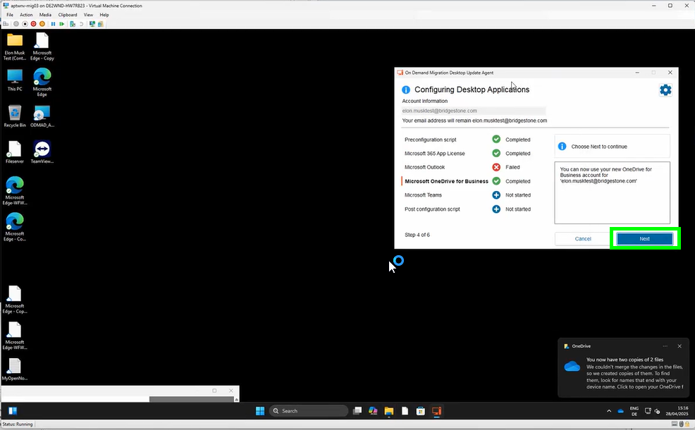

alt text

Microsoft Teams will start. You may just ignore the window and go back to the migration agent:

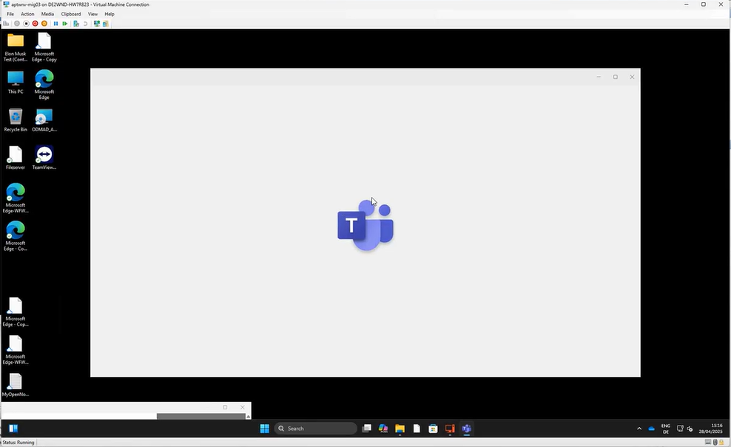

alt text

please click on “Next”:

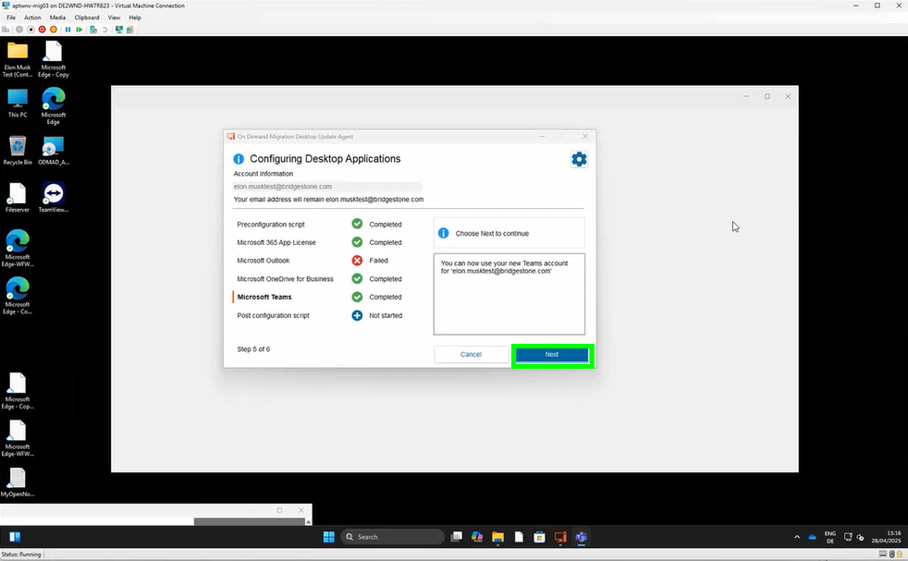

alt text

please wait until the migration is finalized:

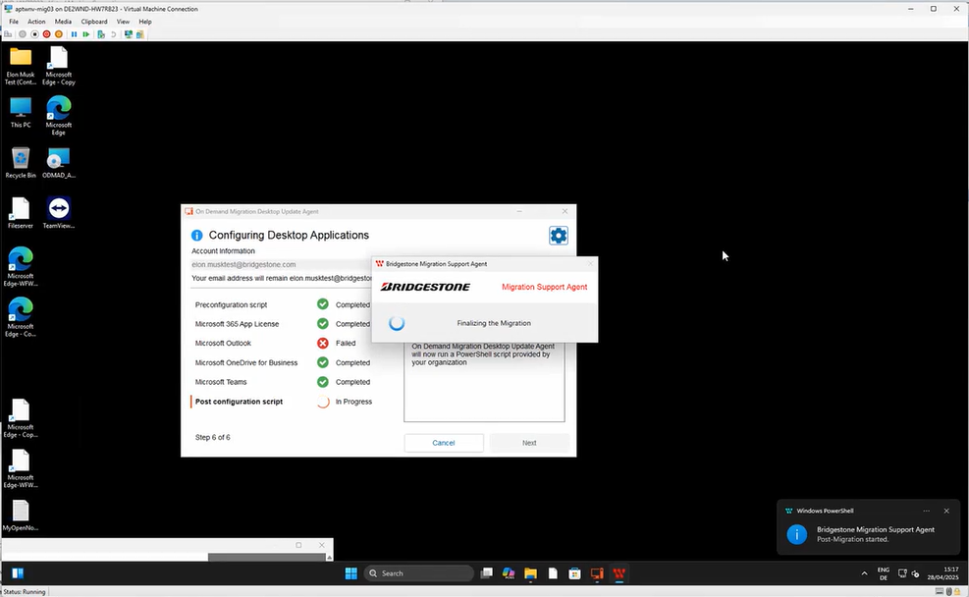

alt text

click now on “Finish”:

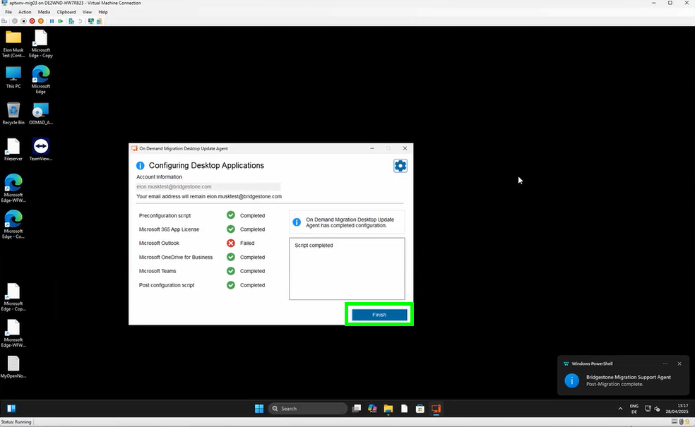

alt text

your devices will be restarted again. You may wait until the countdown finished or you may click on “Restart now”:

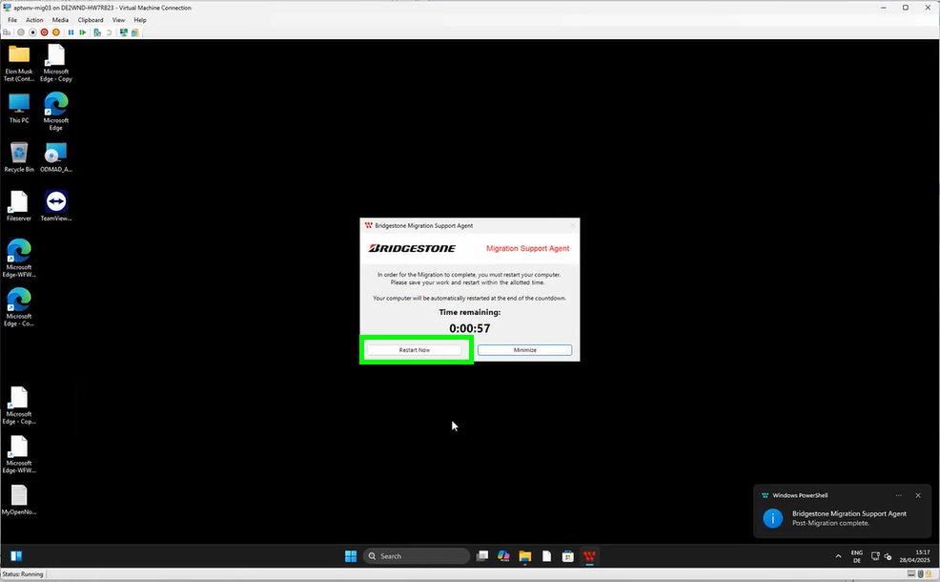

alt text

You can now simply login with your Bridgestone account:

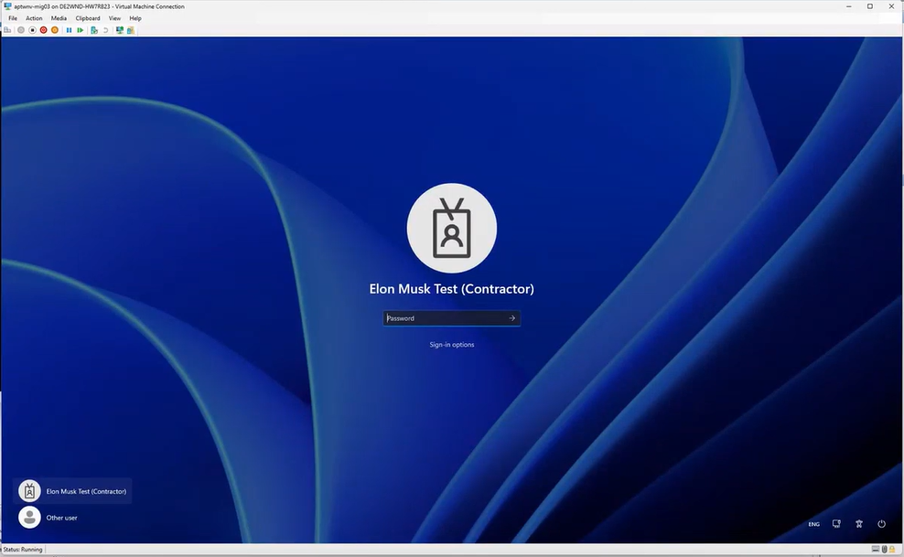

alt text