Agent Documentation_Entra ID joined devices
Welcome in the Bridgestone environment! In order to work normally you need to follow a few steps. Please read the instructions carefully before you start the migration. It is important, that you have already setup the MFA on your smartphones and that during the migration no other program is running.
Once you have started your device it is possible that it will do a restart automatically.
After the restart, the login screen appears, check if the Bridgestone Logo is shown:
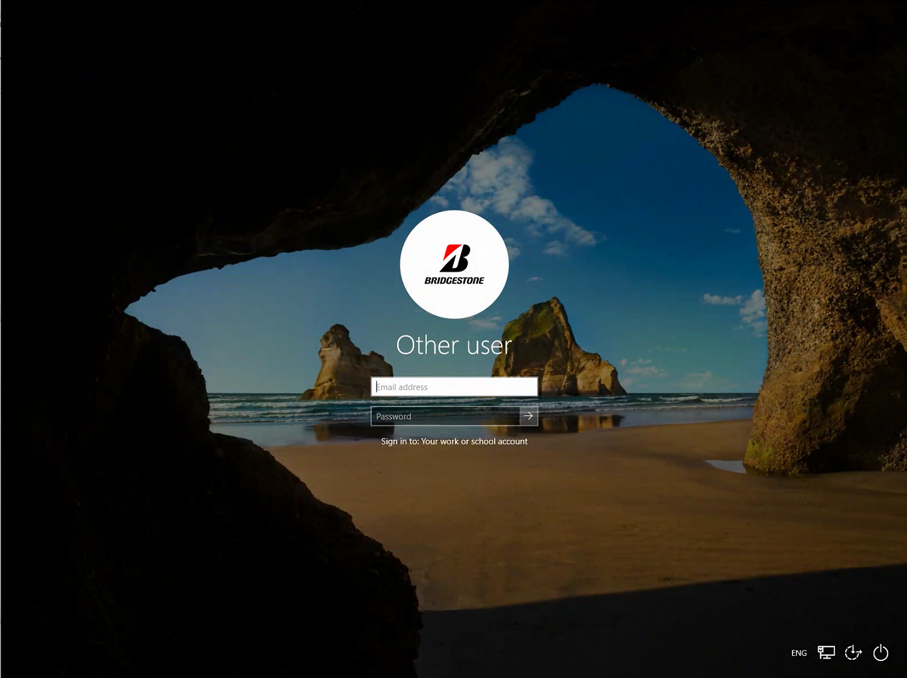
alt text

Should this not be the case, please contact the IT Support.
Please enter now your Bridgestone email address and your password and click on the little arrow next to the password: In case you are not able to login with your Username, please use the @bridgestone.onmicrosoft.com email address.
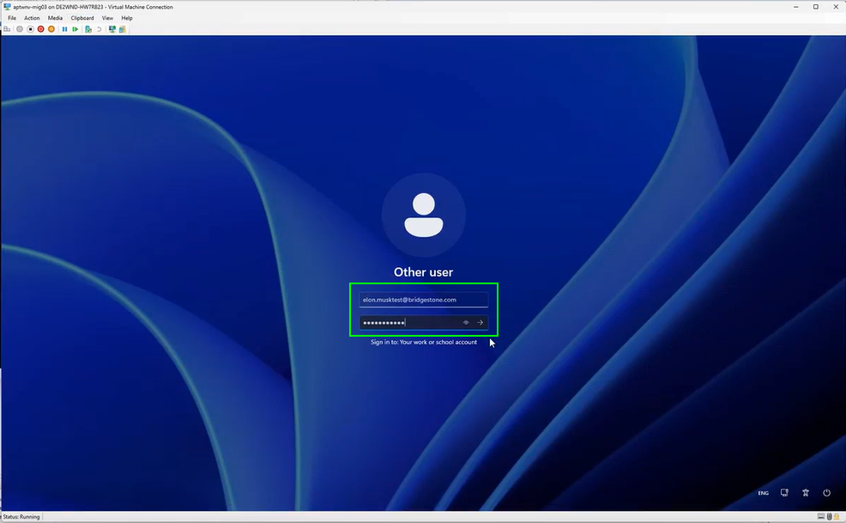
alt text
Open the Migration Desktop on your computer by clicking the Windows button and then the “On Demand Migration Desktop Up..”
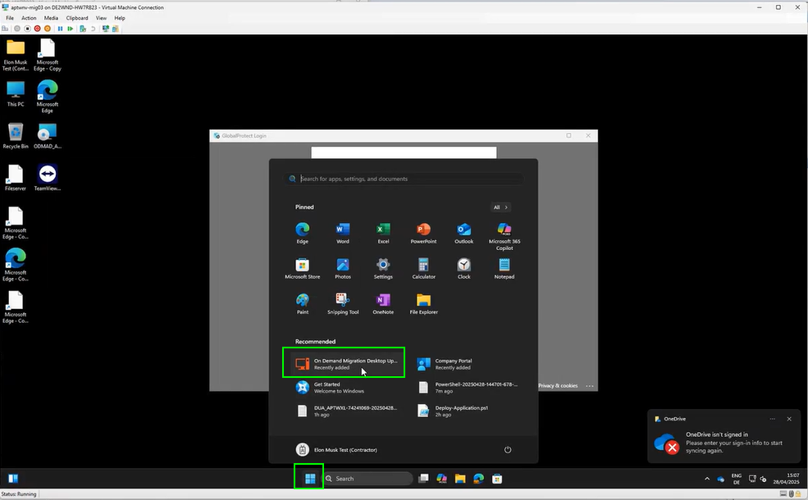
alt text
Start the migration while following the instructions in the Migration Desktop Agent.
The agent will guide you through the entire migration process. In case the agent will not connect by himself, please wait a few minutes and try to strat it again.
When you are ready click on “Start”. Please be aware that NO other program beside of the migration agent may be running.
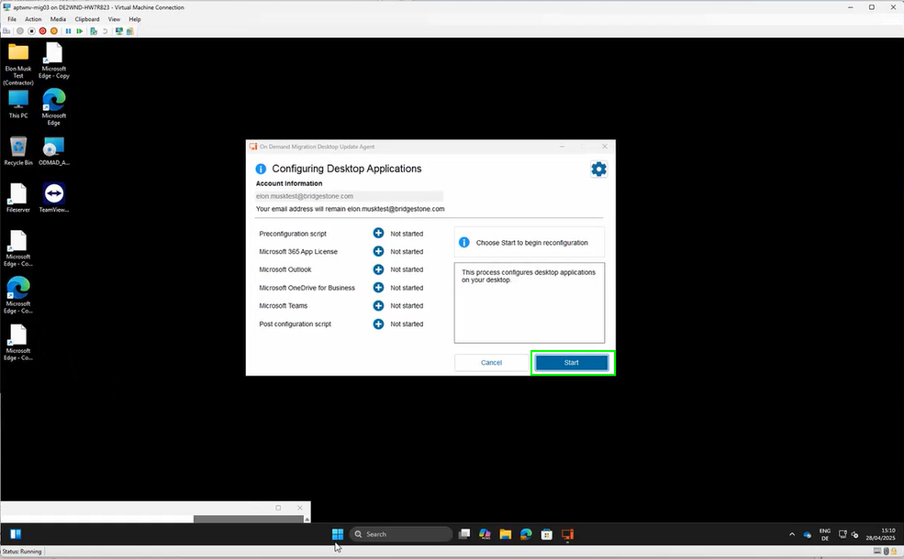
alt text
Please wait, until all steps are completed.
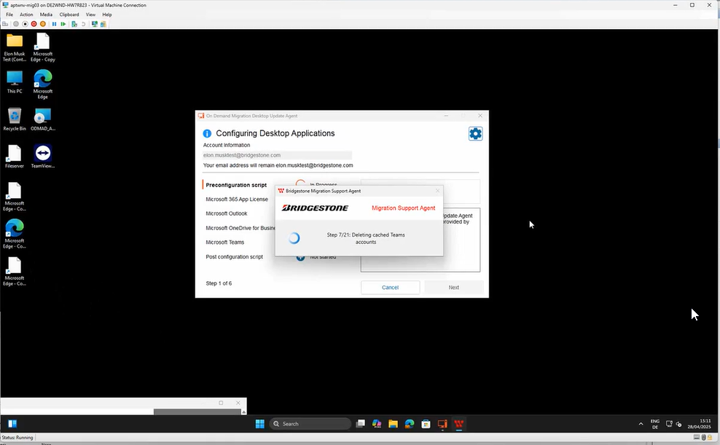
alt text
click on “Next” every time when it is active
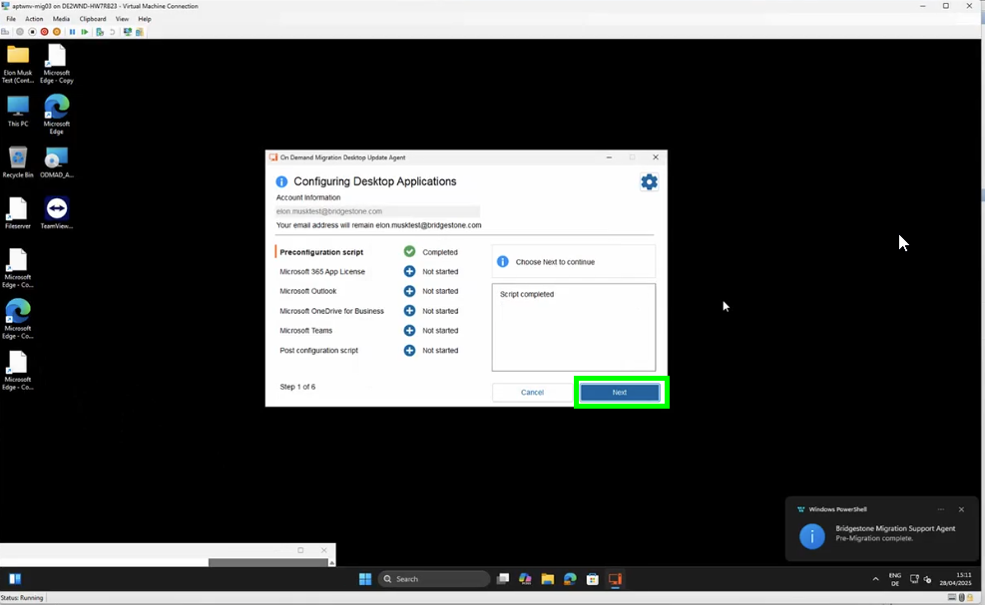
alt text
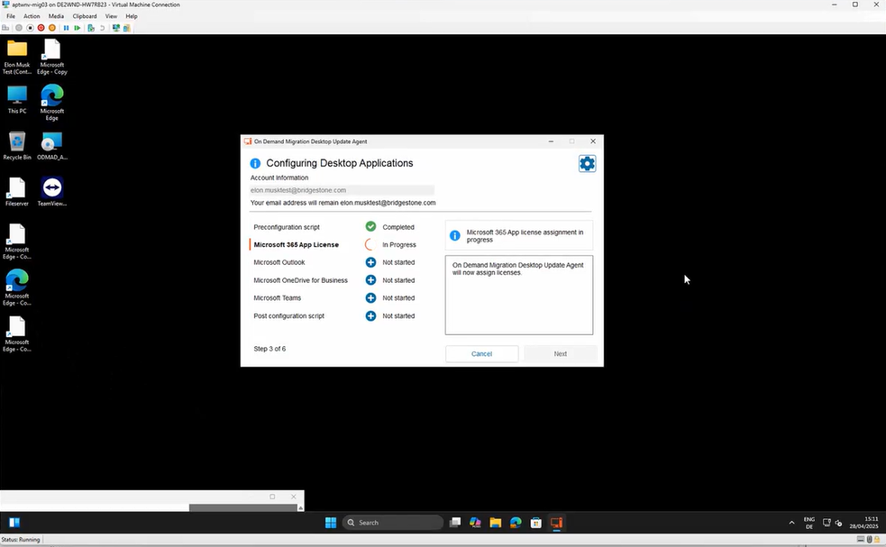
alt text
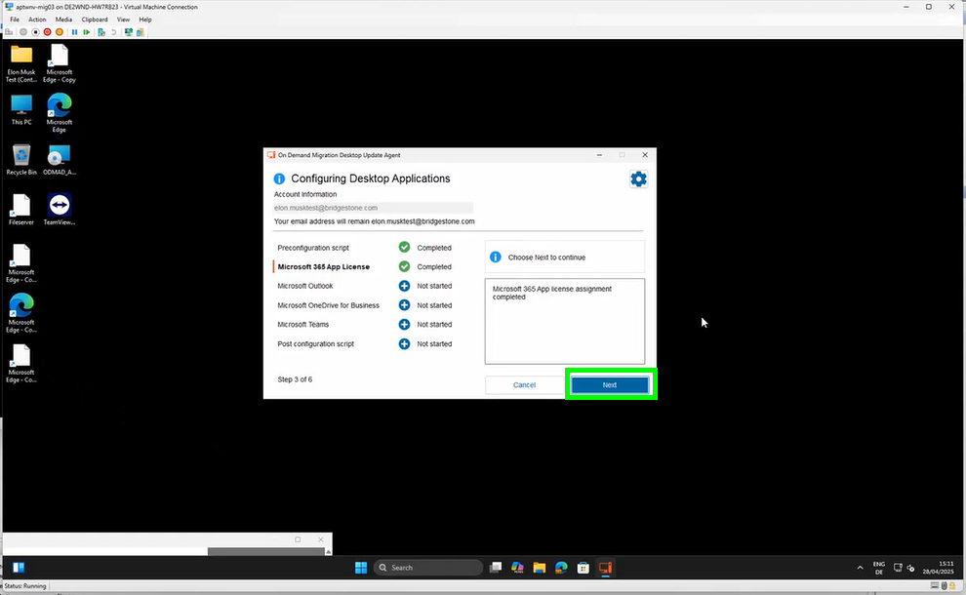
alt text
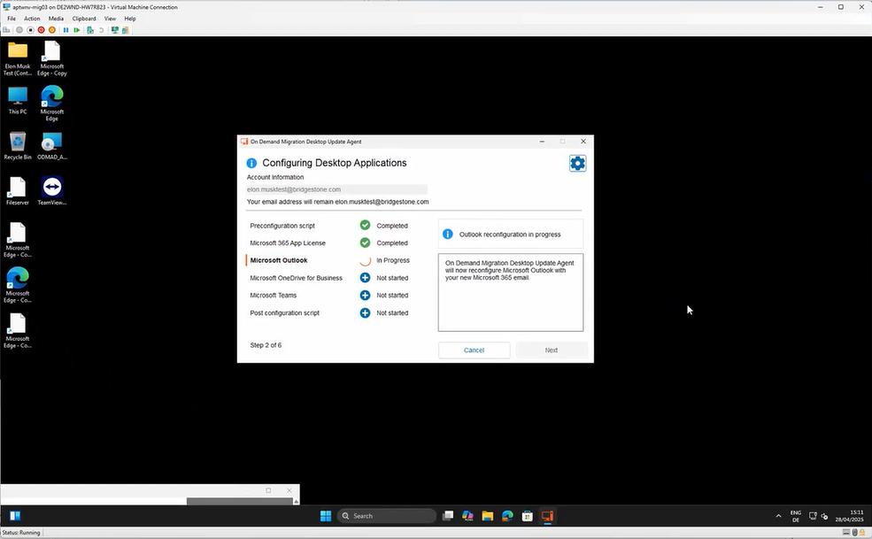
alt text
Once you started the 3rd step Outlook will open in a new window:
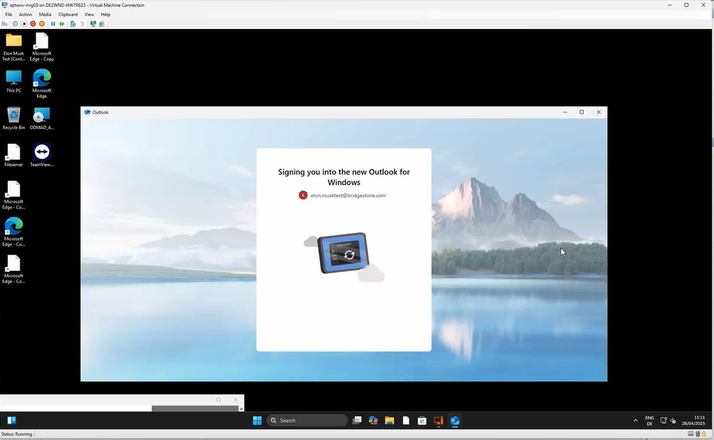
alt text
Wait a little moment until a new window will open and you will be asked to Continue to sign in. Click on “Continue”:
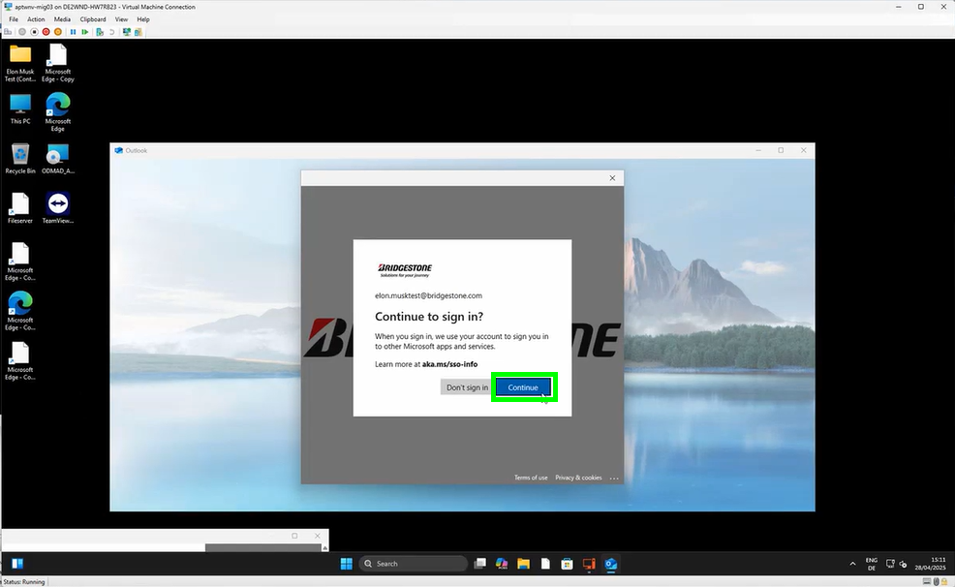
alt text
Outlook will now continue with the migration:
alt text
The migration agent will pop up again. In case you have the following error message, no worry, click simply on “Close Microsoft Outlook now”:
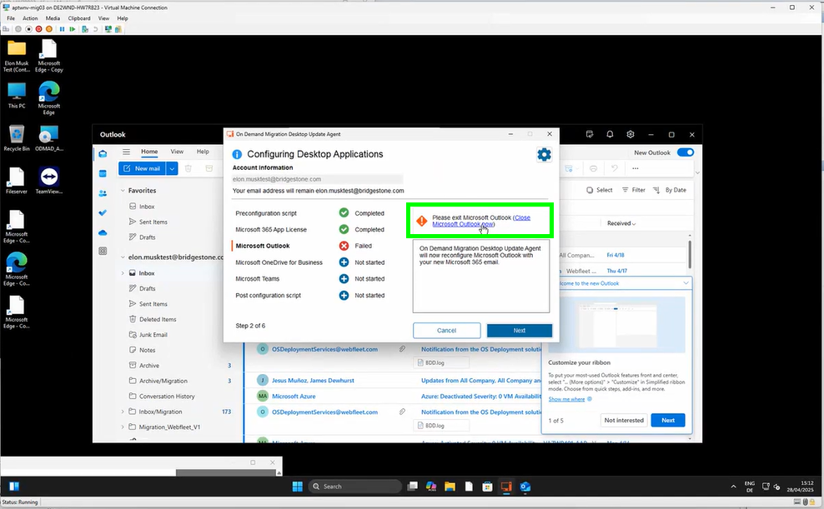
alt text
Once the OneDrive migration starts a new window will pop up. Please sign in with your Bridgestone Account:
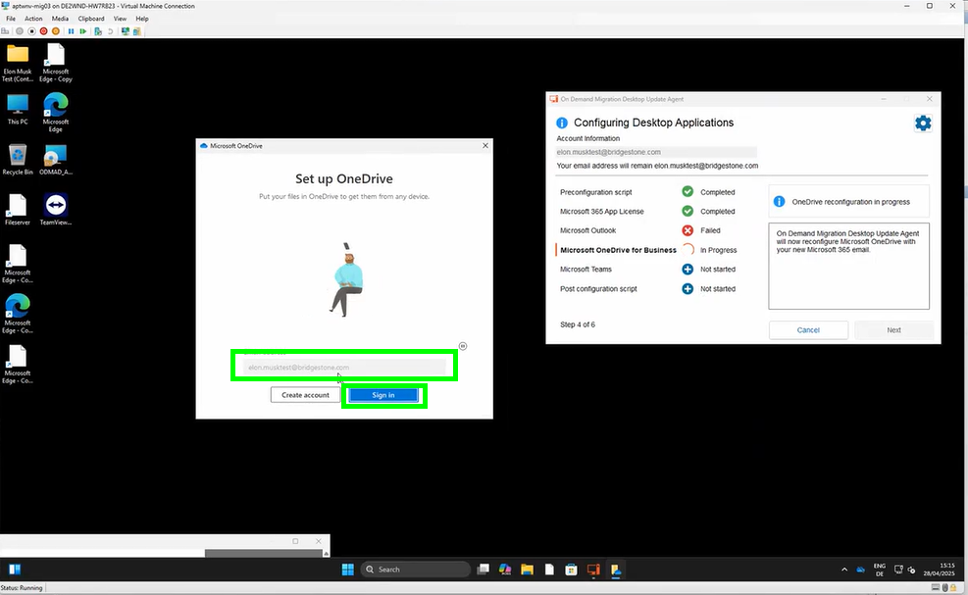
alt text
click on “Next”:
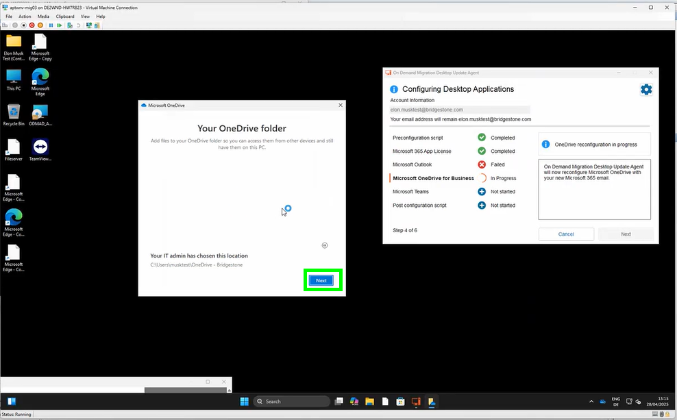
alt text
click on “Use this folder”:
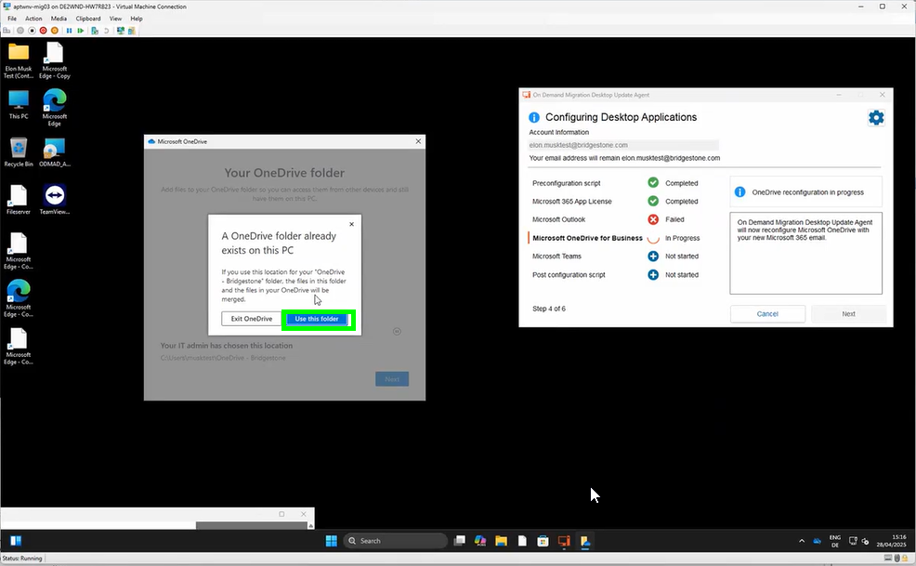
alt text
click on “Next”:
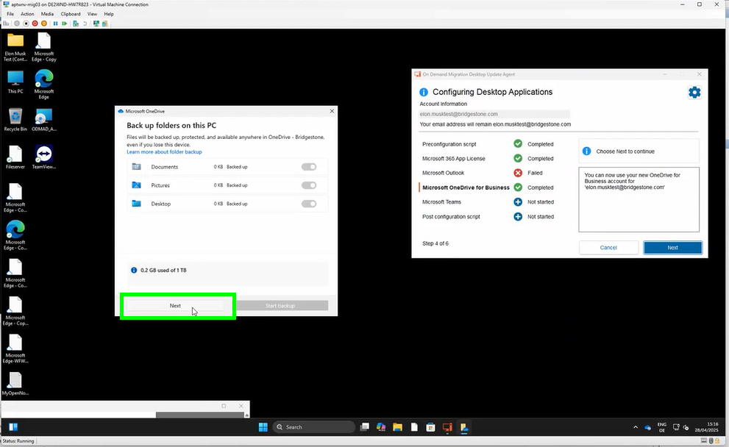
alt text
click again on “Next”:
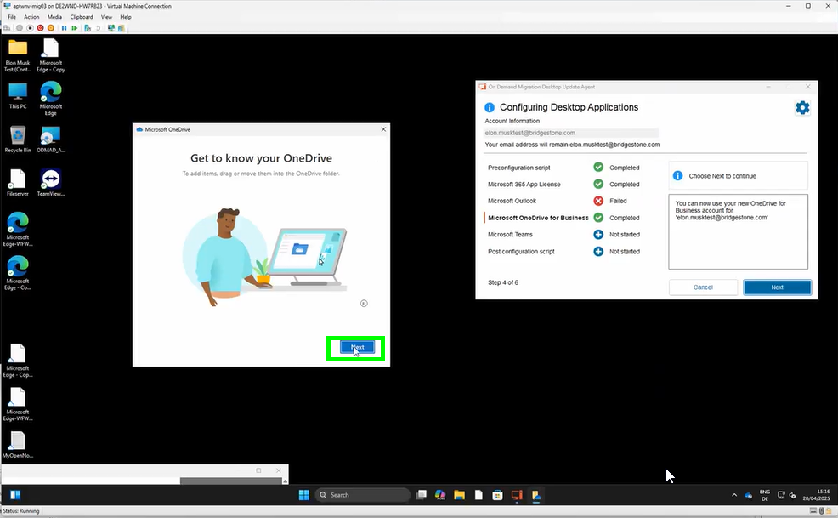
alt text
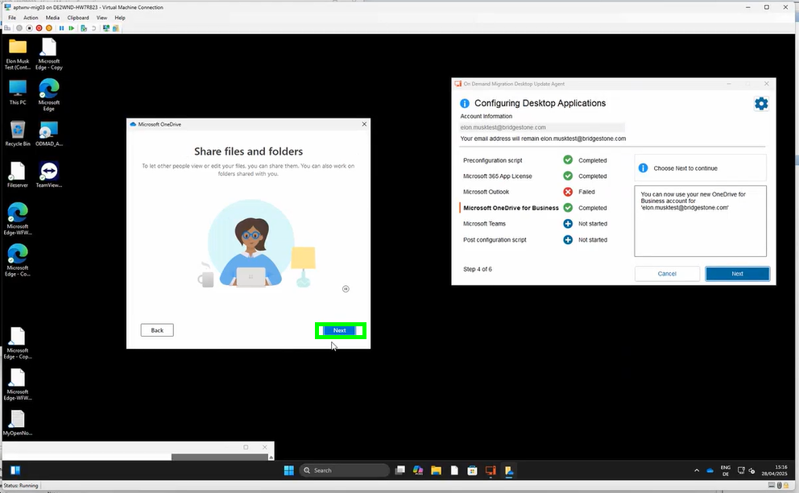
alt text
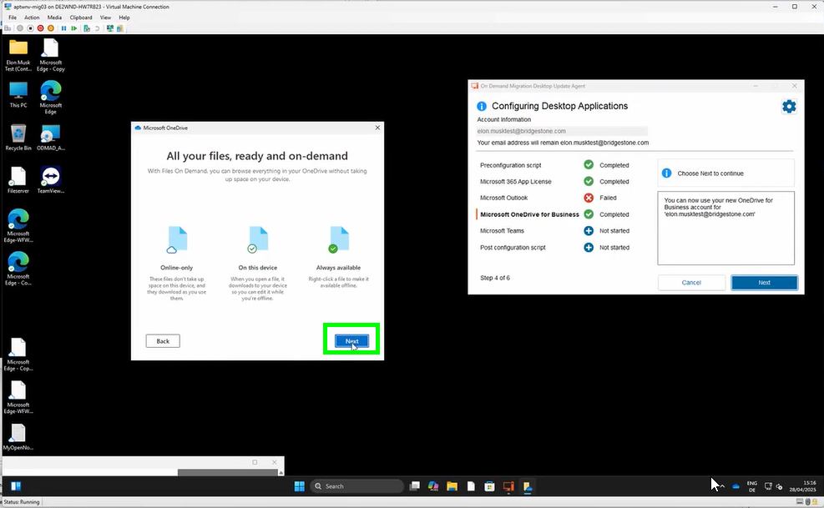
alt text
and now on “Later”:
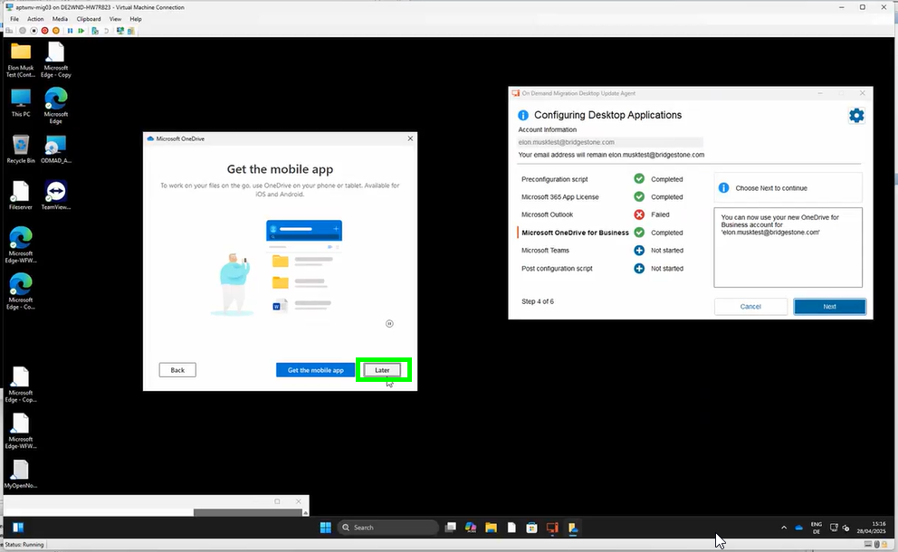
alt text
the migration of your OneDrive is now completed. You may choose “Open my OneDrive Folder” or simply close the window by clicking the cross on the top right:
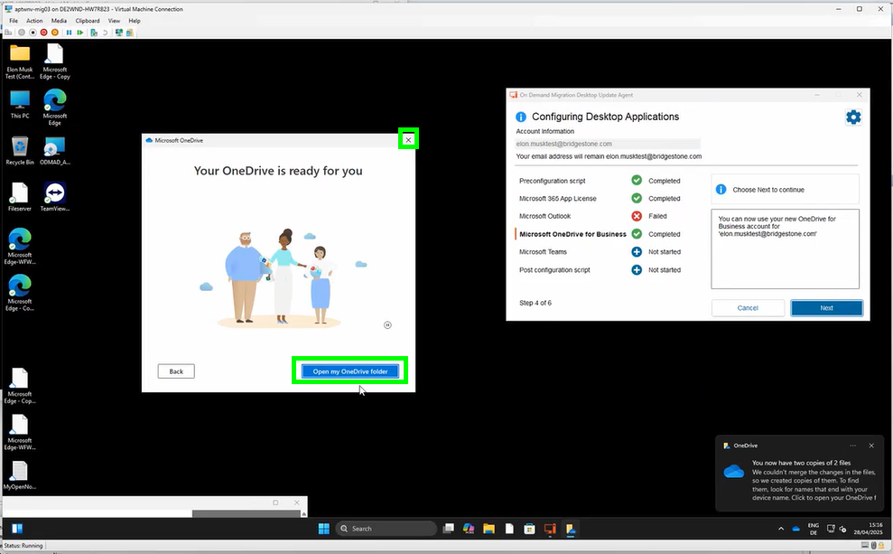
alt text
go now back to the migration agent and click on “Next”:
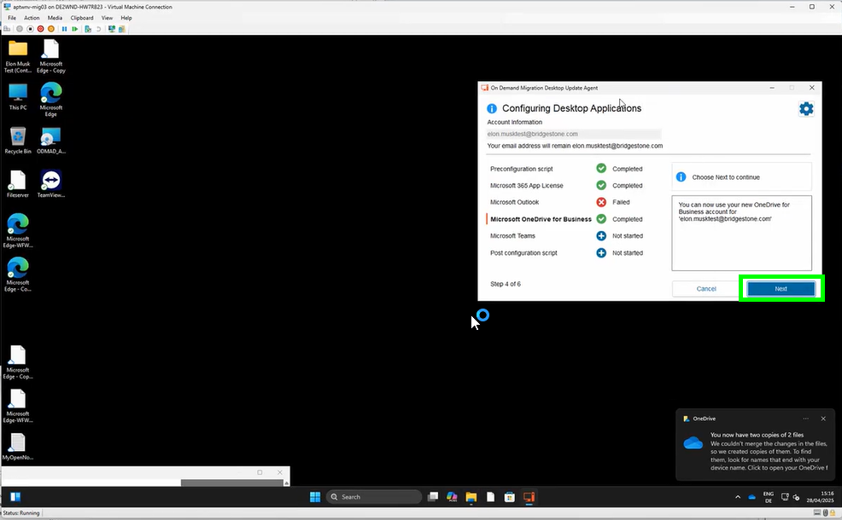
alt text
Microsoft Teams will start. You may just ignore the window and go back to the migration agent:
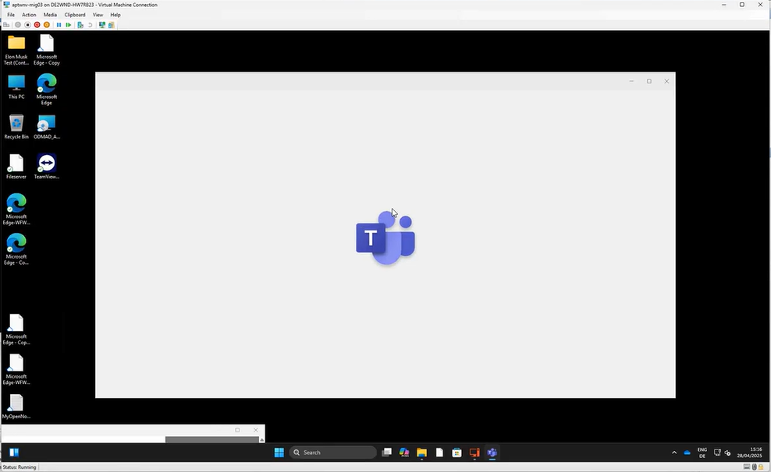
alt text
please click on “Next”:
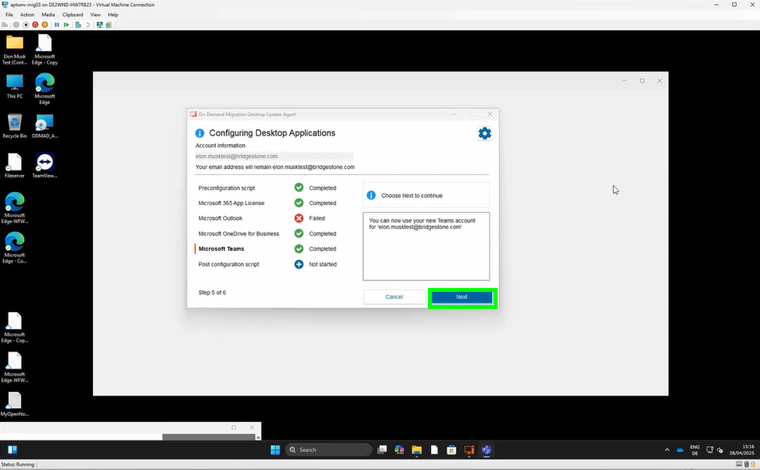
alt text
please wait until the migration is finalized:
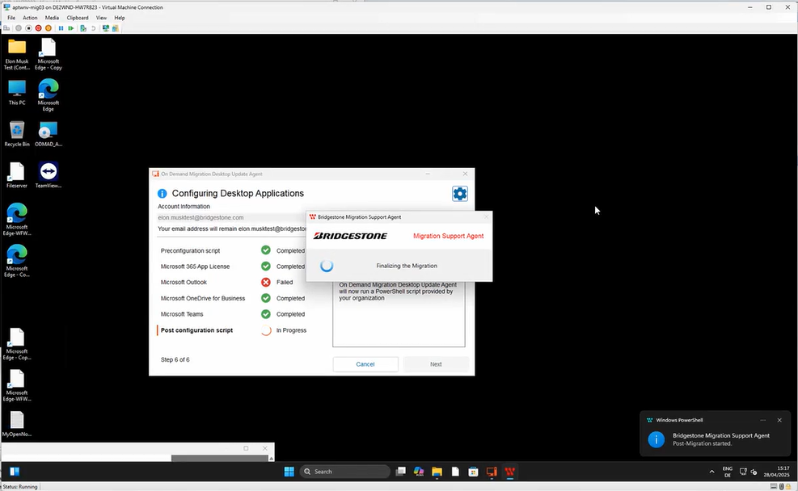
alt text
click now on “Finish”:
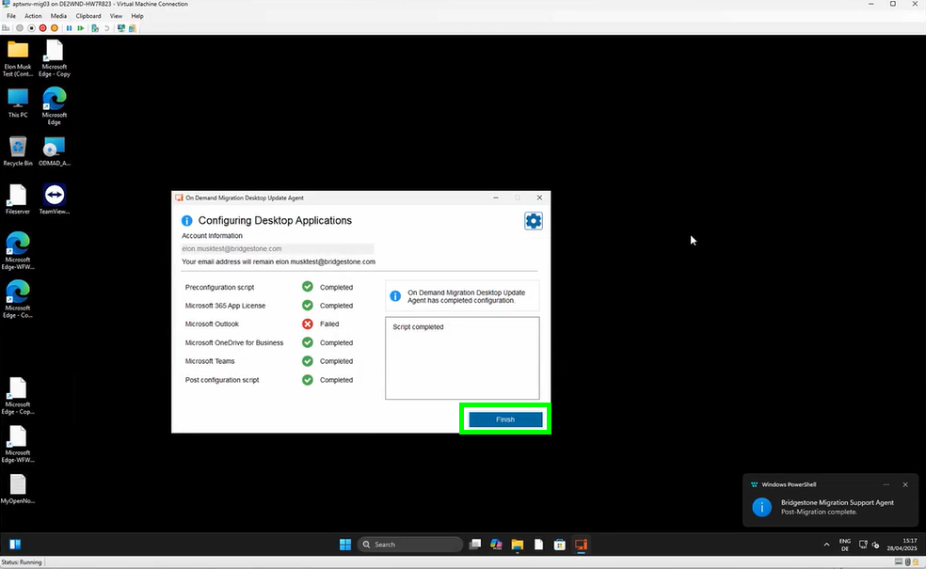
alt text
your devices will be restarted again. You may wait until the countdown finished or you may click on “Restart now”:
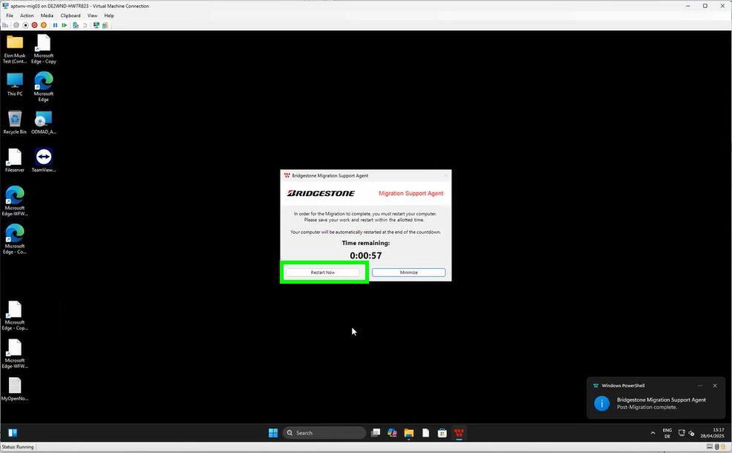
alt text
You can now simply login with your Bridgestone account:
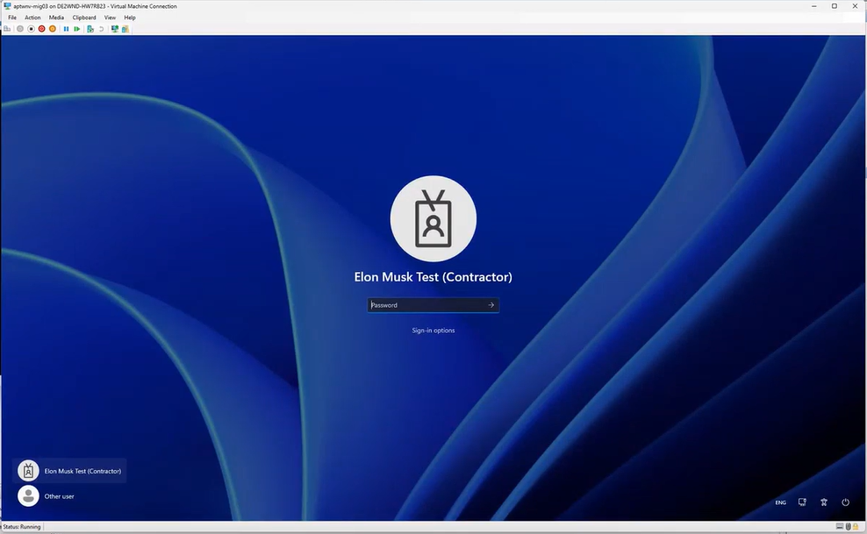
alt text

