Migration of company iPhone

Please take your company iPhone and open your message service. You should have received an SMS with a link.



Please click on the link in the SMS

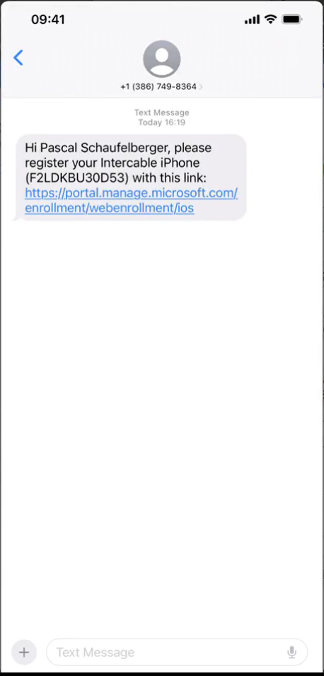

A new window will pop up. Please login with your new Intercable IAS account:

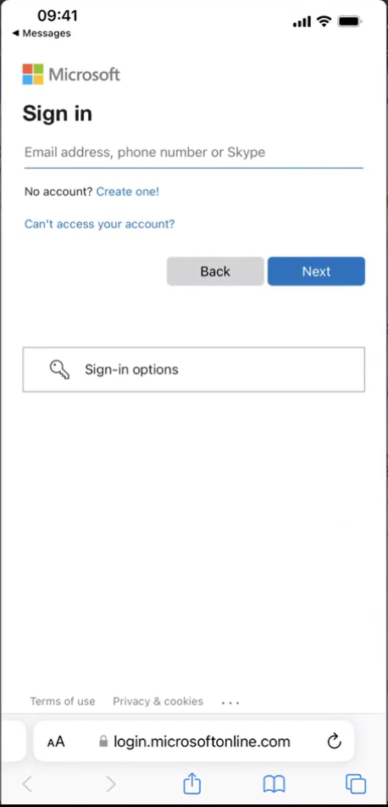

enter your password:

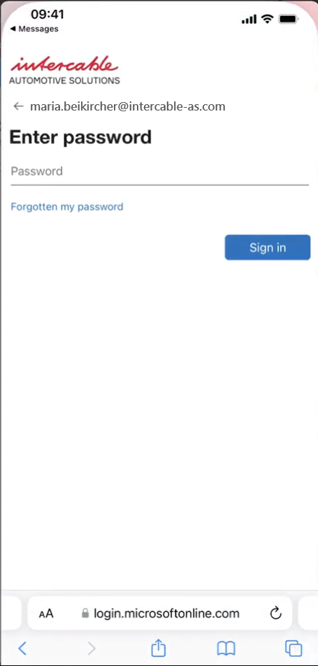

confirm with MFA:

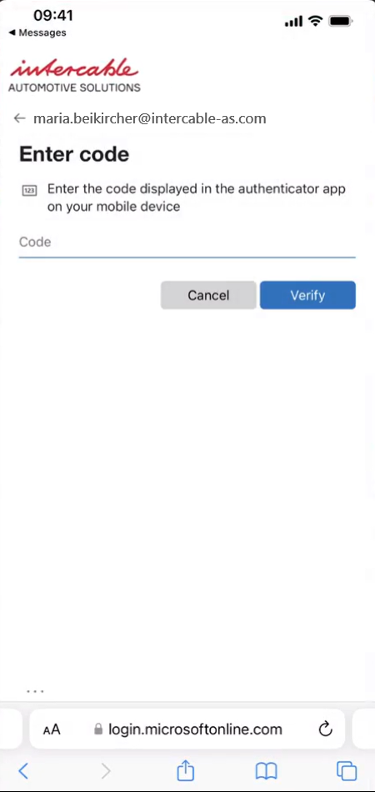

Please click on “Get started”

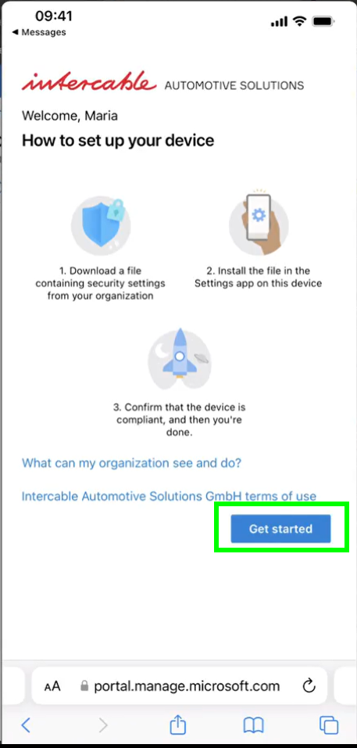

Allow the webiste to donwload a configuration profile

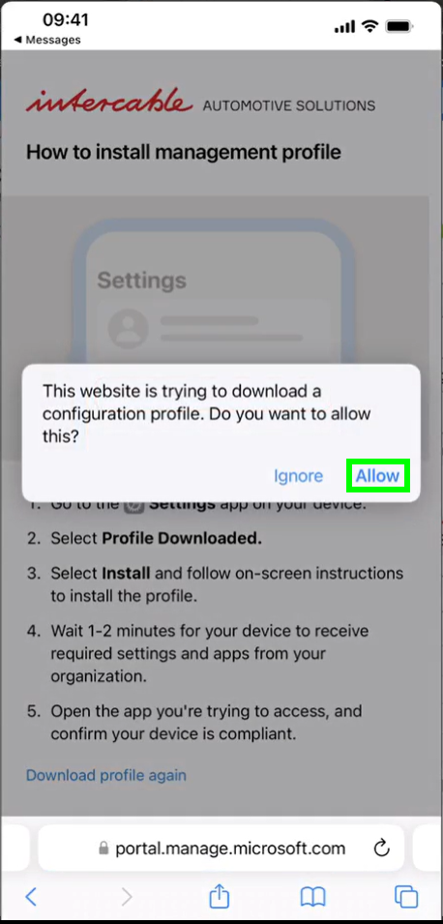

Confirm the download by clicking on “Close”

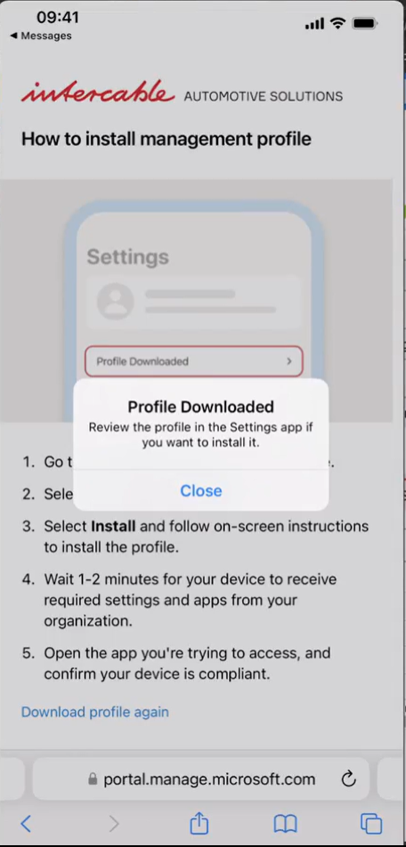

Go to settings

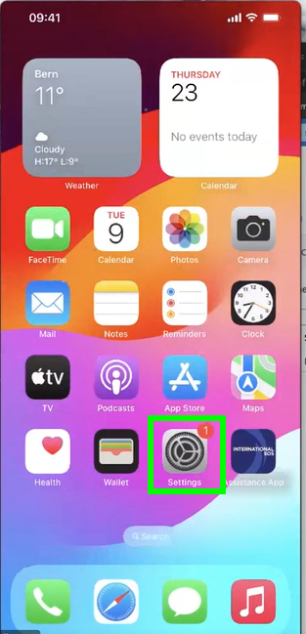

choose “Profile Donwloaded”

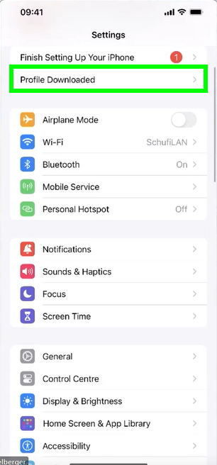

install your new profile by clicking on “Install” at the top right corner

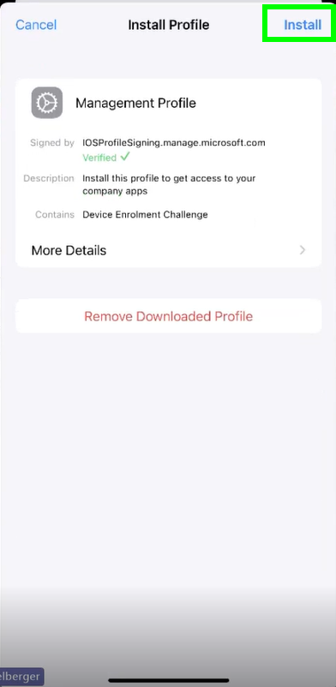

enter your passcode

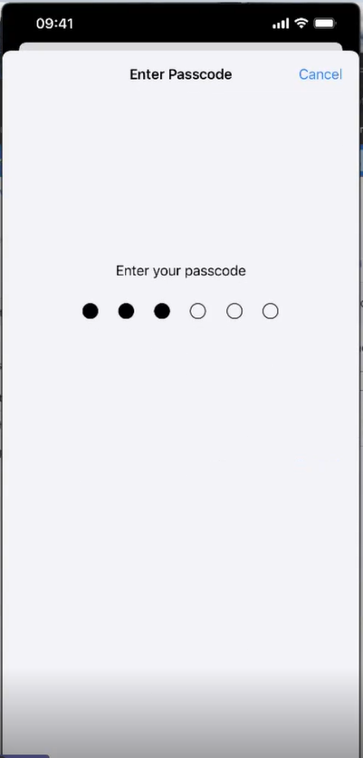

click on install

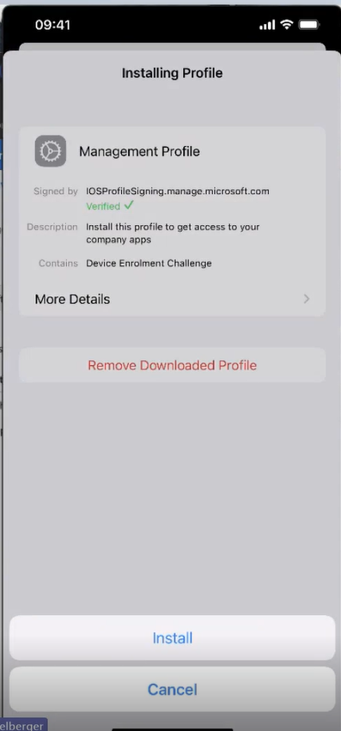

confirm the warning by clicking on “Trust”

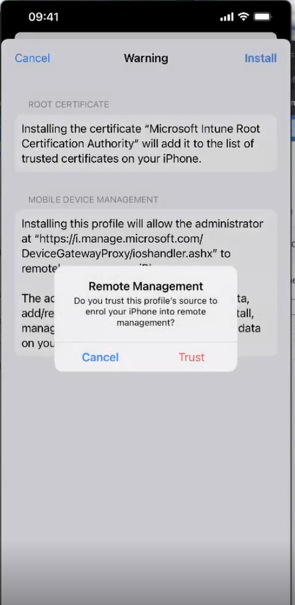

close the process by clicking on “Done”

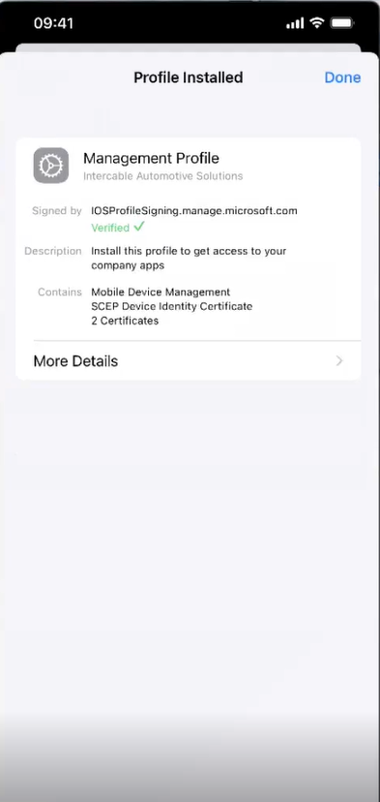

The Microsoft Apps (Outlook, Teams etc.) will be installed automatically. Once all apps are installed please choose one app and login.

In case you still find your old account, please just remove it and sign in with the new one.

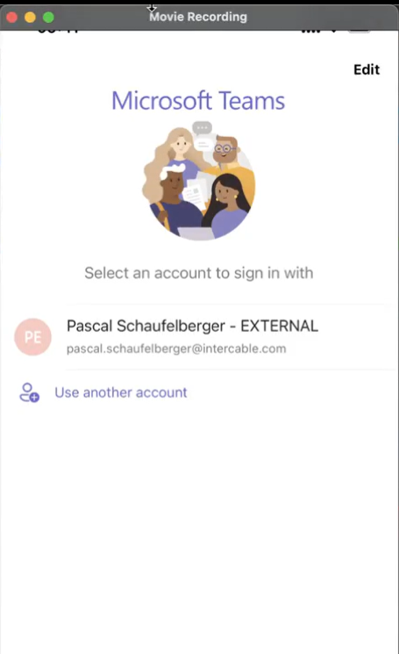

sign in with your new account

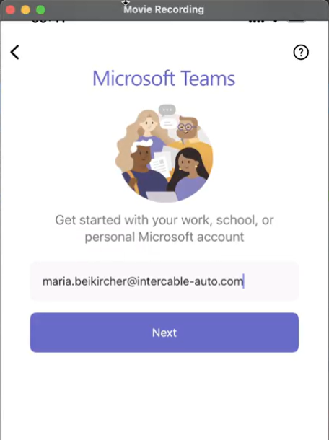

enter your password

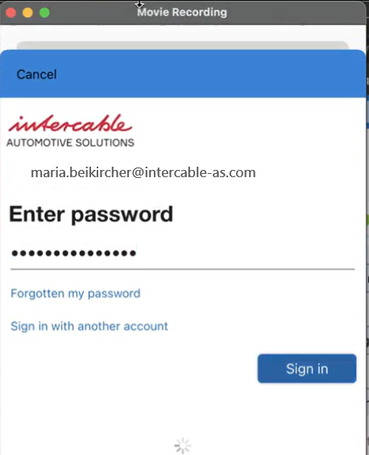

confrim with MFA

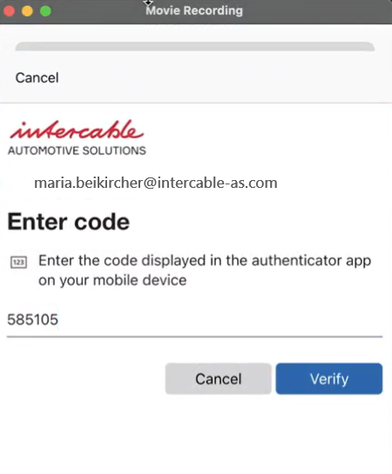

your device will now be checked, if it meets the security requirements

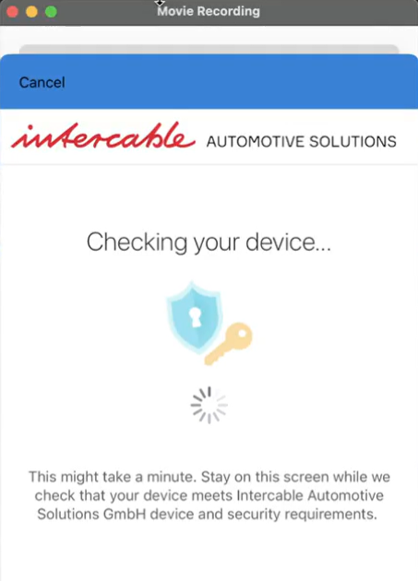

confirm again with MFA

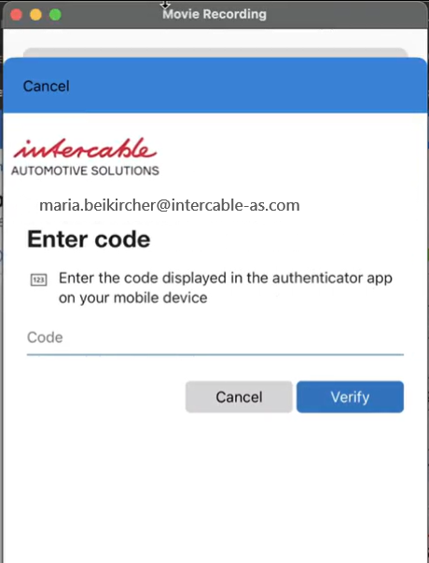

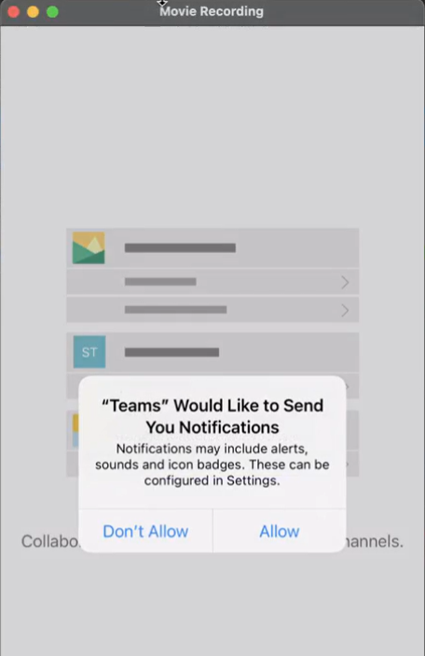

One last step: please open the Company Portal app (Unternehmensportal) on your Home Screen.

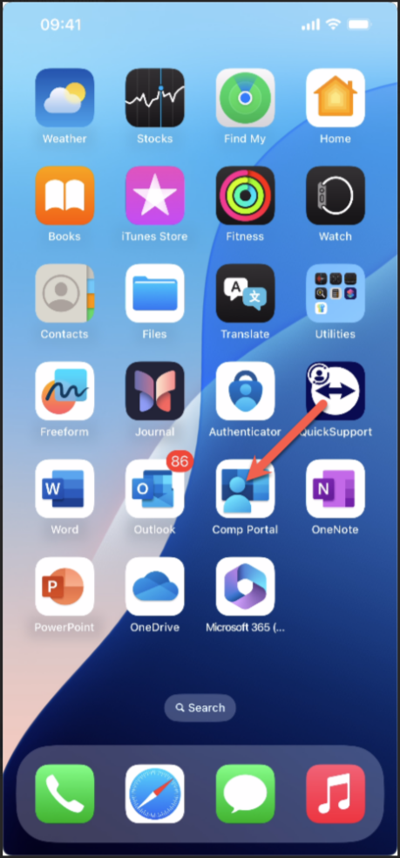

alt text

Click on Sign in (Anmeldung)

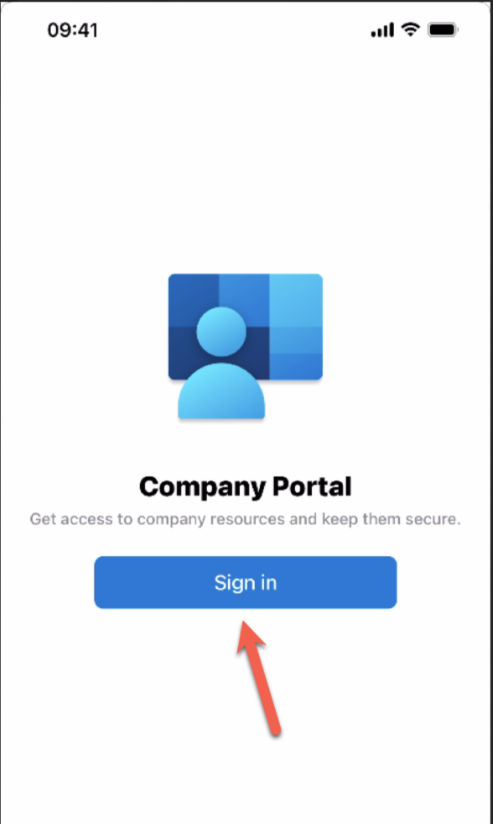

alt text

Select your Intercable IAS account:

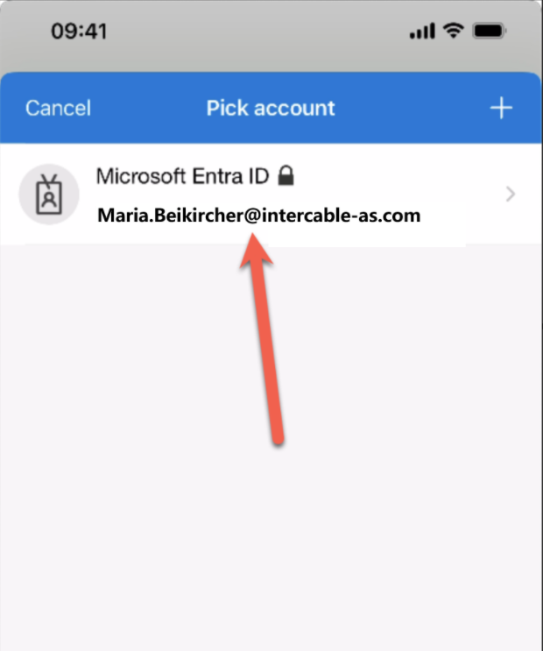

alt text

The migration is now completed. You will need to sign into the different apps.