Set up MFA for VDI

## Documentation for Multifactor Authenticator

### Delete your current account from the Authenticator App

1. Open your Microsoft Multifactor Authenticator on your smartphone
2. Choose the intercable acount
3. Click on the setting symbole on top right and choose “remove account”

### Set the Multifactor Authentication for your automotive account

1. Go to https://mysignins.microsoft.com/security-info
2. Click on “Add sign-in method”

* 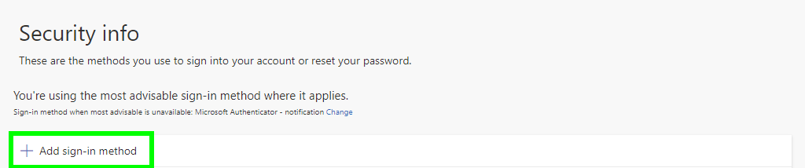

1. Choose the “authenticator app” and click on add

* 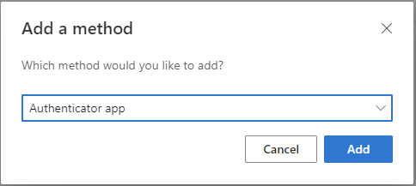

1. Click on “Next”

* 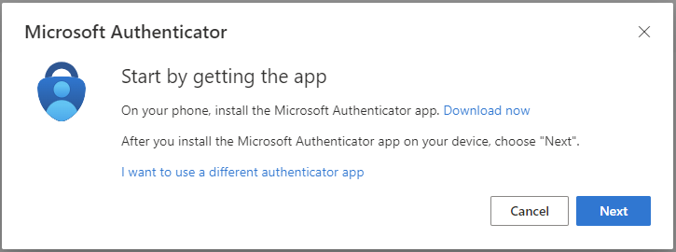
* 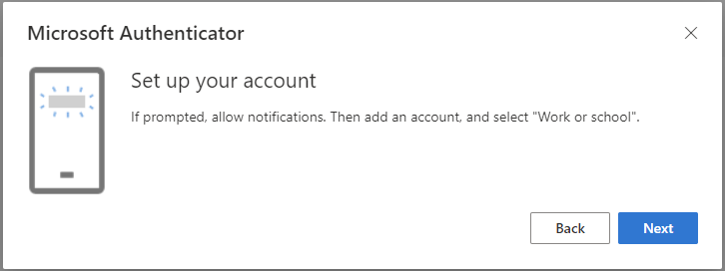

1. Scan now the QR Code with the Microsoft Authenticator App on your smartphone

* 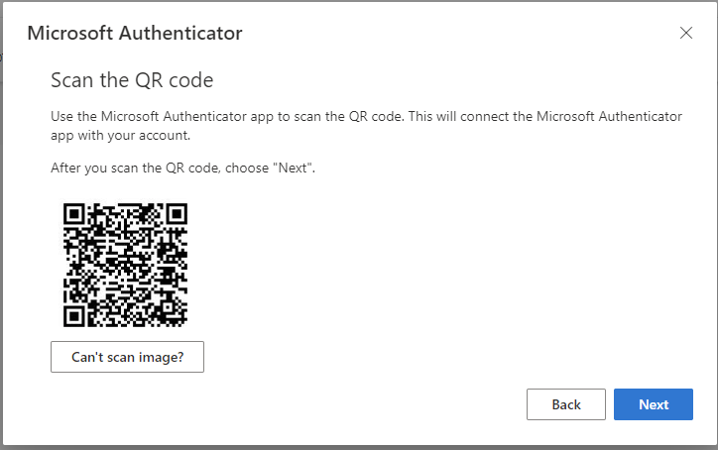

1. Enter the number on your smartphone

* 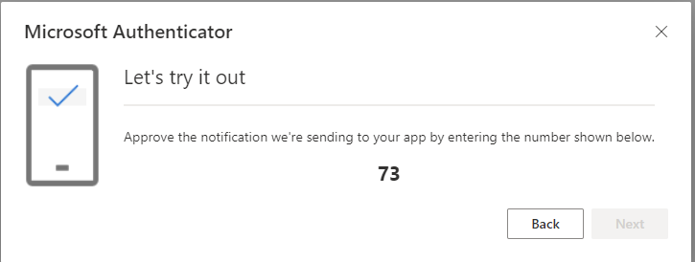

1. Click on “next” to approve the set up

* 