Documentation for Multifactor Authenticator

## Delete your current account from the Authenticator App

Open your Microsoft Multifactor Authenticator on your smartphone

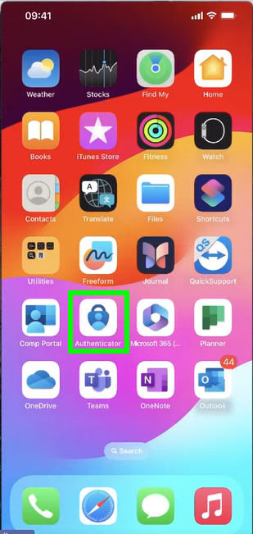

Choose the Intercable account (dosn’t matter if Intercable GmbH or Intercable-as)

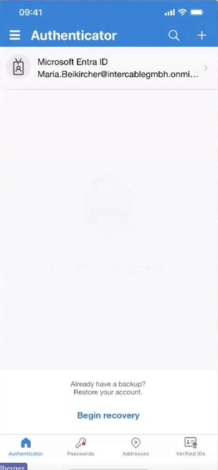

Click on the setting symbol on top right and choose “remove account” and click on “All apps on this device”

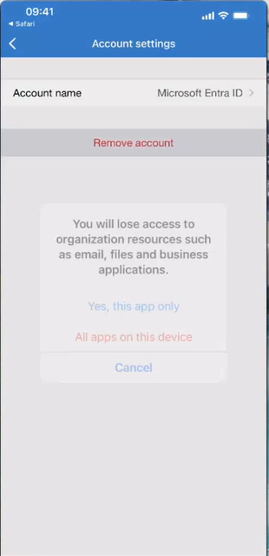

The setup of your Intercable Automotive Solutions account will be done during the migration of your computer/notebook on Monday morning.