How to log in your DECT phone

This example will show how to log in your DECT phone to Microsoft Teams. You will have to do that after each password change on our systems.

Step 1: DECT is in “Sign In” state

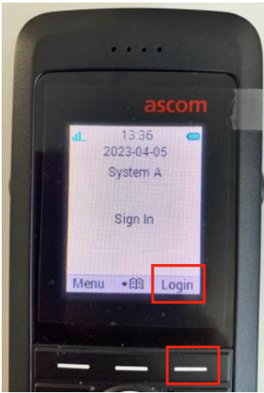

Step 2: Click the right button for “Login”, then the left button for “Yes”

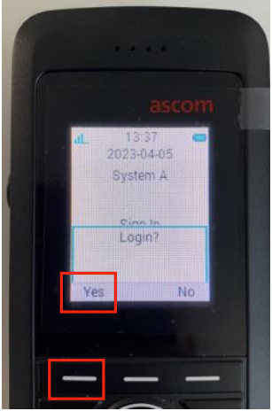

Step 3: Scroll down until you see the Pairing Code

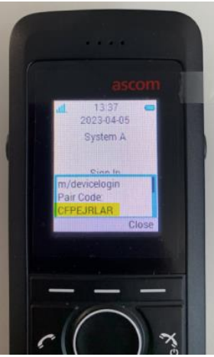

Schritt 4: On your PC, go to https://aka.ms/siplogin

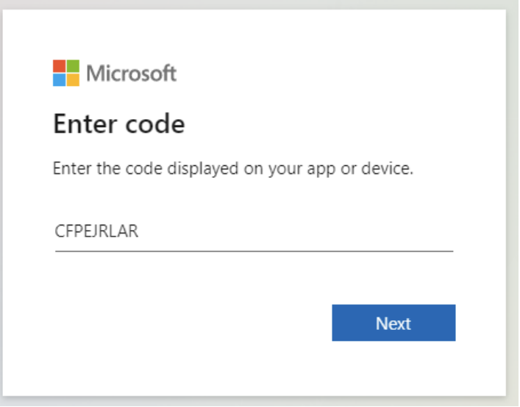

Schritt 5: Enter the pairing code shown on the device, then log in using your own credentials and follow the instructions on the screen.



It may happen that in the following screens shows a different European location (Ireland, Netherlands,…) than your current location as login location due to technical reason.