Agent Documentation
Welcome in the new Intercable Automotive Solution environment! In order to work normally you need to follow a few steps. Please read the instructions carefully before you start the migration. It is important, that during the migration no other program is running.
Open the Quest Agent on your computer.
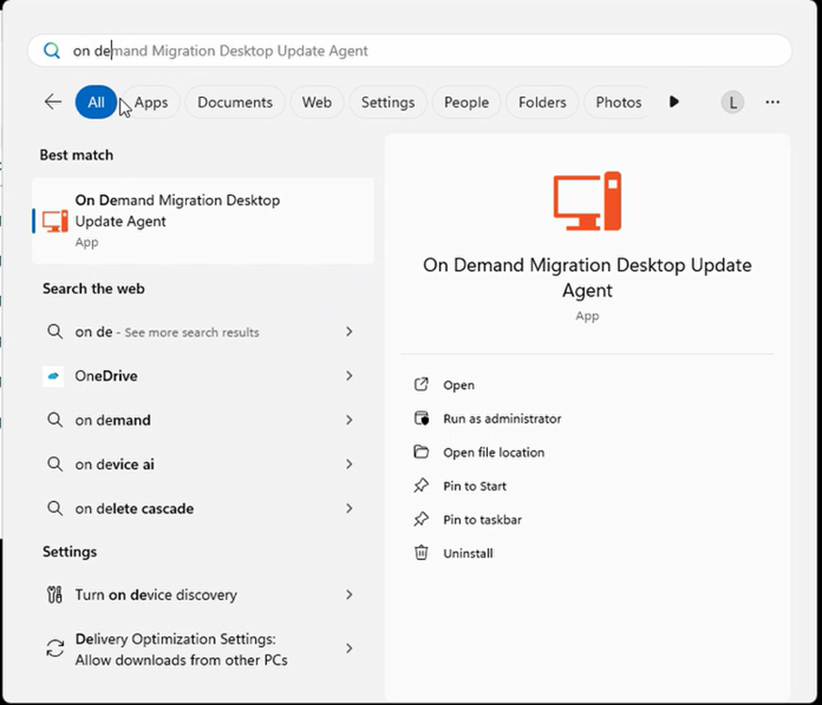
alt text
Start the migration while following the instructions in the Quest Agent.

Quest Agent
The agent will guide you through the entire migration process. In case the agent will not connect by himself, please wait a few minutes and try to strat it again. When you are ready click on “Start”. Please be aware that NO other program beside of Quest may be running.
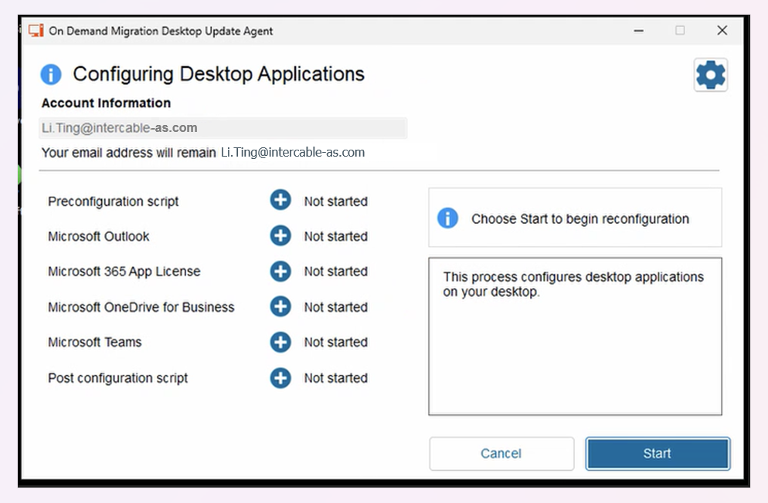
alt text
Please wait, until all steps are completed.
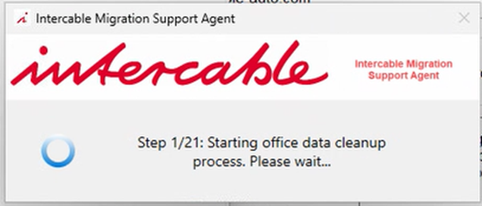
alt text
click on “Next” every time when it is active
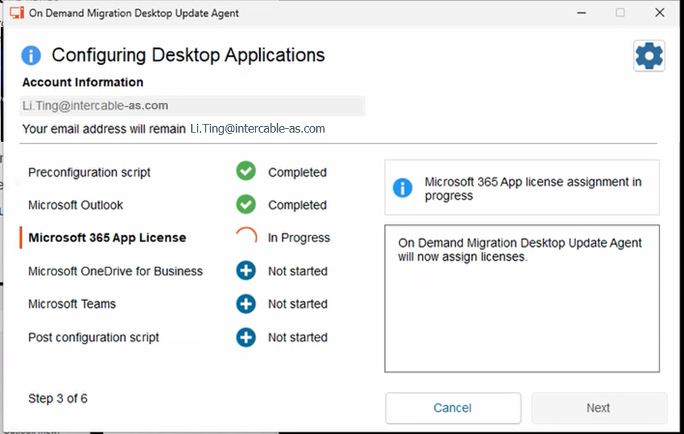
alt text
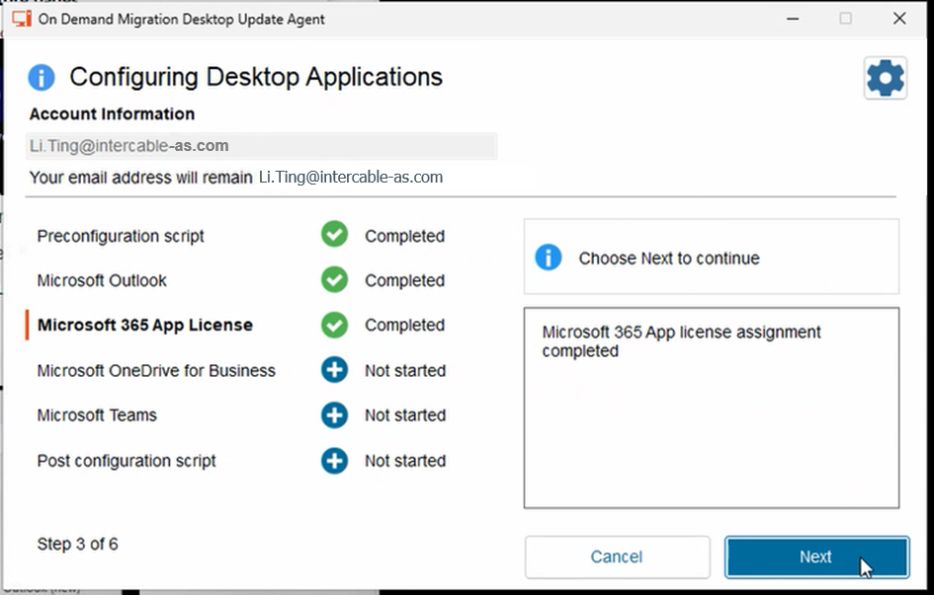
alt text
The process can fail but in this case just click on “Next”
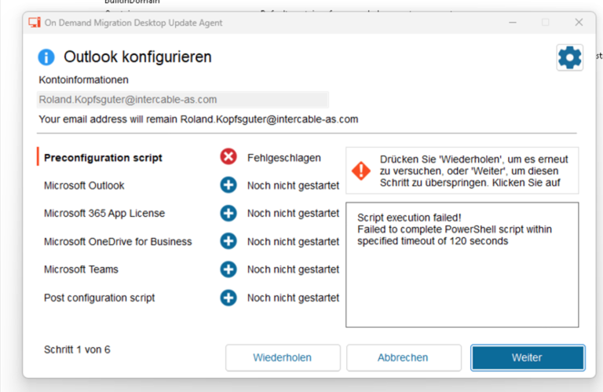
alt text
While OneDrive will be migrated, you will be asked to login again. Please do so!
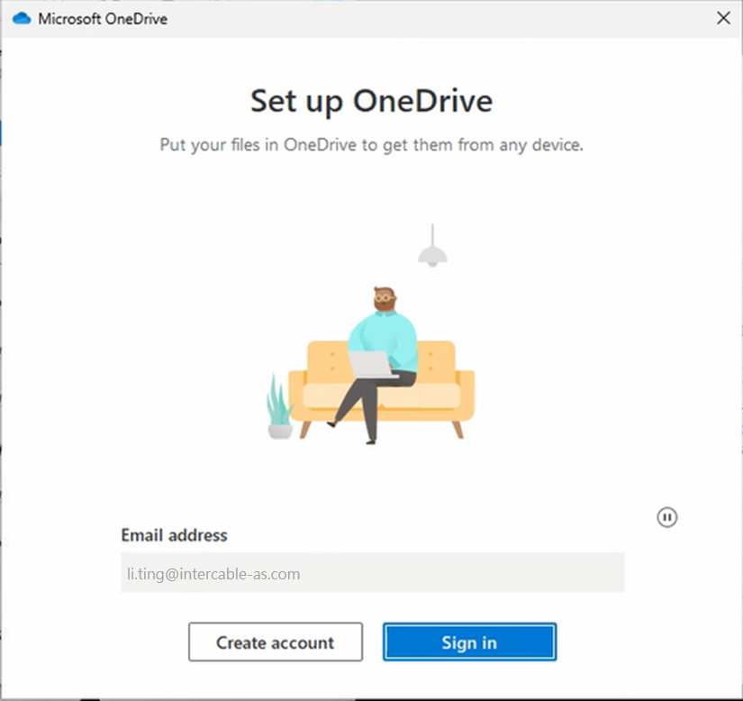
alt text
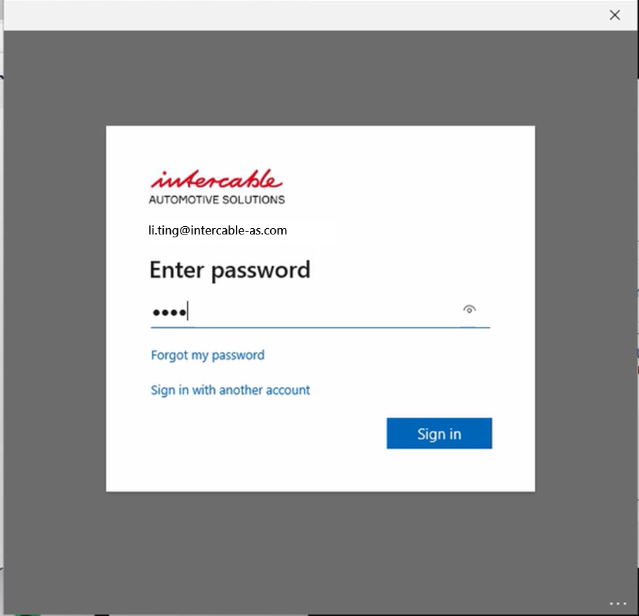
alt text
You will be asked to set up the multifactor authentication. ### First of all, please make sure, that you have deleted your Intercable GmbH account from the Microsoft Authenticator app on your smartphone. You can find the instructions here. Please click then on “Next” to start the process. The “Skip Setup” button is NO option and will cause trouble for the future migration process.
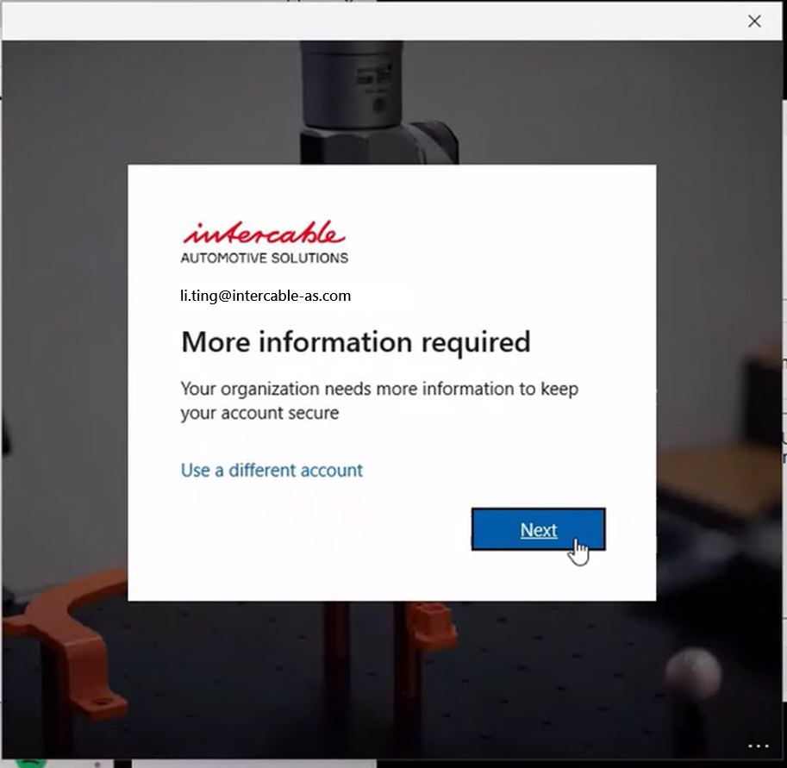
alt text
Please make sure the Microsoft Authenticator app is installed on your smartphone and click on “Next”.
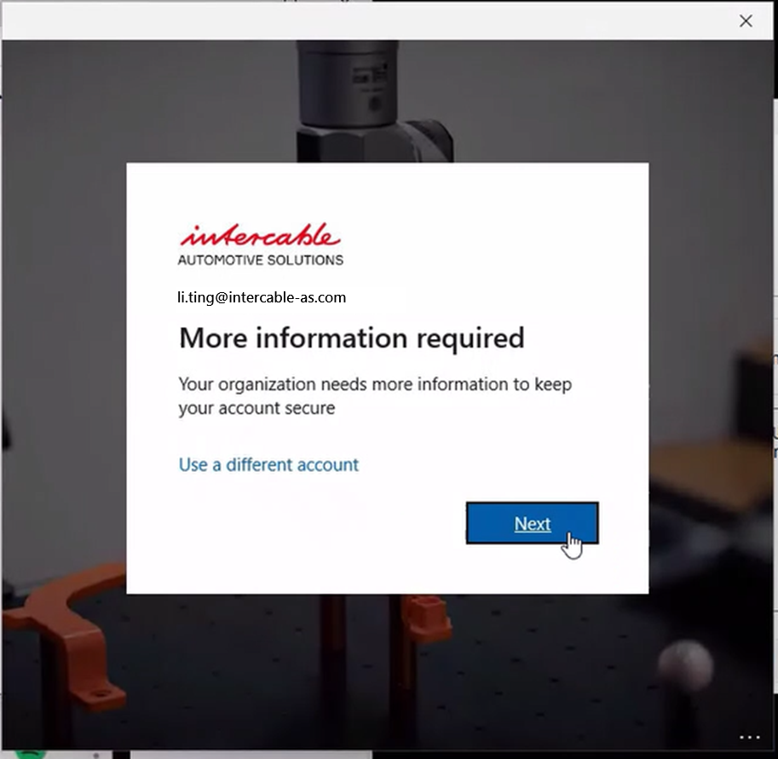
alt text
Add now a new account on your smartphone by clicking on “+” and add a company account. Click after on your computer on “Next”.
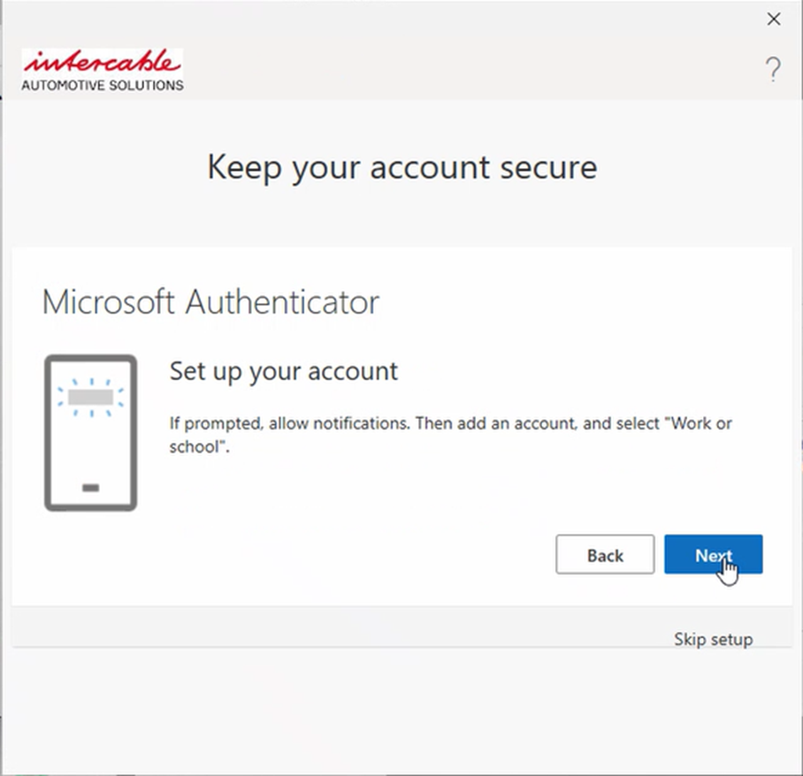
alt text
Scan the QR Code with your smartphone.
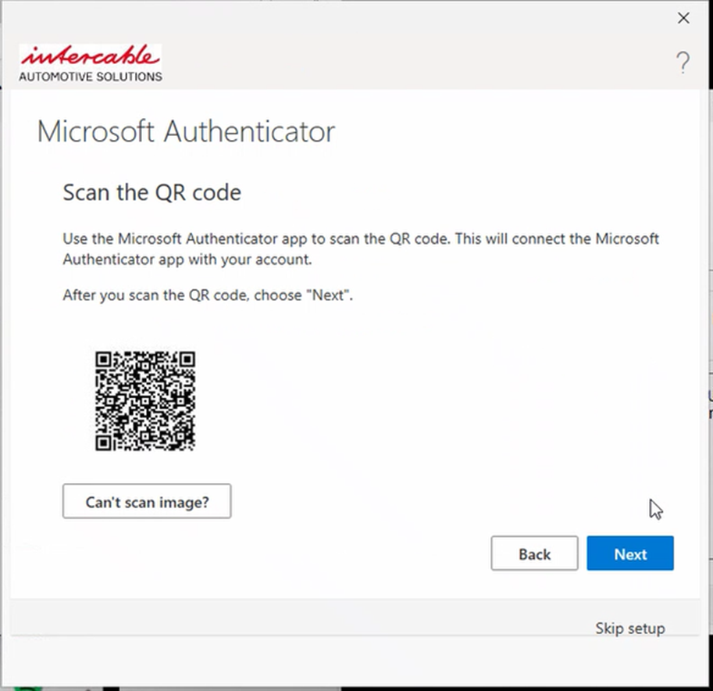
alt text
Please enter now the code which will be shown on your smartphone and click on “Next”.
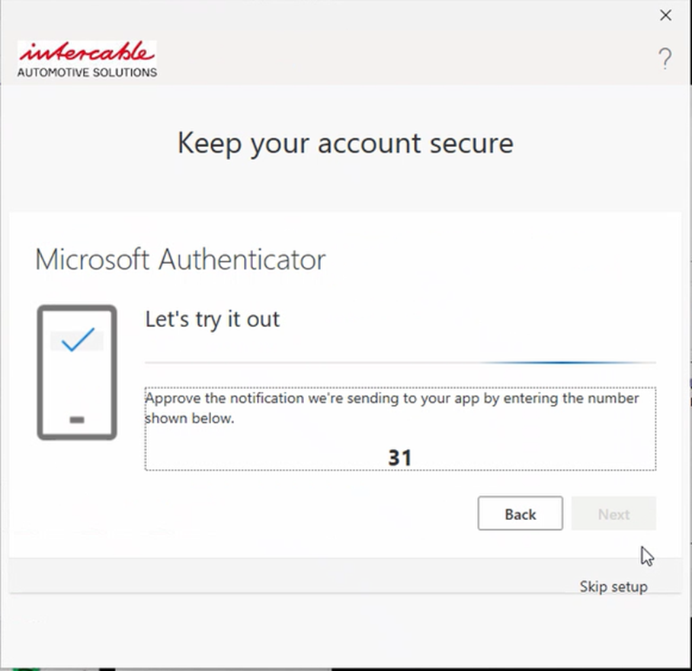
alt text
The setup was successful, please click on “Next” and “Done”.
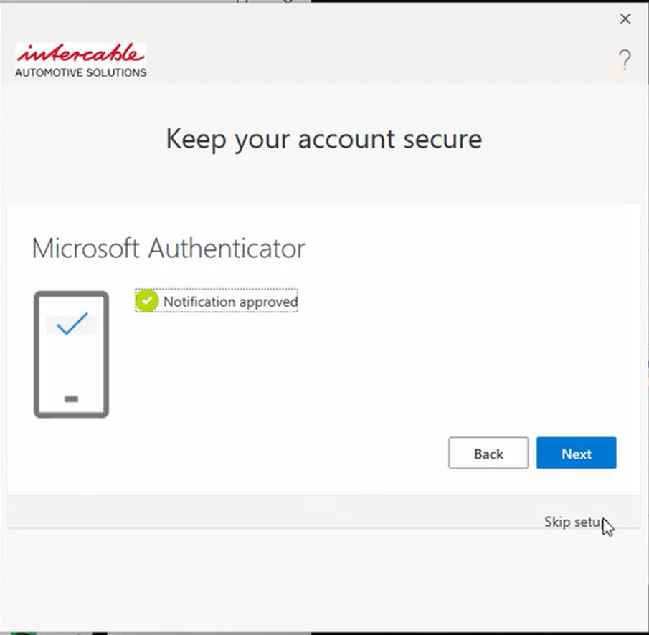
alt text
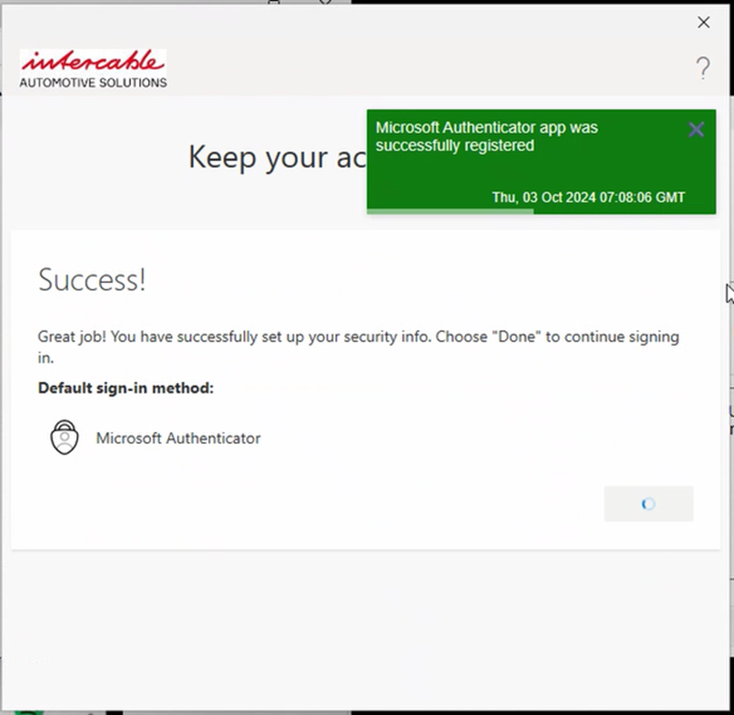
alt text
Let’s continue with the migration by clicking on “Yes, all apps” or “OK”.
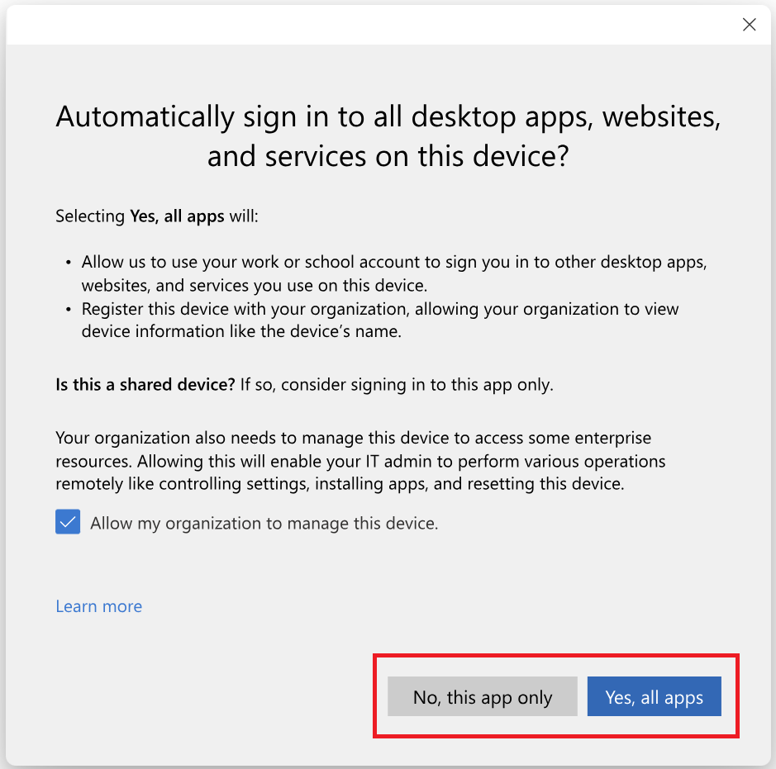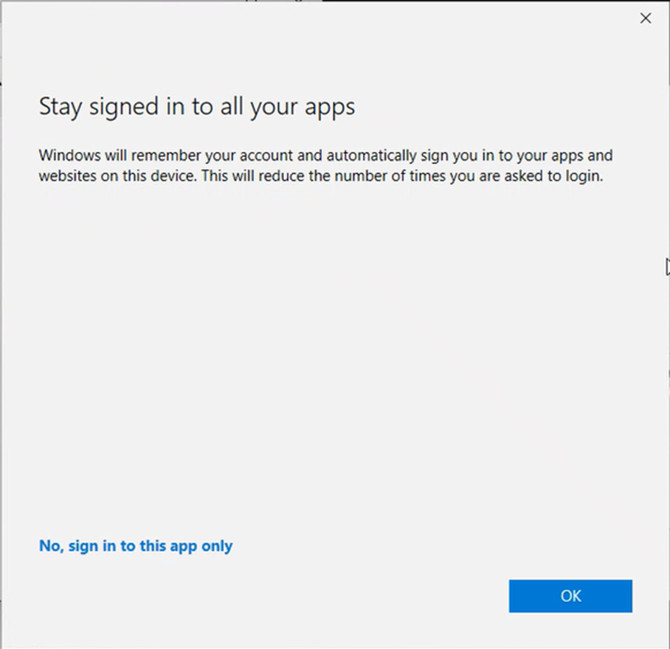
A new window will open. It will take a few minutes until the configuration is completed. Please stay patient, it is normal!
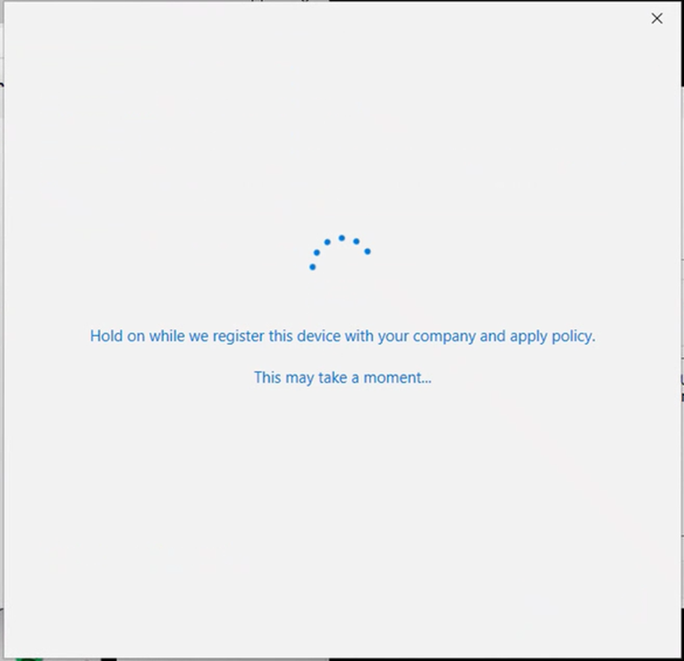
alt text
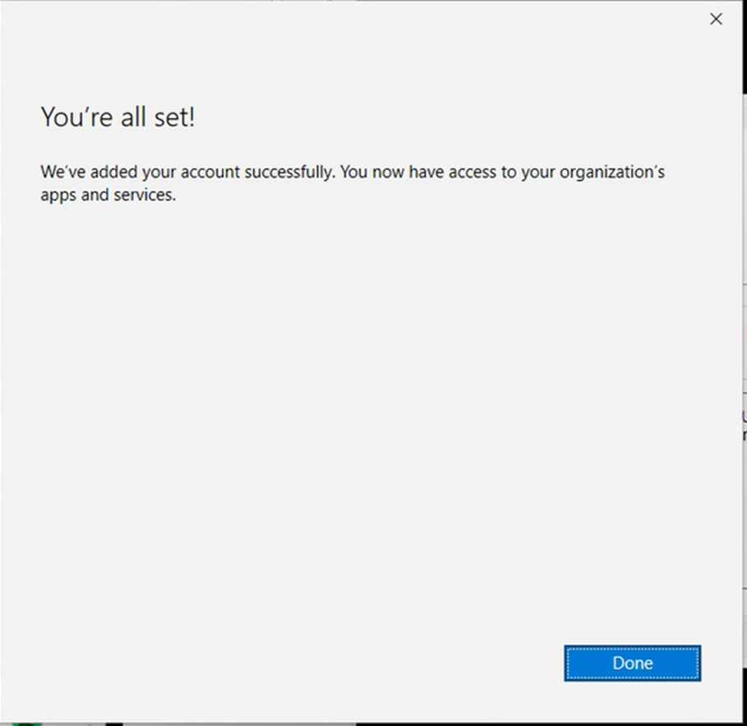
alt text
Let’s go ahead with your OneDrive configuration. Please click on “Next”
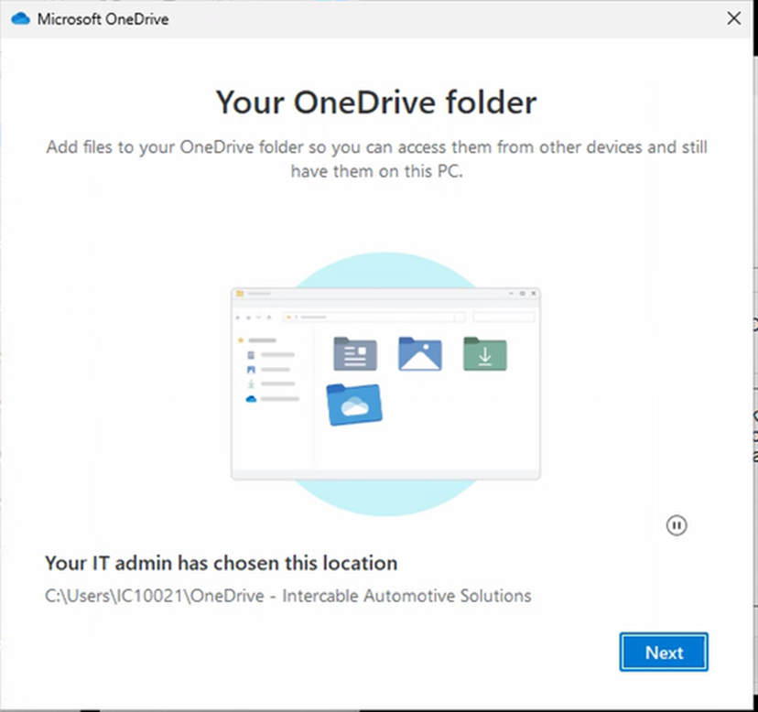
alt text
As your OneDrive already had a folder, please choose “Use this folder”
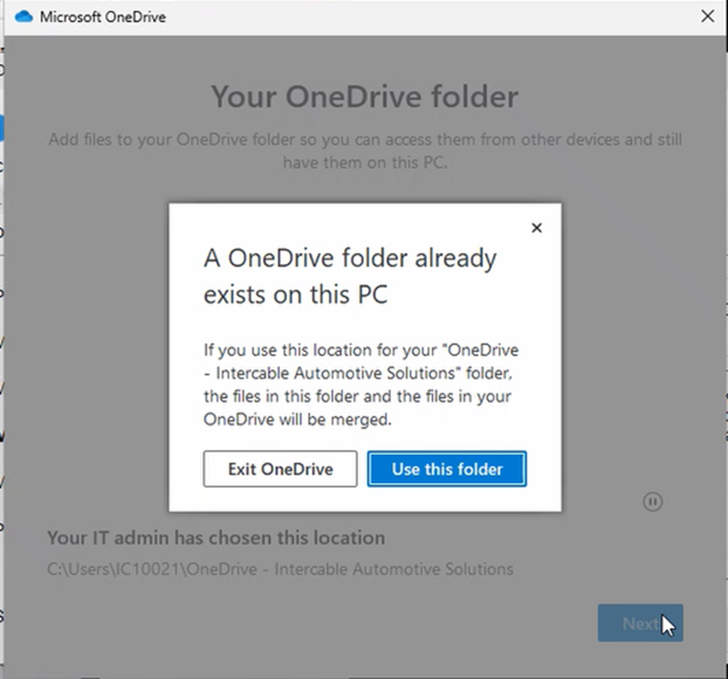
alt text
Please start now the Backup by clicking on “Start backup”
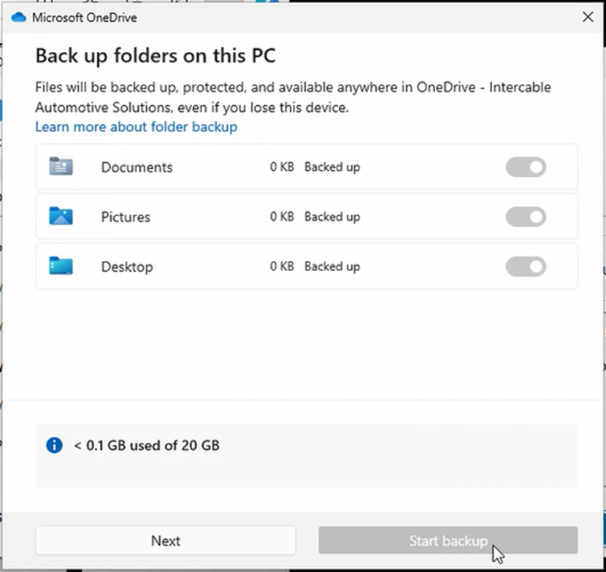
alt text
You will now get a few new windows with information. Read them and continue by clicking “Next”.
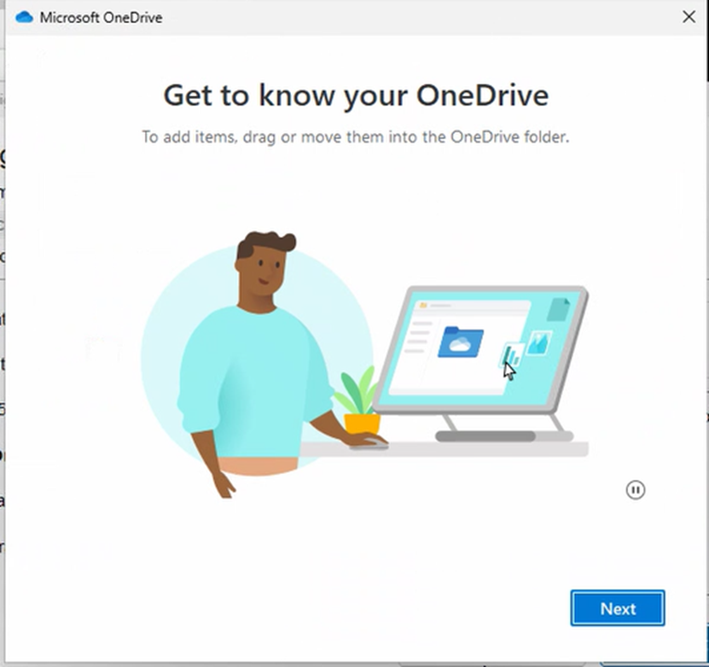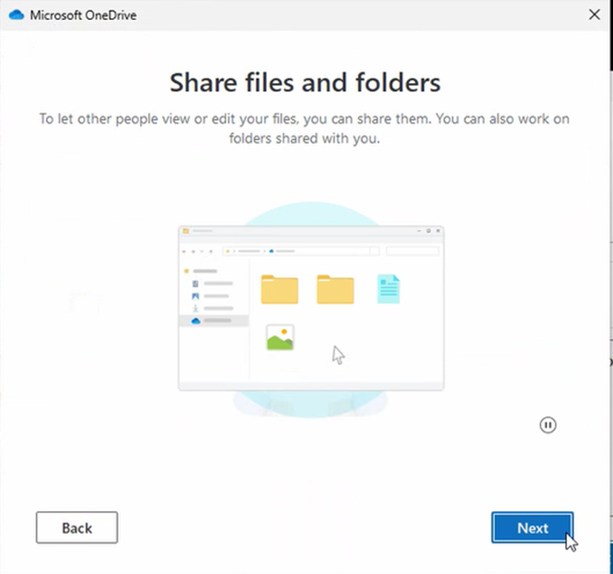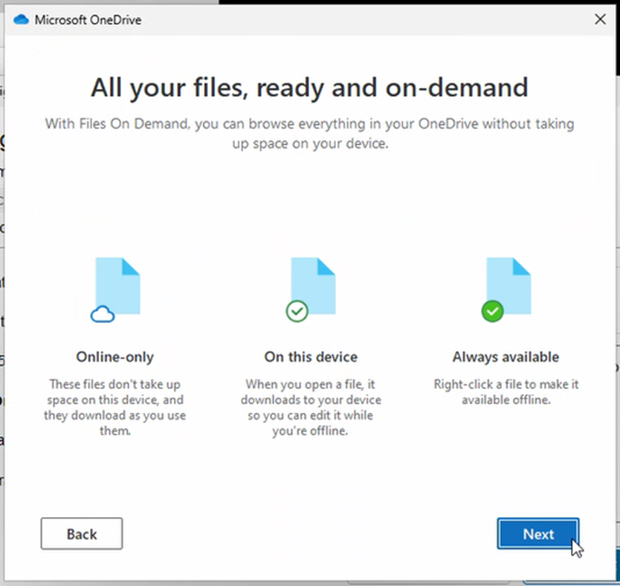
The mobile app you may simply skip by clicking on “Later” 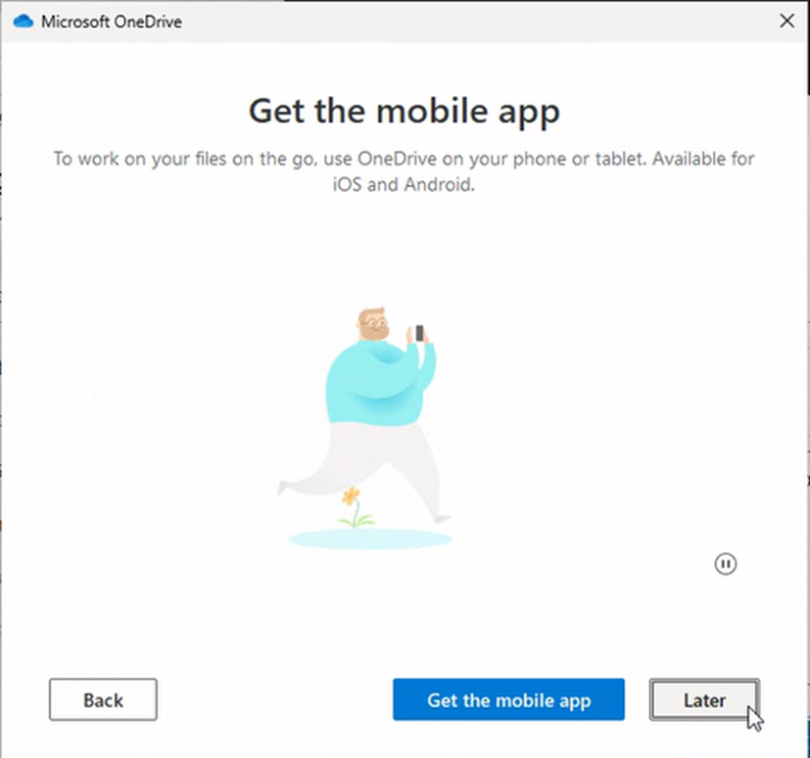
Once the OneDrive is migrated you will receive the following message. You can now simply close the window:
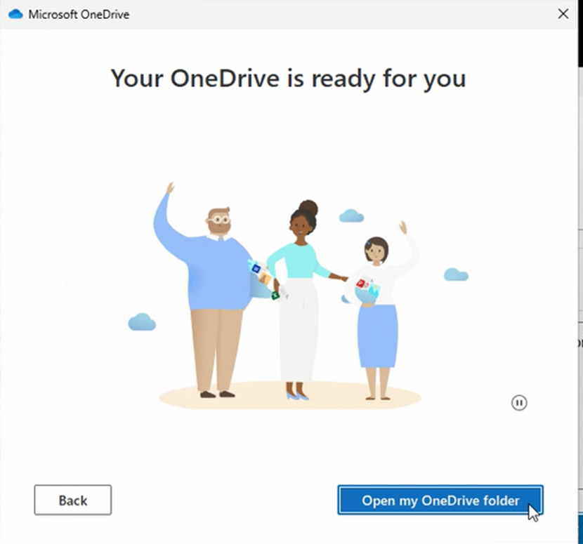
alt text
Let’s go back to the Quest Agend and click on “Next”:
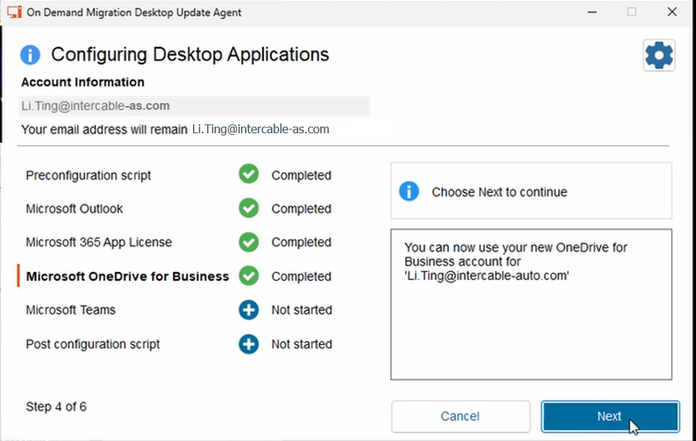
alt text
Microsoft Teams will ask you once to login. Please choose your account.
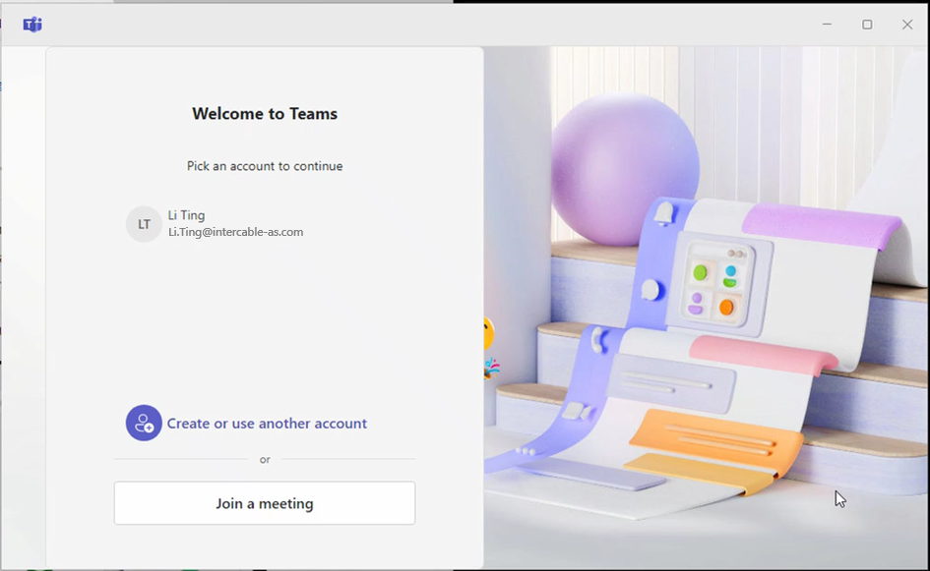
alt text
if a new window will pop up, please confirm with “Next”:
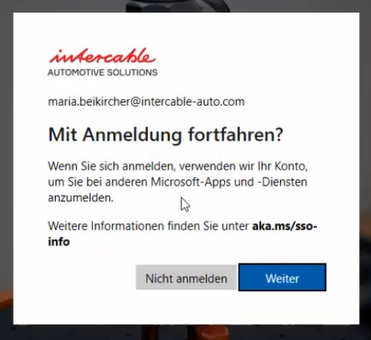
once you are successfully logged in Teams please change again to your Quest Agent and continue by clicking on “Next”
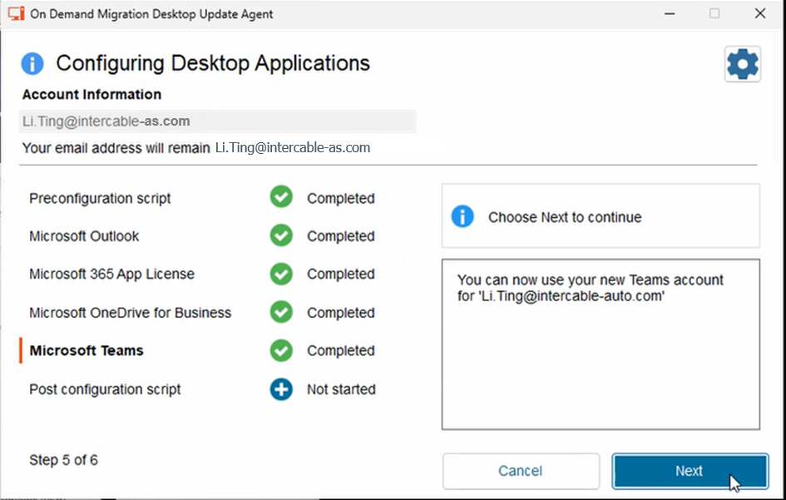
alt text
Once the migration is done, your computer will automatically close all the windows and forces a restart.
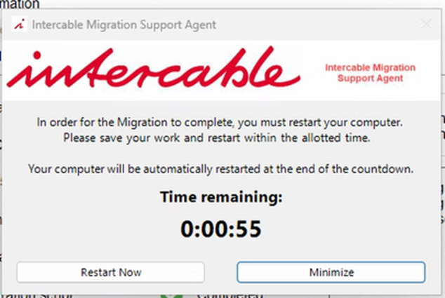
alt text
That is the moment the migration is done successfully and you can start the migration of your smartphone.

Migration of your company iPhone
Migrate your company iPhone ==> Guideline

Migration of your private smartphone
Migrate your private smartphone ==> Guideline

